Continuous Manufacturing | DOI: 10.1002/anie.200((will be filled in by the editorial staff))
End-to-End Continuous Manufacturing of Pharmaceuticals: Integrated Synthesis, Purification, and Final Dosage Formation
Salvatore Mascia, Patrick L. Heider, Haitao Zhang, Richard Lakerveld, Brahim Benyahia, Paul I. Barton, Richard D. Braatz, Charles L. Cooney, James M. B. Evans, Timothy F. Jamison, Klavs F. Jensen, Allan S. Myerson, Bernhardt L. Trout*
The pharmaceutical industry has seen numerous pressures in the past decade to improve efficiency as rising costs outpaced the development of new pharmaceuticals.^{[1]} A growing interest in green processes also highlights areas for improvement in pharmaceutical synthesis and manufacturing where environmental impacts have been higher than other industries.^{[2]} Continuous manufacturing has attracted the attention of industry and academia alike by promising lower costs, greater reliability and safety, better sustainability, and novel pathways not otherwise accessible.^{[3]} Recent studies have demonstrated that economic savings can be realized for certain cases by transforming a batch production into continuous.^{[4]} Existing batch-based manufacturing can take up to 12 months between the start of the first synthetic step and market release of finished tablets,^{[5]} partially resulting from movement of materials around and between facilities and lengthy final product testing. This results in large, expensive inventories and shortages from manufacturing delays if the batch fails after production during final testing. Continuous manufacturing allows faster response to demand changes, which permits reduced inventory compared to batch-based manufacturing resulting in not only lower working capital, but also decreased amounts of potentially hazardous intermediates, including high potency active pharmaceutical ingredients (API). Increasing use of online monitoring and control also reduces the burden of final testing, mirroring the online control present in other continuous manufacturing industries.^{[6]} Simulations of processes that include recycle loops demonstrate improvements to process yield and robustness can be achieved by operating continuously.^{[7]} While promising, there are still many hurdles for implementation of continuous processes.^{[2b, 8]} These include development of flow chemistry transformations, difficulties processing dry solids and solid-laden fluids, lack of equipment at bench and pilot scale, development of control methodologies to guarantee product quality and breaks in the process especially between synthesis and formulation. The literature contains many examples of continuous processes for chemical synthesis in flow,^{[9]} reactions with workup,^{[10]} continuous crystallization,^{[10b, 11]} drying,^{[12]} powder blending,^{[13]} and tableting,^{[13d, 14]} however, only few others have considered multistep portions of a process.^{[9h, 10b, 13d, 14c, 15]}
Here we present the first example of an end-to-end, integrated continuous manufacturing plant for a pharmaceutical product. Our plant starts from a chemical intermediate and performs all the intermediate reactions, separations, crystallizations, drying, and formulation resulting in a formed final tablet in one tightly controlled process. This provides a platform to test newly developed continuous technologies within the context of a fully integrated production system and investigate the system-wide performance of multiple interconnected units. This paper presents the key results of operating the plant for runs of up to 10 days. The 10 day period included start-up of the plant, stabilization of key processes, and periods of end-to-end operation. We specifically highlight areas where we take advantage of continuous flow features and discuss techniques relevant to continuous processes.
[∗] S. Mascia, P. L. Heider, H. Zhang, R. Lakerveld, B. Benyahia, P. I. Barton, R. D. Braatz, C. L. Cooney, J. M. B. Evans, K. F. Jensen, A. S. Myerson, B. L. Trout
Department of Chemical Engineering, MIT
Cambridge, USA
Email: trout@mit.edu

T. Jamison
Department of Chemistry, MIT
[∗∗] We thank Novartis International AG for funding and supplying our starting chemical intermediates. We would like to acknowledge the contribution of the pilot plant team including Soubir Basak, Erin Bell, Stephen Born, Louis Buchbinder, Ellen Cappo, Corinne Carland, Alyssa N. D'Antonio, Joshua Dittrich, John Fisher, Megan A. Foley, Ryan Hartman, Devin Hershey, Rachael Hogan, Bowen Huo, Anjani Jha, Ashley S. King, Tushar Kulkarni, Timur Kurzej, Aaron Lamoureux, Paul S. Madenjian, Sean Ogden, Ketan Pimparkar, Joel Putnam, Anna Santiso, Jose C. Sepulveda, Min Su, Daniel Tam, Mengying Tao, Kristen Talbot, Christopher J. Testa, Justin Quon, Forrest Whitcher, and Aaron Wolfe.
Supporting information for this article is available on the WWW under http://www.angewandte.org or from the author.
The target API is aliskiren hemifumarate (Scheme 1, 6) formulated as tablets containing 112 mg of aliskiren free base, 5. The total throughput of the plant is nominally 45 g h⁻¹ of 6 corresponding to 2.7 × 10⁶ tablets y⁻¹. The throughput can be adjusted by changing control setpoints in the plant between 20 g h⁻¹ and 100 g h⁻¹. The plant layout is compact with a 2.4 m × 7.3 m footprint entirely contained within enclosures. Figure 1 shows the major unit operations in the plant. A more detailed diagram with the automated control loops used to ensure product quality is provided in the supporting information (Figure S1). The number of unit operations is reduced from 21 for the batch process to 14 for the continuous process mainly due to improvements in the downstream steps using continuous flow technologies. For instance, steps such as mixing, granulation, drying, and compression forming are replaced by a single, integrated extrusion and molding device. The process residence time is nominally 48 h which is nearly an order of magnitude shorter than the sum of the processing times for the batch process (300 h not including off-line holding and transport).^{[16]} This is from realizing shorter processing time across all the unit operations (Table 1).
While a detailed description of the process is provided in the supporting information, a brief description is provided here to highlight instances where we took advantage of the continuous and integrated features of the plant. The process starts with the chemical intermediate 1 that is melted and pumped into a tubular reactor (R1) at 100 °C where it combines with 10 equivalents of amine 2 and 1 equivalent of acid catalyst 3 and reacts reversibly to 4. This reaction was developed^{[17]} specifically for the flow process and provides several advantages over the batch process. Running neat in a single-phase reaction, the reaction is much faster than existing batch processes which can also produce solids (3–4 h vs. 72 h).^{[18]} Workup is performed inline by adding water and ethyl acetate under pressure (7.5 × 10⁵ Pa) at the reaction temperature to solubilize the reagents before cooling. This is more easily done in flow where the solvents are mixed at temperatures above their boiling points whereas in batch, cooling of the reaction crude results in a highly viscous liquid that is difficult to mix. The two-phase stream is separated using a membrane-based liquid-liquid separator (S1) that is scaled up from microfluidic flow applications.^{[19]} The organic phase contains only 1 and 4 while the aqueous phase removes 2 and 3.
The separated organic phase is fed into a two-stage, mixed suspension, mixed product removal (MSMPR) crystallization process (Cr1 and Cr2).^{[20]} The solution is cooled to 5 °C and mixed with the antisolvent heptane. The slurry is then fed into an in-house built continuous filter (W1). A thin layer of slurry is formed over a rotating, porous plate and is washed with ethyl acetate and ethanol. Vacuum applied to the back side of the plate pulls the mother liquor and wash solvent through and the purified wet cake is scraped off and conveyed into another vessel (D1). A density flow cell in a side loop monitors the concentration of 4 in the vessel and feedback control adjusts the flow rate of an ethyl acetate dilution stream to maintain the concentration at 26.2 wt%, as measured by the density meter, as required for the second reaction of 4 to 5 (shown in Scheme 1).
This movement of material from the crystallization through the filter into the second reaction provides an example where a critical material attribute (CMA) of a key intermediate is controlled within the process (Figure 2). A detailed study of the CMAs and their control has been previously reported.^{[21]} Control for the process is split up into two layers: stabilizing and quality. The stabilizing control layer consists of automated level control loops that maintain sufficient holdup in each vessel while the quality control layer maintains a desired product quality (by targeting CMAs). Figure 2 shows the propagation of a disturbance originating from Cr1 after several days of operation. The inlet flow rate to Cr2 dropped after the vessel had already been operating close to steady state. The stabilizing control layer includes level control for Cr2 and for D1 (Figure 2a–d). The controlled variable close to the disturbance, the level of Cr2, was not tightly controlled which holds the effects of the disturbance in throughput locally, decreasing the volume in Cr2 (Figure 2a), while mitigating effects downstream. The concentration of 4 going into the second reaction (R2) is a key intermediate CMA and is adjusted in the quality control layer. The solvent flow rate going into D1 follows the throughput disturbances passing through W1 more aggressively and reaches a minimum slightly after the outlet flow rate of Cr2 reaches a minimum (Figure 2b and f). As a result, the concentration of 4 in D1 does not show large variations (Figure 2e) which ensures a minimal effect of the disturbance on the performance of R2. Illustrations of long-term, automated control of CMAs are provided in the supporting information (Figure S6).
The second reaction is an acid-catalyzed removal of the Boc protecting group. This is done in a tubular reactor (R2) where concentrated HCl is mixed with the slurry of 4 in ethyl acetate. Control of the concentration of 4 is necessary to maintain the appropriate equivalents of acid in the reactor (16 equivalents HCl:4). Mixing is ensured by CO₂ formation in the reactor. The reaction is rapidly quenched on-line with 25 wt% NaOH which would produce a large exotherm if performed in batch. Under continuous flow, the temperature exiting the quench remains around 40 °C without any cooling beyond convection from air circulation in the enclosure over the 1.6 mm ID × 3.2 mm OD × 2.5 m length PFA tubing that connected the reactor to the settling tank for liquid-liquid separation (S3).
Workup of the organic phase containing 5 requires a few steps that arise from operating the process continuously. The objective of the steps is to produce a stream with 6 wt% 5 in ethyl acetate with less than 0.1 wt% water starting with the 25 wt% 5 in ethyl acetate that has approximately 6 wt% water after contacting the aqueous quench stream.^{[22]} The stream is continuously diluted with ethyl acetate which causes NaCl (from the quench) to precipitate. Microfiltration membranes (S4) remove the solid in order to clarify the solution prior to measuring the concentration with an inline UV flow cell used to control the dilution stream. Lastly, the stream is passed through a packed column (S5) of molecular sieves to remove water. The extra steps allow us to use a main solvent (ethyl acetate) through the whole process and avoid isolations and solvent swaps which would disrupt the flow of material through the process and require more challenging solids-handling processes.
A reactive crystallization^{[22]} is performed to create and purify the final salt form (6). Fumaric acid is added using feed-forward control based on a second inline UV detector at a slight excess (0.55 acid:5). The material initially forms the salt in the first MSMPR vessel (Cr3) at 20 °C and then the yield is further increased by cooling in a second MSMPR vessel at −10 °C. The material is filtered and washed on a second continuous filter (W2) similar to W1. The wet cake is diluted to 10-15 wt% with ethyl acetate using feedback control from a density flow cell. Before drying the crystals for formulation, we add the first excipient (SiO₂). The final crystals are needle-shaped (Figure S7) and flow poorly resulting in inconsistent tablet composition from fluctuations in the gravimetric powder feeder. Poor flowability is often solved by adding a glidant,^{[23]} in our case 2.5 wt% SiO₂ on a dry basis. This is typically done late in the formulation process, however, that would require metering SiO₂ at 1.15 g h⁻¹ which is well outside the capabilities of commercial powder feeders. We solve this by metering the SiO₂ in a slurry prior to drying. This would not be as easy to integrate if the traditionally upstream and downstream processes were disconnected and done in separate locations.
The drying process (S6 and S7) also uses in-house built equipment. It involves two stages, the first dries the stream to less than 5 wt% solvent using two convection-heated drums that turn to produce a thin sheet of powder. The sheet is scraped off and broken into flakes that fall into a vacuum chamber that is periodically pumped down and opened to the vacuum drying stage. This consists of three 6 cm ID × 1.5 m long tubes with a rotating screw that conveys the powder. The tubes are heated at increasing temperatures (40, 60, and 75 °C) to prevent trapping of solvent inside the flakes due to rapid heating of the outside surfaces. The material exiting the dryer had less than 5,000 ppm of ethyl acetate (Figure S8). The dried powder is loaded into a gravimetric feeder using a vacuum conveyor alongside a second feeder with 6,000 Da polyethylene glycol (PEG). The two powders are metered at a mass ratio of 35:65 6:PEG into a twin screw extruder that continuously melts and mixes the materials at 60 °C.^{[24]} A tablet mold is coupled to the extruder outlet and forms the mixed material into tablets with a defined geometry which are ejected six at a time.
Tablets were produced for several periods of time during the 10 day operation for lengths of up to 8 h. Finished tablets pass several tests of product quality. The tablets have a uniform visual appearance (Figure 3a) and have comparable size and dosage as commercial tablets. The tablets dissolve rapidly, faster than commercial tablets made of a different excipient (Figure S9), which puts them within specification for immediate release doses.^{[25]} Residual solvents are also within specification^{[26]} since no solvent is added after drying such as for granulation which is commonly performed in batch processing. The API retains characteristic crystalline peaks by x-ray diffraction in the final product after drying and processing through the extruder and mold (Figure S10). The tablets also pass content uniformity tests (Figure 3b and supporting information).^{[27]} The product contains only one significant impurity, 7, which was kept to within specification^{[28]} (Figure 3b).
The source of 7 present in the product can be traced back to several places in the process (Table S5) as both 1 and 5 can react to form it. The first is unreacted 1 that carries into the second reaction where it undergoes removal of the Boc group similar to 4. The second is the reversible cyclization to reform the lactone from 5 which can occur spontaneously at higher temperatures. The conditions in R1 are optimized to increase the conversion of 1 to limit the amount of 1 entering the first crystallization and filtration. The crystallizations and filtration/washings are optimized to minimize the amount of impurities carried into subsequent steps from temporary impurity spikes by using excess washing solvent. The three temperature zones in the vacuum dryer expose the API to high temperatures for a shorter time once the majority of the solvent is removed. Use of PEG in the extrusion and molding reduces the temperature required to the melting point of PEG (Figure S11), rather than operating as a melt extrusion at the melting point of the API.
In summary, we have developed and operated a continuous pharmaceutical plant that integrates chemical synthesis, purification, formulation, and tableting. From chemical synthesis to tableting, the entire process runs continuously. An automated control system monitors and controls the process to maintain product quality. Several new pieces of continuous equipment are used. The process is redesigned changing many aspects of the batch process to avoid issues with solids handling and eliminating solvent swaps. The final tablets meet specifications for drug product quality. Future work in this area will involve developing and understanding new continuous processes and show their application across a range of drug products. This will be done alongside collaborations with industry and regulators to aid in translating these innovations beyond the lab.
Received: ((will be filled in by the editorial staff))
Published online on ((will be filled in by the editorial staff))
Keywords: continuous processing · flow chemistry · lactones · protecting groups · synthetic methods

[1] a) J. A. DiMasi, R. W. Hansen, H. G. Grabowski, J. Health Econ. 2003, 22, 151-185; b) P. Suresh, P. Basu, J. Pharm. Innov. 2008, 3, 175-187.
[2] a) R. A. Sheldon, Green Chem. 2007, 9, 1273-1283; b) C. Jiménez-González, P. Poechlauer, Q. B. Broxterman, B.-S. Yang, D. am Ende, J. Baird, C. Bertsch, R. E. Hannah, P. Dell’Orco, H. Noorman, S. Yee, R. Reintjens, A. Wells, V. Massonneau, J. Manley, Org. Process Res. Dev. 2011, 15, 900-911.
[3] a) P. Poechlauer, J. Manley, R. Broxterman, B. Gregertsen, M. Ridemark, Org. Process Res. Dev. 2012, 16, 1586-1590; b) J. Evans, The Chem. Eng. 2013, 32-34.
[4] a) D. M. Roberge, B. Zimmermann, F. Rainone, M. Gottsponer, M. Eyholzer, N. Kockmann, Org. Process Res. Dev. 2008, 12, 905-910; b) F. Benaskar, A. Ben-Abdelmoumen, N. Patil, E. Rebrov, J. Meuldijk, L. Hulshof, V. Hessel, U. Krtschil, J. Schouten, J. Flow Chem. 2011, 1, 74-89; c) S. D. Schaber, D. I. Gerogiorgis, R. Ramachandran, J. M. B. Evans, P. I. Barton, B. L. Trout, Ind. Eng. Chem. Res. 2011, 50, 10083-10092.
[5] J. Jimenez, in The Future of Manufacturing in the U.S., Cambridge, MA, USA, 2012.
[6] a) H. Wu, M. A. Khan, A. S. Hussain, Chem. Eng. Commun. 2007, 194, 760-779; b) R. Lionberger, S. Lee, L. Lee, A. Raw, L. Yu, AAPS J. 2008, 10, 268-276.
[7] a) A. E. Cervera-Padrell, T. Skovby, S. Kiil, R. Gani, K. V. Gernaey, Eur. J. Pharm. Biopharm. 2012, 82, 437-456; b) B. Benyahia, R. Lakerveld, P. I. Barton, Ind. Eng. Chem. Res. 2012, 51, 15393-15412; c) F. Boukouvala, V. Niotis, R. Ramachandran, F. J. Muzzio, M. G. Ierapetritou, Comput. Chem. Eng. 2012, 42, 30-47.
[8] a) D. M. Roberge, L. Ducry, N. Bieler, P. Cretton, B. Zimmermann, Chemical Engineering & Technology 2005, 28, 318-323; b) J. Wegner, S. Ceylan, A. Kirschning, Chem. Commun. 2011, 47, 4583-4592.
[9] a) D. Webb, T. F. Jamison, Chem. Sci. 2010, 1, 675-680; b) R. L. Hartman, J. P. McMullen, K. F. Jensen, Angew. Chem. 2011, 123, 7642-7661; Angew. Chem. Int. Ed. 2011, 50, 7502-7519; c) L. Malet-Sanz, F. Susanne, J. Med. Chem. 2012, 55, 4062-4098; d) M. Baumann, I. R. Baxendale, S. V. Ley, N. Nikbin, C. D. Smith, J. P. Tierney, Org. Biomol. Chem. 2008, 6, 1577-1586; e) A. R. Bogdan, S. L. Poe, D. C. Kubis, S. J. Broadwater, D. T. McQuade, Angw. Chem. 2009, 121, 8699-8702; Angew. Chem. Int. Ed. 2009, 48, 8547-8550; f) P. Pollet, E. D. Cope, M. K. Kassner, R. Charney, S. H. Terett, K. W. Richman, W. Dubay, J. Stringer, C. A. Eckert, C. L. Liotta, Ind. Eng. Chem. Res. 2009, 48, 7032-7036; g) K. M. Christensen, M. J. Pedersen, K. Dam-Johansen, T. L. Holm, T. Skovby, S. Kiil, Chem. Eng. Sci. 2012, 71, 111-117; h) J. Wegner, S. Ceylan, A. Kirschning, Adv. Synth. Catal. 2012, 354, 17-57.
[10] a) H. R. Sahoo, J. G. Kralj, K. F. Jensen, Angew. Chem. 2007, 119, 5806-5810; Angew. Chem. Int. Ed. 2007, 46, 5704-5708; b) M. D. Johnson, S. A. May, J. R. Calvin, J. Remacle, J. R. Stout, W. D. Diseroad, N. Zaborenko, B. D. Haeberle, W.-M. Sun, M. T. Miller, J. Brennan, Org. Process Res. Dev. 2012, 16, 1017-1038; c) A. E. Cervera-Padrell, S. T. Morthensen, D. J. Lewandowski, T. Skovby, S. Kiil, K. V. Gernaey, Org. Process Res. Dev. 2012, 16, 888-900; d) M. O'Brien, P. Koos, D. L. Browne, S. V. Ley, Org. Biomol. Chem. 2012, 10, 7031-7036.
[11] a) J. Chen, B. Sarma, J. M. B. Evans, A. S. Myerson, Cryst. Growth Des. 2011, 11, 887-895; b) S. Lawton, G. Steele, P. Shering, L. Zhao, I. Laird, X.-W. Ni, Org. Process Res. Dev. 2009, 13, 1357-1363; c) D. W. Griffin, D. A. Mellichamp, M. F. Doherty, Chem. Eng. Sci. 2010, 65, 5770-5780; d) R. J. P. Eder, E. K. Schmitt, J. Grill, S. Radl, H. Gruber-Woelfler, J. G. Khinast, Cryst. Res. Technol. 2011, 46, 227-237; e) S. Y. Wong, A. P. Tatusko, B. L. Trout, A. S. Myerson, Cryst. Growth Des. 2012, 12, 5701-5707.
[12] a) Y. Gonnissen, S. I. V. Gonçalves, B. G. De Geest, J. P. Remon, C. Vervaet, Eur. J. Pharm. Biopharm. 2008, 68, 760-770; b) M. Wang, G. C. Rutledge, A. S. Myerson, B. L. Trout, J. Pharm. Sci. 2012, 101, 1178-1188; c) B. Brettmann, K. Cheng, A. Myerson, B. Trout, Pharm. Res. 2013, 30, 238-246.
[13] a) L. Pernenkil, C. L. Cooney, Chem. Eng. Sci. 2006, 61, 720-742; b) P. M. Portillo, M. G. Ierapetritou, F. J. Muzzio, Powder Technol. 2008, 182, 368-378; c) A. Dubey, A. U. Vanarase, F. J. Muzzio, AIChE J. 2012, 58, 3676-3684; d) K. Järvinen, W. Hoehe, M. Järvinen, S. Poutiainen, M. Juuti, S. Borchert, Eur. J. Pharm. Sci. 2013, 48, 680-688.
[14] a) E. I. Keleb, A. Vermeire, C. Vervaet, J. P. Remon, Eur. J. Pharm. Biopharm. 2001, 52, 359-368; b) D. Djuric, B. Van Melkebeke, P. Kleinebudde, J. P. Remon, C. Vervaet, Eur. J. Pharm. Biopharm. 2009, 71, 155-160; c) R. Singh, M. Ierapetritou, R. Ramachandran, Int. J. Pharm. 2012, 438, 307-326.
[15] M. Sen, A. Chaudhury, R. Singh, J. John, R. Ramachandran, Int. J. Pharm. 2013, 445, 29-38.
[16] Based on the process used by Novartis.
[17] M. A. Foley, T. F. Jamison, Org. Process Res. Dev. 2010, 14, 1177-1181.
[18] a) H. Rüeger, S. Stutz, R. Göschke, F. Spindler, J. Maibaum, Tetrahedron Lett. 2000, 41, 10085-10089; b) D. A. Sandham, R. J. Taylor, J. S. Carey, A. Fässler, Tetrahedron Lett. 2000, 41, 10091-10094; c) A. Dondoni, G. De Lathauwer, D. Perrone, Tetrahedron Lett. 2001, 42, 4819-4823; d) S. Hanessian, S. Guesné, E. Chénard, Org. Lett. 2010, 12, 1816-1819.
[19] J. G. Kralj, H. R. Sahoo, K. F. Jensen, Lab Chip 2007, 7, 256-263.
[20] H. Zhang, J. Quon, A. J. Alvarez, J. Evans, A. S. Myerson, B. Trout, Org. Process Res. Dev. 2012, 16, 915-924.
[21] R. Lakerveld, B. Benyahia, R. D. Braatz, P. I. Barton, AIChE J. 2013, DOI: 10.1002/aic.14107.
[22] J. L. Quon, H. Zhang, A. Alvarez, J. Evans, A. S. Myerson, B. L. Trout, Cryst. Growth Des. 2012, 12, 3036-3044.
[23] G. Gold, R. N. Duvall, B. T. Palermo, J. G. Slater, J. Pharm. Sci. 1966, 55, 1291-1295.
[24] a) E. R. Bell, PhD thesis, MIT (USA), 2011; b) J. Breitenbach, Eur. J. Pharm. Biopharm. 2002, 54, 107-117.
[25] USP <711>.
[26] ICH Q3C (R5).
[27] USP <905>.
[28] ICH Q3B(R2).

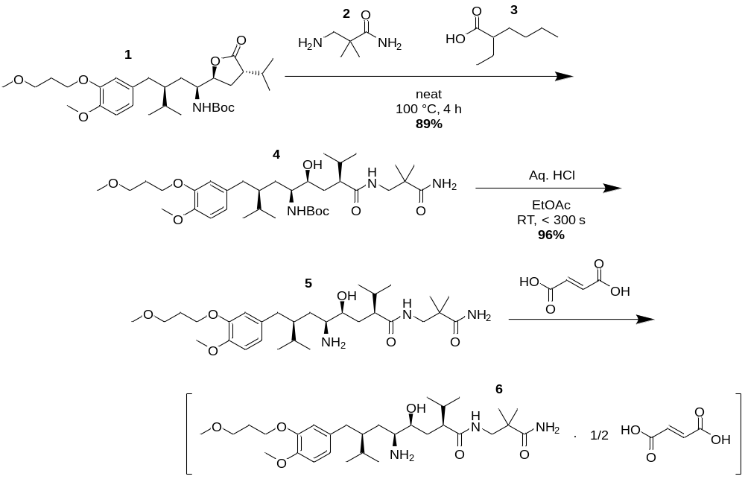
Scheme 1. Synthetic steps from intermediate, 1, to aliskiren hemifumarate, 6.

Table 1: Nominal residence times for continuous process
Unit operation^{[a]} | t / h
R1 | 04
S1 | < 0.1
Cr1+Cr2 | 08
W1 | < 0.1
D1 | 02
R2 | < 0.1
S3 | 02
S5 | 15
Cr3+Cr4 | 08
W2 | < 0.1
D2 | 02
S6+S7 | 06
E1 | < 0.1
MD  Total | < 0.1  47
[a] Unit operations refer to designations given in Figure 1.
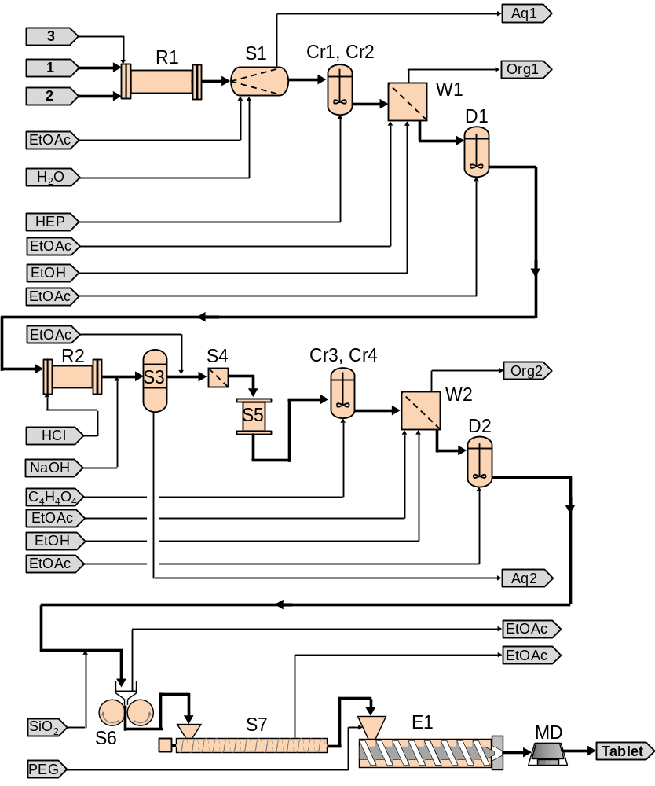
Figure 1. Process flow diagram with major unit operations. R – reactor; S – separation; Cr – crystallization; W – filter/wash; D – dilution tank; E – extruder; MD – mold. Detailed diagram provided in supporting information (Figure S1).

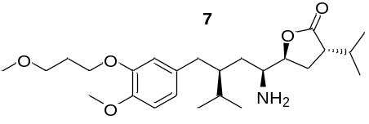
Scheme 2. Main impurity, 7, present in the final product.

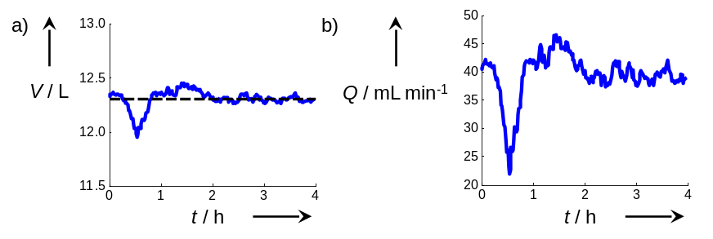
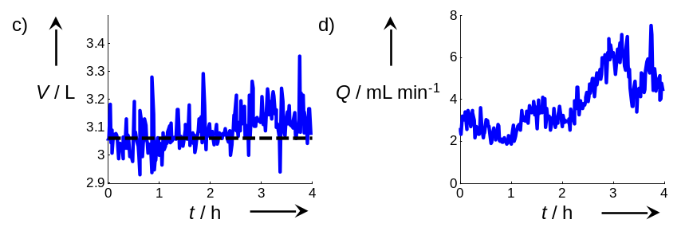
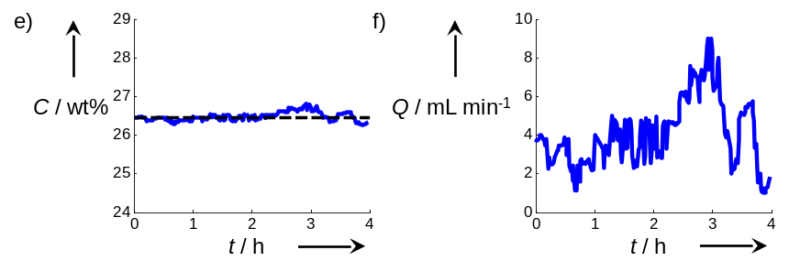
Figure 2. Example of disturbance mitigation through a cascade of three integrated unit operations after several days of operation, a) volume in Cr2, b) outlet flow rate of Cr 2, c) volume in D1, d) outlet flow rate of D1, e) concentration of 4 in D1, f) solvent flow rate into D1. The setpoints in a, c, and e are marked as horizontal dashed lines and a constant steady-state offset as a result of proportional-only control has been subtracted.

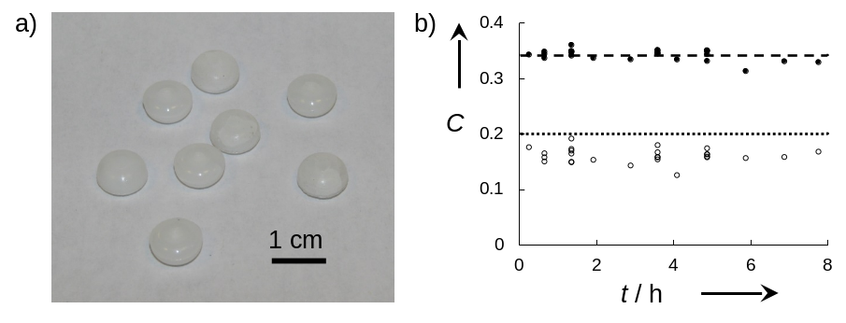
Figure 3. Analysis of tablets produced by the integrated, continuous plant, a) photograph of tablets, b) tablet mass fraction of 6 (filled circles) with the nominal concentration shown with a dashed line (0.341) and % content of 7 (open circles) with specification limit shown with a dotted line (0.2 %).

Continuous Manufacturing | 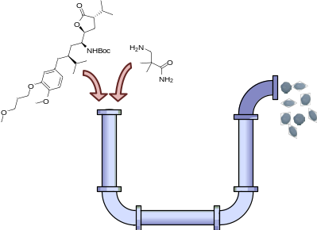 | A series of tubes: Continuous manufacture of a finished drug product starting from chemical intermediates is reported. The continuous pilot-scale plant used a novel route incorporating many advantages available to continuous flow to produce API and drug product in one integrated system.
S. Mascia, P. L. Heider, H. Zhang, R. Lakerveld, B. Benyahia, P. I. Barton, R. D. Braatz, C. L. Cooney, J. M. B. Evans, T. F. Jamison, K. F. Jensen, A. S. Myerson, B. L. Trout __________ Page – Page
End-to-End Continuous Manufacturing of Pharmaceuticals: Integrated Synthesis, Purification, and Final Dosage Formation

