Supplemental Information: Occupation clustering methodology for training in-demand engineering technician skills in the advanced manufacturing industry

Elizabeth A. Moore*, Frank Field, Randolph Kirchain
eamoore@mit.edu

Contents
Semi-Structured Interview Description 4
Advanced Robotics 5
Firm Classification 5
Respondent Demographics 7
Demand for occupations 8
Hiring Challenges 9
Training Effort Required 11
Skills required for In-Demand Positions 12
Mechatronics Engineering Technician 13
Mechanical Engineering Technician 16
Electrical Engineering Technician 17
Industrial Engineering Technician 20
CNC Tool Operator 22
Critical thinking skill needs 24
Common Skills 25
Flexible electronics 27
Firm Classification 27
Respondent Demographics 29
Demand for occupations 29
30
Hiring Challenges 30
Training Effort Required 32
Skills required for in-demand positions 33
Mechanical Engineering Technician 33
Electrical Engineering Technician 35
Industrial Engineering Technician 37
Chemical/Materials Technician 39
CNC Tool Operator 42
Critical thinking skills 44
Common Skills 45
Advanced Fabrics and Fibers 47
Firm Classification 47
Respondent Demographics 49
Demand for Occupations 50
Hiring Challenges 52
Training Effort Required 53
Skills Required for In-Demand Positions 55
Mechanical Engineering Technician 55
Industrial Engineering Technician 56
Fabric Designer and Patternmaker 57
CNC Tool Operator 58
Common Skills 60
Integrated Photonics 61
Firm Classification 61
Respondent Demographics 63
Demand for occupations 65
Hiring Challenges 67
Training Effort Required 68
Skills required for in-demand positions 69
Middle-Skilled Workers 69
Industrial Engineering Technician 74
Lower-Skilled Workers 75
Ceramics Production Operator 77
Common Skills 78
Firm Classification 79
Respondent Demographics 81
Demand for occupations 83
Hiring Challenges 84
Training Effort Required 85
Skills required for in-demand positions 86
Critical Thinking Skills 99
Common Skills 101
Cluster analysis results 102

Semi-Structured Interview Description
Respondents were randomly assigned three relevant occupations to assess. For each, they were asked to characterize the expected skill level for each position for their current technicians, the skill level of new hires for these positions, and rank the importance of the skills in 5 years compared to today. The categories for skill level included the following:
- Not applicable
- Aware of
- Familiar with
- Competent at
- Proficient with
- Mastery of
The expected importance ranks from much less important than now to much more important than now. A gap was defined as the difference between the skill level of a new hire compared to the expected skill level.
For each of these positions, respondents were asked to evaluate the importance of skills when evaluating a new hire in five years. The importance categories included the following:
- Extremely important
- Very important
- Moderately important
- Slightly important
- Not at all important
For each specific skill, an importance was computed based on the interview responses. Weighted average importance is computed for each General Task/Skill (GTS) and Intermediate Task/Skill (ITS) based on importance of all skills that are a member of that category
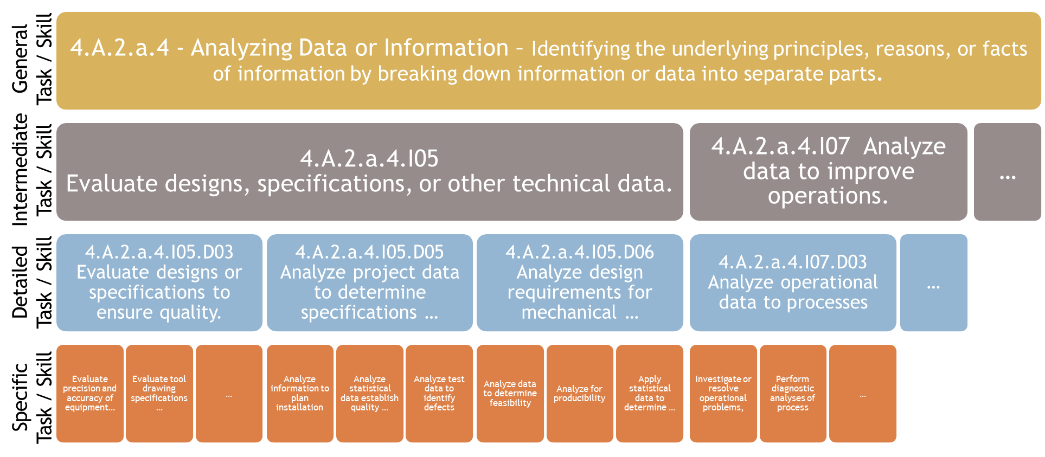
Figure 1 An example of the O*NET specific skill hierarchy and how the skills map to the different levels (specific, detailed, intermediate, and general).

Advanced Robotics

Firm Classification
Table 1 Robotics industry classification archetype examples
Company | US Standard Industrial Classification –  D.B. Hoovers Expanded Version (SIC8) | North American Industrial Classification System (NAICS)
Ascend Robotics | 35359904 - Robotic conveyors | 333922 - Conveyor and Conveying Equipment Manufacturing
Dynamic Robotic Solutions | 35419913 - Robots for drilling, cutting, grinding, polishing, etc. | 333517 - Machine Tool Manufacturing
Absolute Robot, Inc. | 35429917 - Robots for Metal forming: pressing, extruding, etc. | 333517 - Machine Tool Manufacturing
Symbotic LLC | 35499901 - Assembly machines, including robotic | 333519 - Rolling Mill and Other Metalworking Machinery Manufacturing
Shark | 35599925 - Robots, molding and forming plastics | 333249 - Other Industrial Machinery Manufacturing
Ares Robotics LLC | 35630202 - Robots for industrial spraying, painting, etc. | 333912 - Air and Gas Compressor Manufacturing
Boston Dynamics | 35699914 - Robots, assembly line: industrial and commercial | 333999 - All Other Miscellaneous General Purpose Machinery Manufacturing
Dive Technologies | 37319906 - Submersible marine robots, manned or unmanned | 336611 - Ship Building and Repairing
Vecna Robotics | 87420101 - Automation and robotics consultant | 541611 - Administrative Management and General Management Consulting Services

Table 2. Most common NAICS codes for firms identified as in the robotics industry. These codes capture 85% of firms identified.
NAICS Code | NAICS Description | BLS Equivalent Code
334516 | Analytical Laboratory Instrument Manufacturing | 334500
333999 | All Other Miscellaneous General Purpose Machinery Manufacturing | 3330A1
333519 | Rolling Mill and Other Metalworking Machinery Manufacturing | 333500
334513 | Instruments and Related Products Manufacturing for Measuring, Displaying, and Controlling Industrial Process Variables | 334500
333922 | Conveyor and Conveying Equipment Manufacturing | 3330A1
333249 | Other Industrial Machinery Manufacturing | 3330A1

Table 3. Focal occupations that were evaluated in this study. Bold titles represent representative occupations that were served as proxy for the subsequent specific occupations.
Occupation | Standard Occupation Classification Code
Electrical and electronics engineering technicians(representing)
Electrical and electronics engineering technicians |  | 17-3023
Electrical and electronics drafters |  | 17-3012
Electro-mechanical technicians |  | 17-3024
Industrial engineering technicians(representing)
Industrial engineering technicians |  | 17-3026
Aerospace engineering and operations technicians |  | 17-3021
Mechanical engineering technicians(representing)
Mechanical engineering technicians |  | 17-3027
Mechanical drafters |  | 17-3013
Chemical technicians |  | 19-4031
Maintenance and Support Technicians (representing)
Industrial machinery mechanics |  | 49-9041
Maintenance workers, machinery |  | 49-9043
HVAC mechanics and installers |  | 49-9021
Mobile heavy equipment mechanics, except engines |  | 49-3042
Electrical & electronics repairers, commercial & ind. equipment |  | 49-2094
Computer-controlled machine tool operators(representing)
Computer-controlled machine tool operators |  | 51-4011
Computer numerically controlled machine tool programmers |  | 51-4012
Other Technical Production Worker (representing)
Machinists |  | 51-4041
Tool and die makers |  | 51-4111

Respondent Demographics
Survey respondents came from a broad array of firms. As shown in Figure 2a, a majority of the respondents came from Massachusetts, with a few firms from other New England states. Firms ranged in size from as few as seven employees to as many as 1.2 million. The median firm size was 240 employees. Annual revenue ranged from $0 to $380B with a median of $5M per year (Figure 2b).
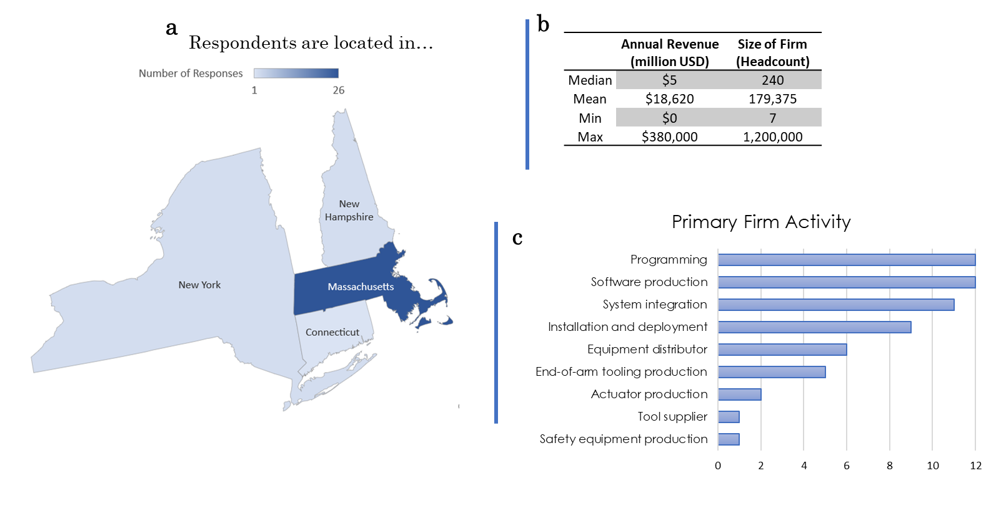
Figure 2. Distribution of respondent location, size, revenue, and primary supply chain activity.
Firms were asked to identify their role in the supply chain. There was a range of primary activities for each firm (see Figure 2c) with a majority focused on programming, software production, and system integration.

Demand for occupations
We expect demand for this type of position in our firm will....
In the future, firms indicated that the demand for all positions evaluated in the study is strong and will continue to grow (Figure 3. The technical worker occupations studied were classified according to future demand growth in the robotics industry. Number of respondents, n =31.). The position that is expected to have the highest demand in the future is electro-mechanical or mechatronics engineering technicians due to the robotics field requiring knowledge of both electrical and mechanical engineering principles. Telling of its importance to this industry, this position is often referred to simply as “robotics technician”. Electrical and mechanical engineering technicians are also expected to be in great demand due to trends within the industry. For example, in the next few years, many firms are likely to design their own platforms internally, especially at robotic arm companies, and therefore will need technicians in house to build. Installation and deployment technicians are also expected to have significant growth. Deployment technicians were emphasized by several firms where firms are seeking technicians that have both a customer facing personality as well as the ability to perform technical work.
CNC Operators and Maintenance Technicians are expected to have moderate demand growth and are positions that were common among many of the firms. The positions with the largest amount of ‘not applicable’ responses were chemical/materials technicians and industrial engineering technicians. This suggests that these types of workers are not universal for robotics firms and while the number of these positions will expand with the industry, it will do so at a rate less than other positions. Overall, these results suggest that curricula that emphasizes electrical and mechanical engineering skills will be invaluable to robotics firms and curricula that addresses the skills necessary for deployment technicians will aid in growing the robotics industry in the U.S.

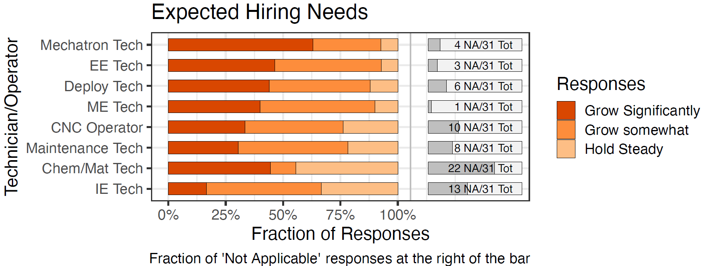
Figure 3. The technical worker occupations studied were classified according to future demand growth in the robotics industry. Number of respondents, n =31.
The demand for each position can be summarized as follows:
Strong Growth | Moderate Growth | Hold
- Mechatronics Technician  - Electrical Engineering Technician  - Installation and Deployment Technician | - Mechanical Engineering Technician  - CNC Tool Operator  - Maintenance and Support Technician | - Chemical/Material Technician  - Industrial Engineering Technician

Hiring Challenges
Filling this type of position is ....
Respondents were also asked about how difficult each occupation is to fill. At this point in time, many respondents explained it is more difficult than usual to hire technicians due to pandemic-related challenges. However, even prior to the pandemic, many respondents indicated that hiring technicians such as electro-mechanical or mechatronics engineering technicians can be challenging (Figure 4). This is because technicians that have both electrical and mechanical knowledge and experience are rare. Interestingly, none of the positions were easy to hire and all positions except other technical production worker, industrial engineering technician, and mechanical engineering technician had >50% of respondents indicate that the positions were difficult to fill. These results suggest a low supply of technical workers as well as a challenge of attracting and retaining workers in this industry.
When asked about how firms typically find candidates, they shared that they hire through temporary agencies or staffing companies or through networking at schools nearby. However, there is a high turnover rate especially at the technician level. For small companies especially, firms noted that they often lose technicians to larger companies and with a lot of existing technicians retiring, they don’t have the internal capability to transfer knowledge.
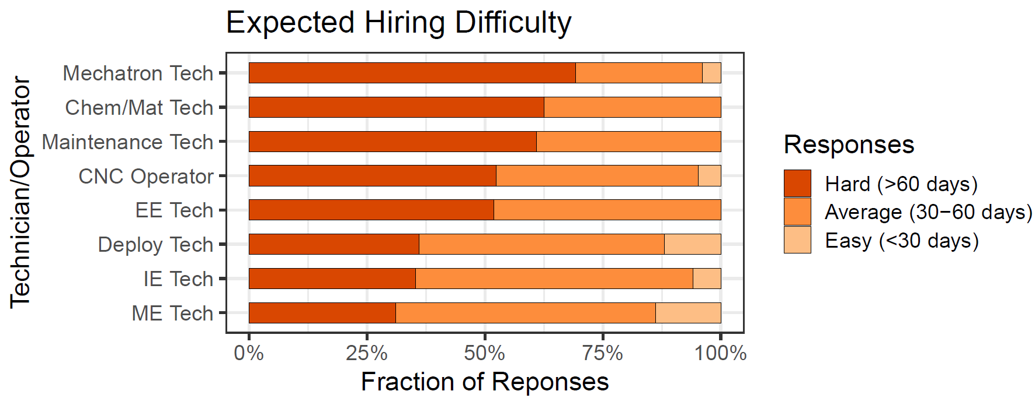
Figure 4 The difficulty of hiring middle-skilled positions was assessed for the robotics industry (n=31). Most positions were found to be difficult to fill.

The hiring difficulty for each position can be summarized as follows:
Considerable hiring effort | Moderate | Nominal
- Mechatronics Technician  - Chemical/Material Technician  - Maintenance and Support Technician  - CNC Tool Operator  - Electrical Engineering Technician | - Installation and Deployment Technician  - Industrial Engineering Technician  - Mechanical Engineering Technician

In comparing the demand and hiring results, mechatronics technicians are the most in demand and most difficult positions to fill. While chemical/material technicians are difficult to hire, their demand growth is expected to hold steady. It is worth noting that mechanical engineering technicians are relatively easy to hire compared to the other positions and are in high demand at firms. This suggests that an emphasis on training and attracting electro-mechanical and mechatronics engineering technicians and electrical engineering technicians would be especially valuable for the robotics manufacturing industry.

Training Effort Required
New hires typically require training that is …
The amount of on-the-job training for each occupation was also evaluated by respondents as extensive, some, or basic orientation only. Many respondents noted that extensive training is required for most positions and can take up to six months in order for workers to be productive. They also noted that since intelligent automation and robotics is rapidly evolving, the jobs are also changing. There is demand for improved training of new hires as well as upskilling for existing workers. Specifically, respondents suggested additional or improved training in
- hydraulics,
- reading blueprints,
- programming and debugging,
- technical writing, and
- lean manufacturing
would help reduce the amount of training hours required by the firm. An emphasis in technical communication is also of interest to many firms since it is needed at every step of the production process.
The interview results showed that chemical/material technicians, maintenance and support technicians, and installation and deployment technicians require the most on-the-job training. Chemical/material technicians are not common at all robotics firms, but those that require this position feel that there is company-specific knowledge that must be taught regardless of the training level coming in. Maintenance and support technicians and installation and deployment technicians also required extensive training due to the equipment and programming languages unique to each firm. The engineering technician positions mostly require some training and the CNC tool operator requires the least amount of on-the-job training for the occupations studied. Additional exposure to diverse equipment and programming languages could help increase the supply of qualified workers. Many respondents suggested improve relationships among equipment suppliers and community colleges to enable a better understanding of the equipment in the industry.
To address these training challenges, several firms recommended apprenticeship programs as well as assistance in increasing the awareness among middle-skilled workers of how training can fit into broader career goals.
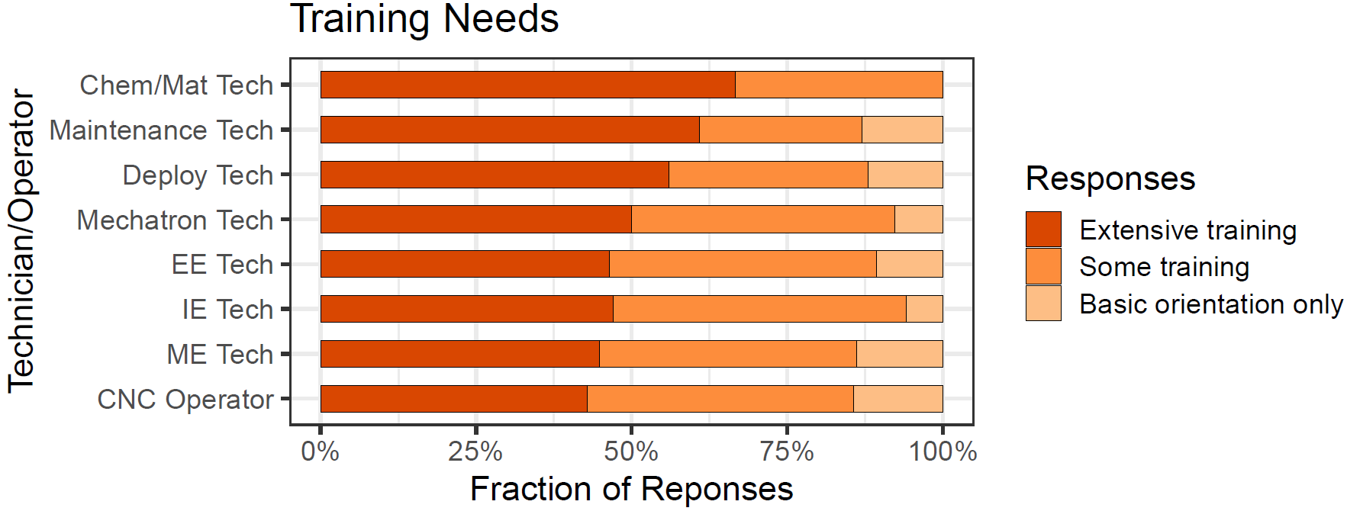
Figure 5 The training required for each position was assessed as extensive, some training, or basic orientation only (n=31). Most of the middle-skilled positions required extensive training (>50% of the responses) and the remaining positions required at least some training.
In comparing the training effort results to the hiring challenge results, we observe that many of the middle-skilled positions are difficult to hire and also require additional specialized training for new hires.
The training challenges for each position can be summarized as follows:
Extensive training | Some training | Basic  orientation only
- Chemical/materials Technician  - Maintenance and Support Technician  - Installation and Deployment Technician  - Mechatronics Technician | - Electrical Engineering Technician  - Industrial Engineering Technician  - Mechanical Engineering Technician  - CNC Tool Operator

Skills required for In-Demand Positions
Interview results demonstrate the growing demand for middle-skilled workers in the robotics industry, significant hiring and retainment challenges, and training gaps for robotics manufacturing workers. The training gaps for each occupation were explored in detail for 8-10 specific skills where respondents were asked to rank the skill level for existing workers, new hires, and the importance of the skill in five years compared to today. The research team identified skills that were classified as high priority or moderate priority. High priority skills are those that have a large gap between existing workers and new hires and were also ranked as important. Moderate priority skills are those with either a large gap or were ranked as much more important or skills that fell in the mean range of the data for both categories. For those skills that were not ranked as high or moderate priority, the research team recommends these skills be re-evaluated for inclusion in the curricula for that occupation.
There were a sufficient number of responses (n>=5) to characterize five positions including mechatronics technicians, mechanical engineering technician, electrical engineering technician, industrial engineering technician, and CNC tool operator. Since there are significant training gaps for these workers, we highlight opportunities to improve training programs for the future.

Mechatronics Engineering Technician
Survey responses for mechatronics technicians are shown in Figure 6. Recommendations for training based on these results are summarized in Table 4. The skills on the left are drawn from O*NET descriptions of work activities for specific job classifications. The green line represents the competency stated for new hires into the position. The red line is the competency stated for current employees in the position. The proportional change in importance in five years is represented by the blue circles. In this study, we interpret that change in importance to indicate that future competency levels for those tasks will need to shift accordingly.

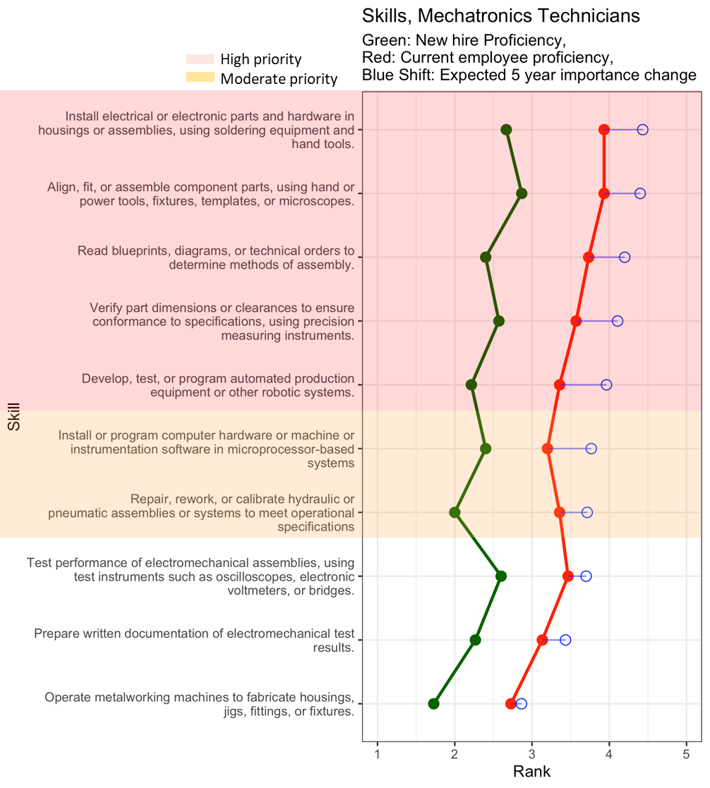
Figure 6. The gaps and expected future importance of skills for mechatronics technicians are shown with high priority skills highlighted in red and moderate priority skills highlighted in orange.

Recommendation | Skill | Full Skill Description
Emphasize training on… | Fabricate components and systems | Install electrical or electronic parts and hardware in housings or assemblies, using soldering equipment and hand tools.
Emphasize training on… | Fabricate components and systems | Align, fit, or assemble component parts, using hand or power tools, fixtures, templates, or microscopes.
Emphasize training on… | Understand, evaluate, and maintain quality | Read blueprints, diagrams, or technical orders to determine methods of assembly.
Emphasize training on… | Understand, evaluate, and maintain quality | Verify part dimensions or clearances to ensure conformance to specifications, using precision measuring instruments.
Emphasize training on… | Develop, test, and program hardware systems | Develop, test, or program automated production equipment or other robotic systems
Improve training on… | Develop, test, and program hardware systems | Install or program computer hardware or machine or instrumentation software in microprocessor-based systems
Improve training on… | Hydraulic or pneumatic assembly repair | Repair, rework, or calibrate hydraulic or pneumatic assemblies or systems to meet operational specifications
Maintain training/evaluate training on… | Use test instruments | Test performance of electromechanical assemblies, using test instruments such as oscilloscopes, electronic voltmeters, or bridges.
Maintain training/evaluate training on… | Prepare reports | Prepare written documentation of electromechanical test results.
Maintain training/evaluate training on… | Operate metalworking machines | Operate metalworking machines to fabricate housings, jigs, fittings, or fixtures
Table 4. Recommended changes in the training of mechatronics technicians in the robotics industry. The orange skills are those that are ranked as moderate priority and therefore have a skill gap and are also important in the future.

Mechanical Engineering Technician
Survey responses for mechanical engineering technicians are shown in Figure 7. Recommendations for training of mechanical engineering technicians based on these results are summarized in Table 5.
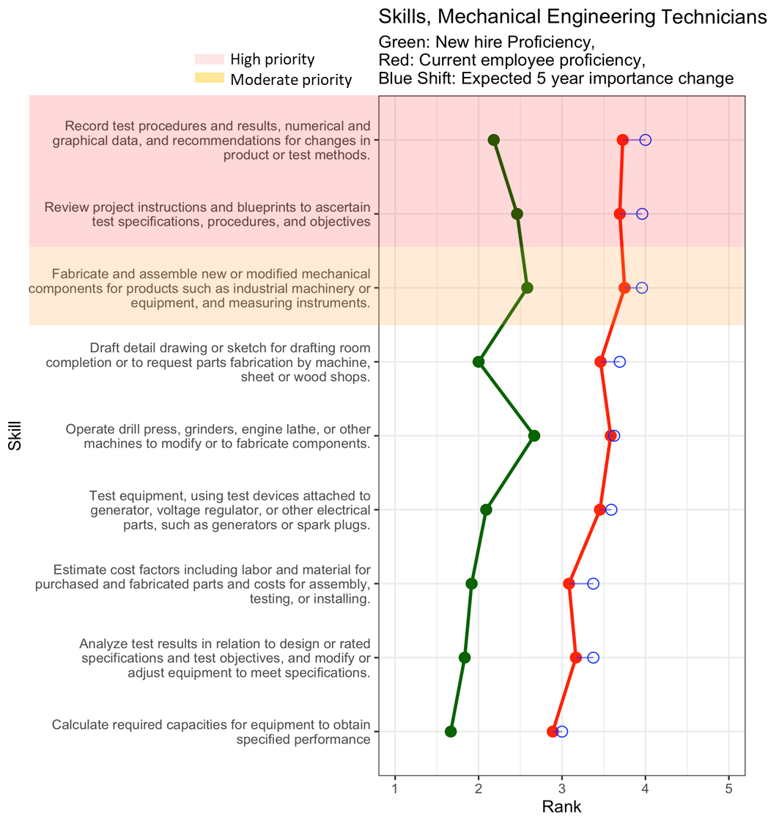
Figure 7. The gaps and expected future importance of skills for mechanical engineering technicians are shown with high priority skills highlighted in red and moderate priority skills highlighted in orange.
Table 5. Recommended changes in the training of mechanical engineering technicians in the robotics industry. The orange skills are those that are ranked as moderate priority and therefore have a skill gap and are also important in the future.
Recommendation | Skill | Full Skill Description
Emphasize training on… | Recommend changes in product or process design | Record test procedures and results, numerical and graphical data, and recommendations for changes in product or test methods.
Emphasize training on… | Understand, evaluate, and maintain quality | Review project instructions and blueprints to ascertain test specifications, procedures, and objectives
Improve training on… | Fabrication methods | Fabricate and assemble new or modified mechanical components for products such as industrial machinery or equipment, and measuring instruments.
Maintain training/evaluate training on… | Drafting for fabrication | Draft detail drawing or sketch for drafting room completion or to request parts fabrication by machine, sheet or wood shops.
Maintain training/evaluate training on… | Estimate system capabilities and costs | Estimate cost factors including labor and material for purchased and fabricated parts and costs for assembly, testing, or installing.
Maintain training/evaluate training on… | Estimate system capabilities and costs | Calculate required capacities for equipment to obtain specified performance
Maintain training/evaluate training on… | Understand, evaluate, and maintain quality | Analyze test results in relation to design or rated specifications and test objectives, and modify or adjust equipment to meet specifications.
Maintain training/evaluate training on… | Understand, evaluate, and maintain quality | Test equipment, using test devices attached to generator, voltage regulator, or other electrical parts, such as generators or spark plugs.
Maintain training/evaluate training on… | Operate specific equipment | Operate drill press, grinders, engine lathe, or other machines to modify parts tested or to fabricate experimental parts for testing.

Electrical Engineering Technician
Survey responses for electrical engineering technicians are shown in Figure 8. Recommendations for training of electrical engineering technicians based on these results are summarized in Table 6.
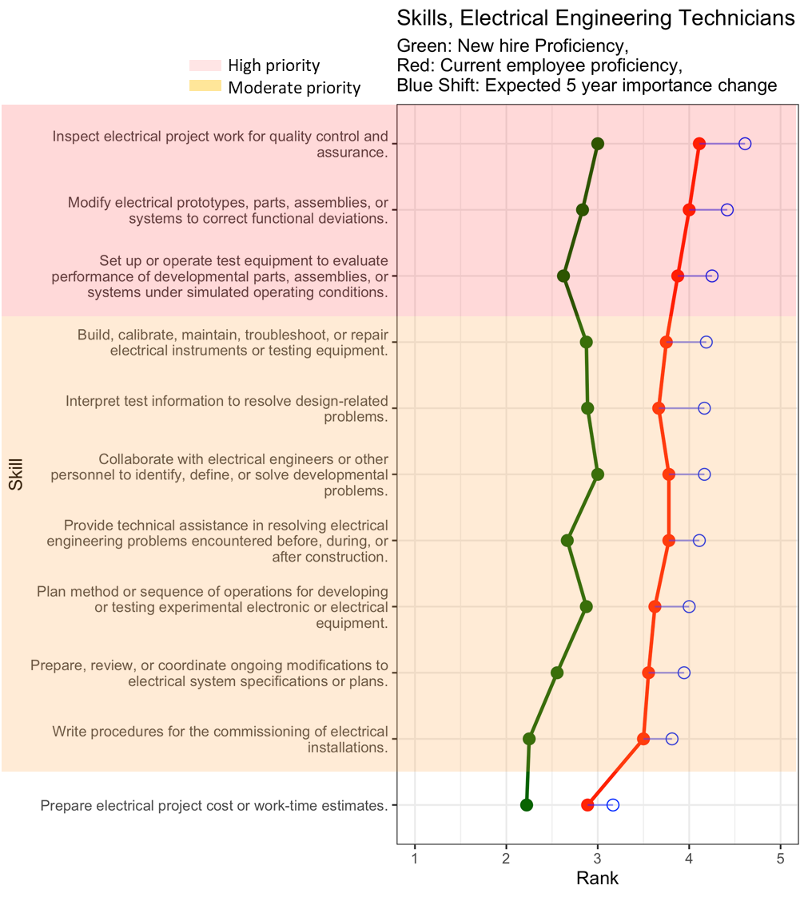
Figure 8. The gaps and expected future importance of skills for electrical engineering technicians are shown with high priority skills highlighted in red and moderate priority skills highlighted in orange.

Table 6. Recommended changes in the training of electrical engineering technicians in the robotics industry. The orange skills are those that are ranked as moderate priority and therefore have a skill gap and are also important in the future.
Recommendation | Skill | Full Skill Description
Emphasize training on… | Diagnose and resolve process or product problems | Inspect electrical project work for quality control and assurance.
Emphasize training on… | Diagnose and resolve process or product problems | Modify electrical prototypes, parts, assemblies, or systems to correct functional deviations.
Emphasize training on… | Diagnose and resolve process or product problems | Set up or operate test equipment to evaluate performance of developmental parts, assemblies, or systems under simulated operating conditions.
Improve training on… | Collaborate to improve design or troubleshoot problems | Provide technical assistance in resolving electrical engineering problems encountered before, during, or after construction.
Improve training on… | Collaborate to improve design or troubleshoot problems | Collaborate with electrical engineers or other personnel to identify, define, or solve developmental problems.
Improve training on… | Manage electrical system specifications | Prepare, review, or coordinate ongoing modifications to contract specifications or plans.
Improve training on… | Manage electrical system specifications | Write procedures for the commissioning of electrical installations.
Improve training on… | Build and maintain electrical instruments or testing equipment | Build, calibrate, maintain, troubleshoot, or repair electrical instruments or testing equipment.
Improve training on… | Develop and execute standard testing procedures | Interpret test information to resolve design-related problems.
Improve training on… | Develop and execute standard testing procedures | Plan method or sequence of operations for developing or testing experimental electronic or electrical equipment.
Maintain training/evaluate training on… | Estimate project or process cost | Prepare electrical project cost or work-time estimates.

Industrial Engineering Technician
Survey responses for industrial engineering technicians are shown in Figure 9. Recommendations for training of industrial engineering technicians based on these results are summarized in Table 7.
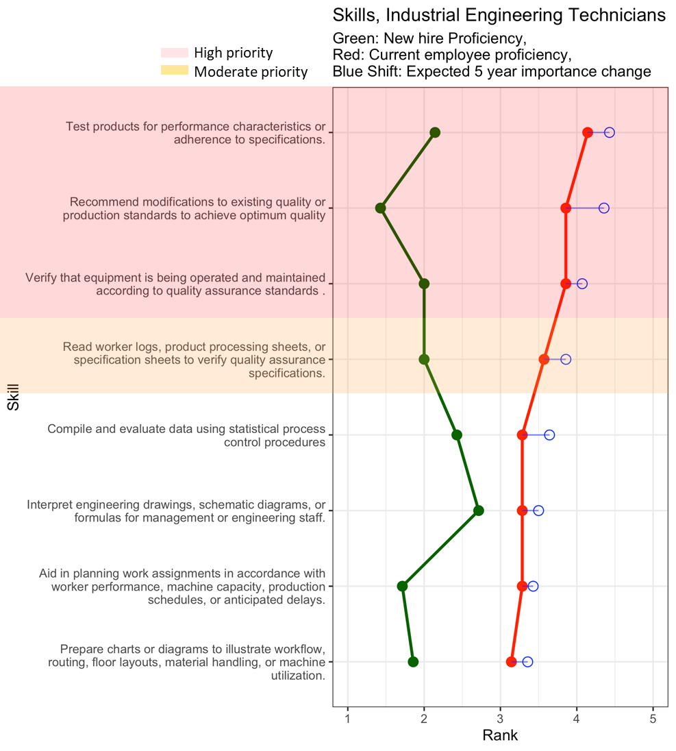
Figure 9. The gaps and expected future importance of skills for industrial engineering technicians are shown with high priority skills highlighted in red and moderate priority skills highlighted in orange.
Table 7. Recommended changes in the training of industrial engineering technicians in the robotics industry. The red skills are those that are high priority with a large gap and high importance in the future. The orange skills are those that are ranked as moderate priority and therefore have a skill gap and are also important in the future.
Recommendation | Skill | Full Skill Description
 | Recommend operational & procedural changes | Recommend modifications to existing quality or production standards to achieve optimum quality
 | Maintain product and process quality assurance standards | Test products for performance characteristics or adherence to specifications.
 | Maintain product and process quality assurance standards | Verify that equipment is being operated and maintained according to quality assurance standards.
Improve training on… | Maintain product and process quality assurance standards | Read worker logs, product processing sheets, or specification sheets to verify quality assurance specifications.
Maintain training/evaluate training on… | Analyze and respond to process data | Compile and evaluate statistical data to determine and maintain quality and reliability of products.
Maintain training/evaluate training on… | Communication with engineering and management | Prepare charts or diagrams to illustrate workflow, routing, floor layouts, material handling, or machine utilization.
Maintain training/evaluate training on… | Communication with engineering and management | Interpret engineering drawings, schematic diagrams, or formulas for management or engineering staff.
Maintain training/evaluate training on… | Recommend operational & procedural changes | Aid in planning work assignments in accordance with worker performance, machine capacity, production schedules, or anticipated delays.

CNC Tool Operator
Survey responses for CNC tool operators are shown in Figure 10. Recommendations for training of CNC tool operators based on these results are summarized in Table 8.
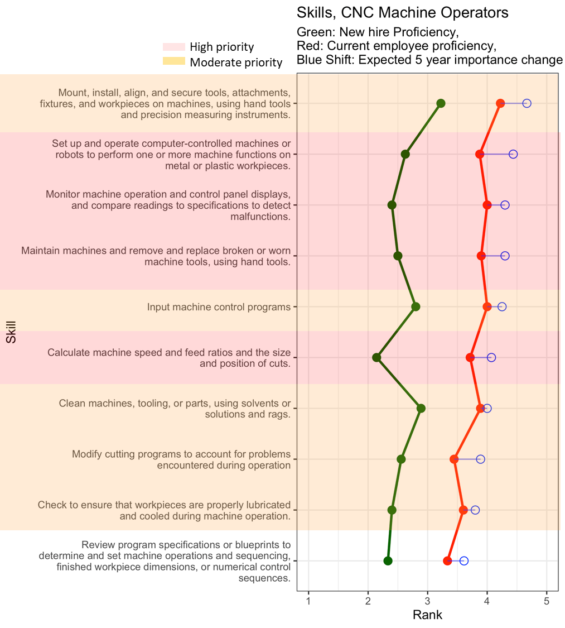
Figure 10. The gaps and expected future importance of skills for CNC tool operators are shown with high priority skills highlighted in red and moderate priority skills highlighted in orange.

Table 8 Recommended changes in the training of CNC tool operators in the robotics industry. The orange skills are those that are ranked as moderate priority and therefore have a skill gap and are also important in the future.
Recommendation | Skill | Full Skill Description
Emphasize training on… | Monitor and maintain machines. | Set up and operate computer-controlled machines or robots to perform one or more machine functions on metal or plastic workpieces.
Emphasize training on… | Monitor and maintain machines. | Monitor machine operation and control panel displays, and compare readings to specifications to detect malfunctions.
Emphasize training on… | Monitor and maintain machines. | Maintain machines and remove and replace broken or worn machine tools, using hand tools.
Emphasize training on… | Calculate machine speeds and feed ratios | Calculate machine speed and feed ratios and the size and position of cuts.
Improve training on… | Apply precision measuring instruments | Mount, install, align, and secure tools, attachments, fixtures, and workpieces on machines, using hand tools and precision measuring instruments.
Improve training on… | Machine operation and maintenance | Input machine control programs
Improve training on… | Machine operation and maintenance | Clean machines, tooling, or parts, using solvents or solutions and rags.
Improve training on… | Machine operation and maintenance | Modify cutting programs to account for problems encountered during operation
Improve training on… | Machine operation and maintenance | Check to ensure that workpieces are properly lubricated and cooled during machine operation.
Maintain training/evaluate training on… | Assess specifications or blueprints | Review program specifications or blueprints to determine and set machine operations and sequencing, finished workpiece dimensions, or numerical control sequences.

Critical thinking skill needs
When trying to define what is meant by critical thinking, one definition is “the ability to analyze evidence and facts to form a judgment” (Gambrill 2005). More practically, we can classify these judgments with the following levels of critical thinking:
- Perceiving the issue – What should I measure or observe to know that a problem exists?
- Hypothesizing about problem cause – What might be causing the problem?
- Developing a framework for hypothesis testing – How can I confirm my hypothesis?
- Inferring whether tests confirm the hypothesis - Does the test suggest that my hypothesis was right?
- Communicating the outcome – How (and to whom) do I report on what has happened?
Respondents were asked to identify what level of critical thinking is expected of technicians. Responses were grouped by Engineering Technician positions and All Other Technical Workers shown in Figure 11.
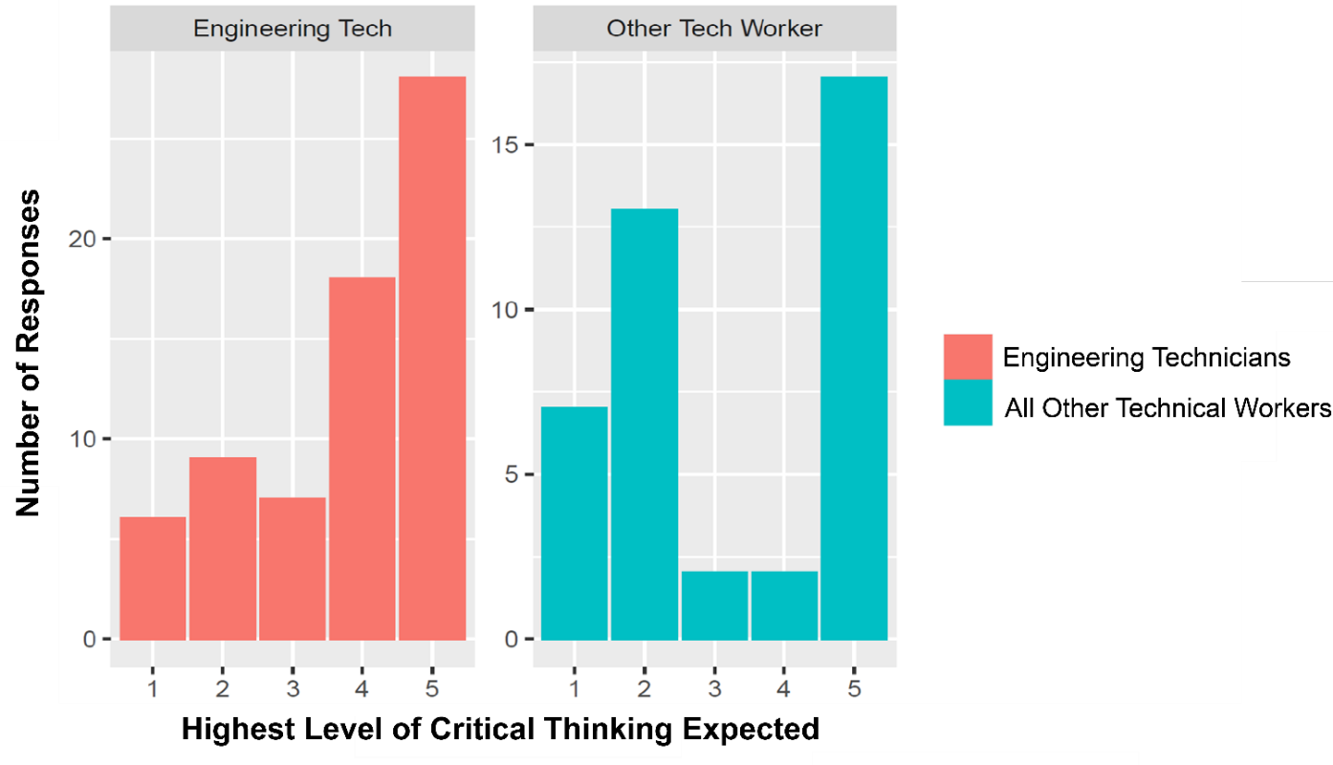
Figure 11. Respondents valued critical thinking skills for all occupations studied. However, most respondents expect a higher level of critical thinking in the 4-5 range for engineering technicians. While there are respondents that expect the highest level for all other technical workers as well, there is still a large percentage of respondents that only expect a level of 1-2.
Results indicate that the majority of engineering technicians (68%) are expected to have competency in nearly all aspects of critical thinking (perceiving, hypothesizing, testing, and interpreting testing) and an additional 15% are also expected to communicate the outcome of the process. Results for other technical workers were split, with about half (48%) expected to only perceive the issue and hypothesize a cause while most of the rest are expected to master all aspects of critical thinking.
Many firms indicated that critical thinking skills are becoming essential, particularly for engineering technician positions. Because technicians are a part of the front line, being able to critically think and spot patterns of error is very important. Respondents explained that being able to determine the root cause of a problem and then communicate the problem to a larger team makes workers more valuable. One example of a judgement that technicians need to regularly make is when to get help. If technicians had training in identifying problems and knowing what information needs to be communicated upstream to help with decision making, firms would be able to improve their overall productivity.
Respondents indicated that two important critically thinking areas include looking for defects and eliminating waste. For cases of failure on certain parts, technicians are expected to collect data on the critical part, document what happened and when, and work with an engineer to figure out the cause of failure. One suggestion was to include the Lean Sigma Define, Measure, Analyze, Improve, Control (DMAIC) process in training for technicians (ASQ 2021). Virtual reality (VR) technology could also be leveraged to practice critical thinking by developing manufacturing simulations.

Common Skills
To understand the skills needed broadly at the middle-skill occupation level, the research team has identified skills that are both shared (common) and important across multiple occupations to enable training programs to be relevant for companies across the robotics supply chain. Figure 12 shows the ten highest weighted average importance scores for the general task/skill (GTS) level ranked from highest to lowest.

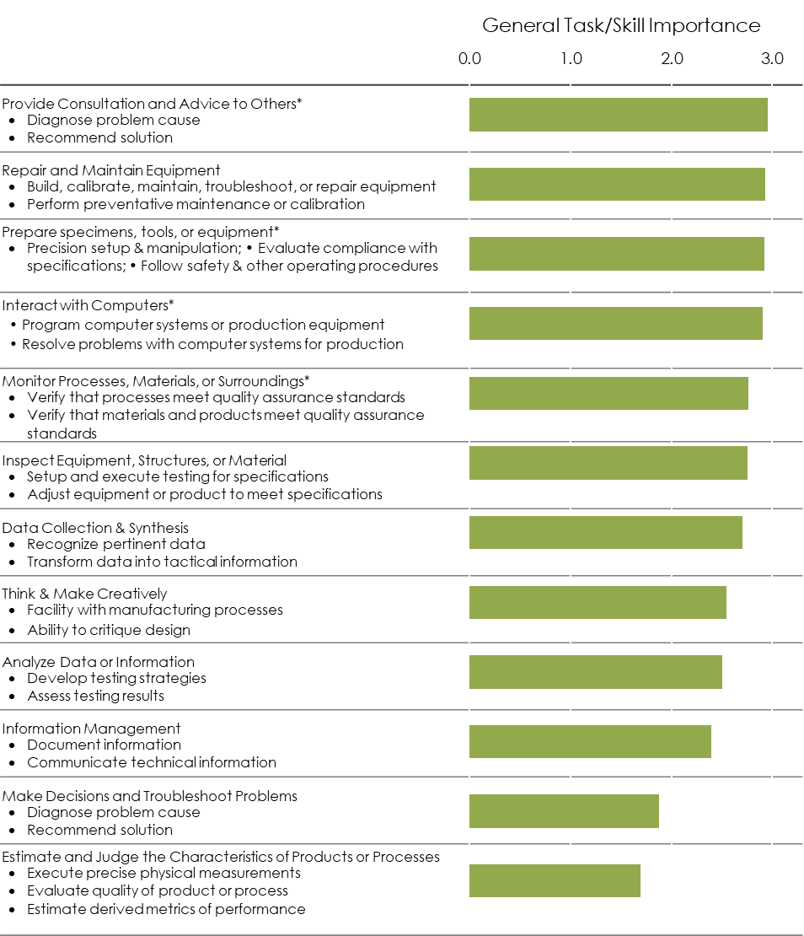
Figure 12 General Task/Skill (GTS) are classes that include many related specific skills. Here relevant GTS are ranked by weighted average importance of the specific skills within that class. Only GTS that are shared across at least two occupations are labeled as common and, therefore, included in this figure. Asterisks indicate skills that have a critical gap and are of significant importance.

.

Flexible electronics

Firm Classification

Company | US Standard Industrial Classification –  DB Hoovers Expanded Version (SIC8) | North American Industrial Classification System (NAICS)
Croda | 28990000 – Chemical preparations, nec | 325998 -- All Other Miscellaneous Chemical Product and Preparation Manufacturing
Lux Semiconductors | 36740000 – Semiconductors and related devices | 334413 – Semiconductor and Related Device Manufacturing
DuPont | 28210200 – Thermoplastic materials | 325211 – Plastics Material and Resin Manufacturing
SI2 Technologies | 35990000 – Industrial machinery, nec | 333999 – All Other Miscellaneous General-Purpose Machinery Manufacturing
Human Systems Integration | 38290000 – Measuring and controlling devices, nec | 333249 - Other Industrial Machinery Manufacturing
Flex | 36720000 – Printed circuit boards | 334519 – Other Measuring and Controlling Device Manufacturing
Analog Devices | 36740200 – Integrated circuits, semiconductor networks, etc. | 334413 – Semiconductor and Related Device Manufacturing
Averatek | 36720000 – Printed circuit boards | 334418 – Printed Circuit Assembly (Electronic Assembly) Manufacturing

Table 9. Most common NAICS codes for firms identified as in the FHE industry. These codes capture 85% of firms identified.
NAICS Code | NAICS Description | BLS Equivalent Code
325998 | All Other Miscellaneous Chemical Product and Preparation Manufacturing | 325000
333999 | All Other Miscellaneous General-Purpose Machinery Manufacturing | 3330A1
334413 | Semiconductor and Related Device Manufacturing | 334400
325211 | Plastics Material and Resin Manufacturing | 325000
334519 | Other Measuring and Controlling Device Manufacturing | 334500
333249 | Other Industrial Machinery Manufacturing | 3330A1
334418 | Printed Circuit Assembly (Electronic Assembly) Manufacturing | 334400

Table 10. Focal occupations that were evaluated in this study. Bold titles represent representative occupations that were served as proxy for the subsequent specific occupations.
Occupation | Standard Occupation Classification Code
Middle-skilled
Electrical and electronics engineering technicians(representing)
Electrical and electronics engineering technicians |  | 17-3023
Electrical and electronics drafters |  | 17-3012
Electro-mechanical technicians |  | 17-3024
Industrial engineering technicians(representing)
Industrial engineering technicians |  | 17-3026
Aerospace engineering and operations technicians |  | 17-3021
Mechanical engineering technicians(representing)
Mechanical engineering technicians |  | 17-3027
Mechanical drafters |  | 17-3013
Chemical/materials technicians (representing)
Chemical technician |  | 19-4031
Materials scientist |  | 19-2032
Maintenance and Support Technicians (representing)
Industrial machinery mechanics |  | 49-9041
Maintenance workers, machinery |  | 49-9043
HVAC mechanics and installers |  | 49-9021
Mobile heavy equipment mechanics, except engines |  | 49-3042
Electrical & electronics repairers, commercial & ind. equipment |  | 49-2094
Computer-controlled machine tool operators(representing)
Computer-controlled machine tool operators |  | 51-4011
Computer numerically controlled machine tool programmers |  | 51-4012
Other Technical Production Worker (representing)
Machinists |  | 51-4041
Tool and die makers |  | 51-4111

Respondent Demographics
Survey respondents came from a broad array of firms. As shown in Figure 2a, a majority of the respondents came from Massachusetts, with a few firms from other states. Firms ranged in size from as few as five employees to as many as 45,000. The median firm size was 70 employees. Annual revenue ranged from $3.5M to $95,000M with a median of $13M per year (Figure 2b).
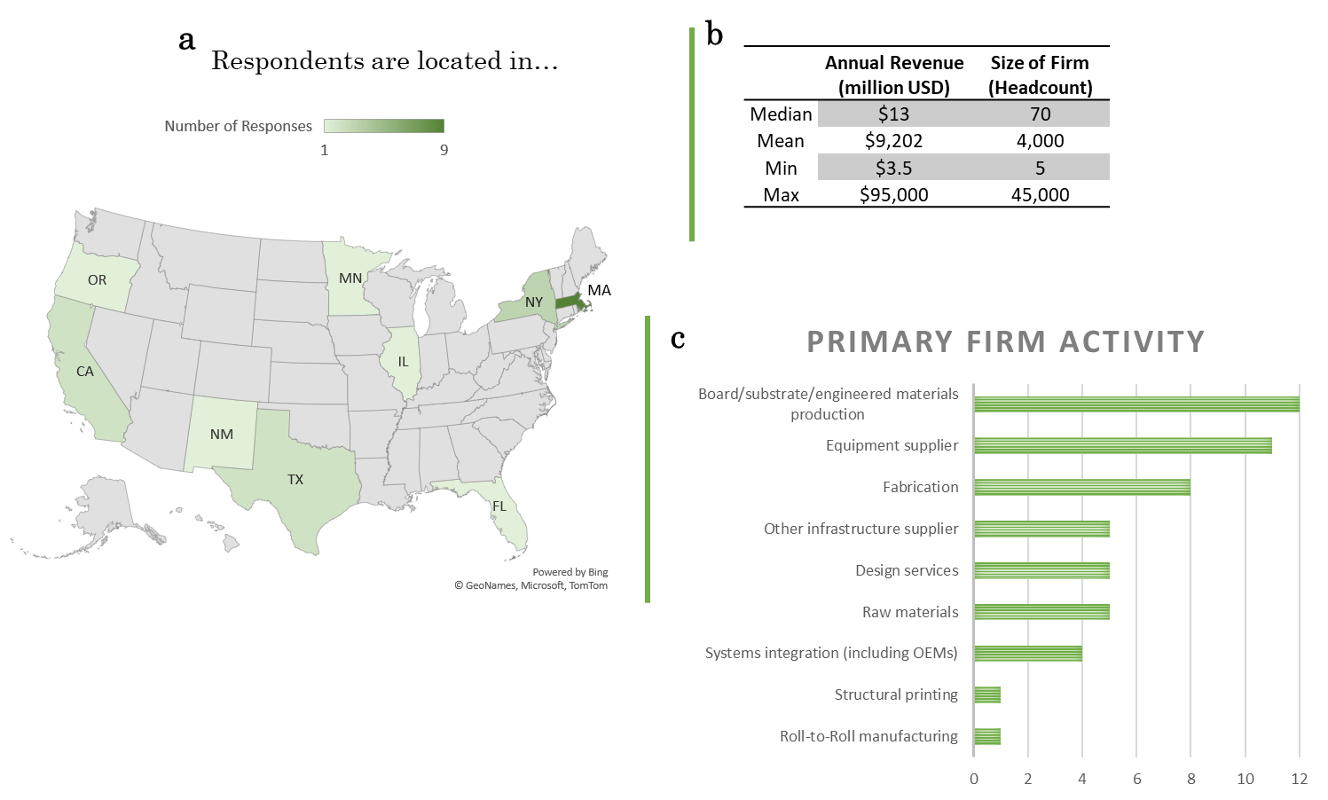
Figure 13. Distribution of respondent location, size, revenue, and primary supply chain activity.
Firms were asked to identify their role in the supply chain. There was a range of primary activities for each firm (see Figure 2c) with a majority focused on board/substrate/engineered materials production and equipment suppliers.

Demand for occupations
FHE firms indicated that the demand for the positions studied is strong and will continue to grow into the future (Figure 3). The occupation expected to have the highest demand growth is the electrical engineering technician. Beyond this, selected firms emphasized a need for more CNC and drilling operators because skilled candidates for these positions are difficult to find.
Among the occupations studied, nearly all were both utilized by most FHE firms and expected to experience moderate demand growth.

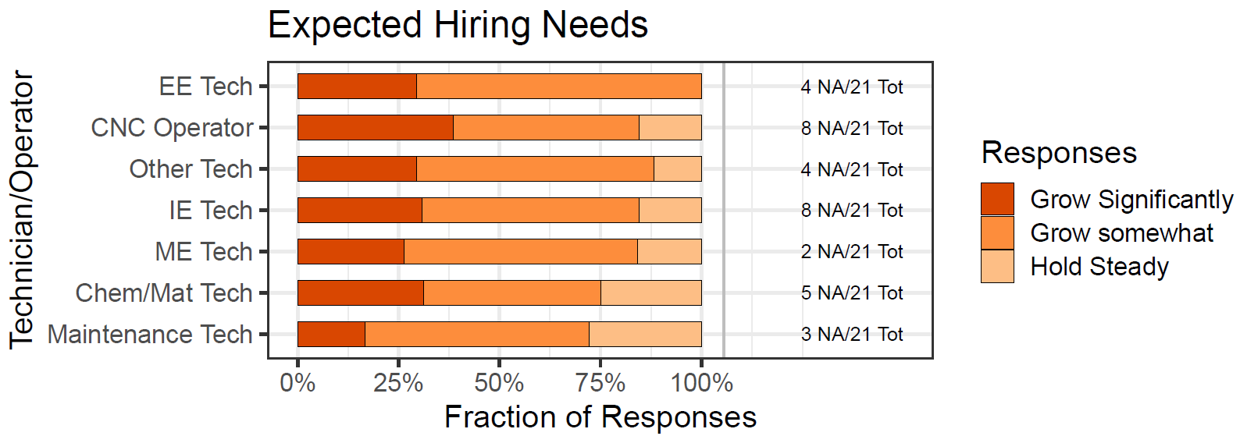
Figure 14. The technical worker occupations studied were classified according to future demand growth in the FHE industry. Number of respondents, n =21. Fraction of ‘Not Applicable’ responses at the right of the bar. Firms indicated that other technical worker would likely be a failure analysis technician or warehouse packer.

The demand for each position can be summarized as follows:
Strong Growth | Moderate Growth | Hold
Electrical Engineering Technician | CNC Tool Operator  Other Technical Production Worker  Industrial Engineering Technician  Mechanical Engineering Technician  Chemical/Materials Technician  Maintenance and Support Technician

Hiring Challenges
Hiring is a significant challenge for most firms (Figure 4) and many small- and medium-sized firms explained that they often lose their skilled workers to larger firms. When asked about how long it typically takes to hire for these positions, most positions require at least 30-60 days to hire with >50% indicating more than 60 days for CNC operators, industrial engineering technicians, and chemical/materials technicians. Respondents indicated that there is a larger supply of Bachelors-level workers but not enough workers at the technician-level, driving firms to hire overqualified workers for technician roles. Many shared that they believe there is a labor shortage and the pandemic has only made hiring more difficult. These results suggest a low supply of technical middle-skilled workers as well as a challenge of attracting and retaining workers in this industry.
In comparing the demand and hiring results, all positions were found to be difficult to hire for and are positions expected to grow in the future. Among the group, electrical engineering technicians stood out as being in particularly high demand and also more difficult to hire compared to the other positions studied. Results recommend an emphasis on training and attracting electrical engineering technicians to meet the demand of the FHE industry.
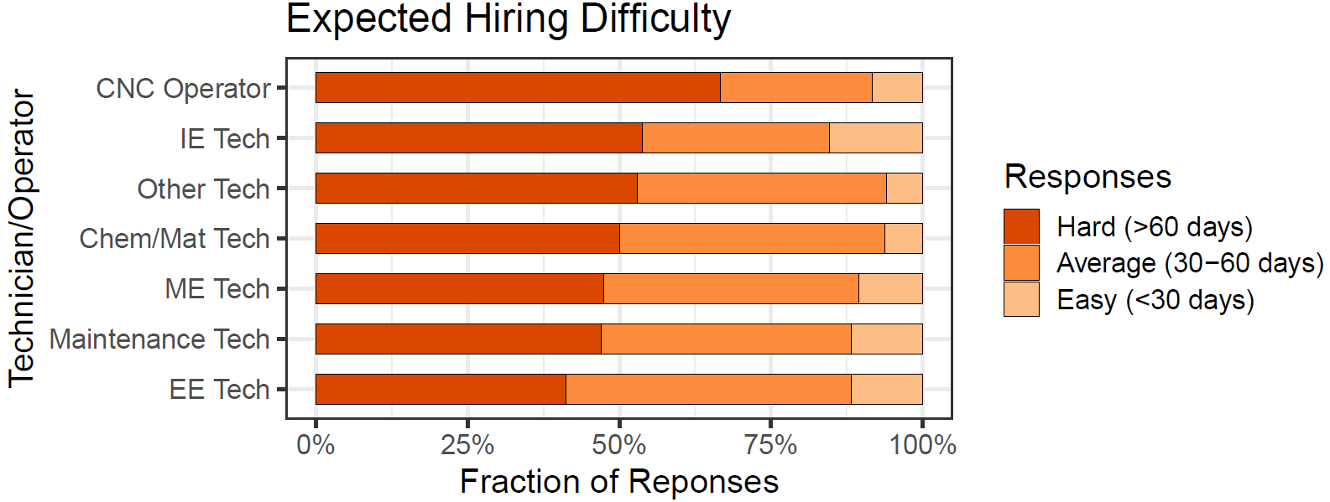
Figure 15 The difficulty of hiring middle-skilled positions was assessed for the FHE industry (n=21). Most positions were found to be difficult to fill.
The hiring difficulty for each position can be summarized as follows:
Considerable hiring effort | Moderate | Nominal
- CNC Operator
- Industrial Engineering Technician
- Other Technical Production Worker
- Chemical/Materials Technician
- Mechanical Engineering Technician
- Maintenance and Support Technician
- Electrical Engineering Technician

Training Effort Required
The amount of on-the-job training for each occupation was also evaluated by respondents as extensive, some, or basic orientation only. Respondents indicated that the training required for all of the occupations studied is extensive, on-the-job training (see Figure 5). At some smaller firms, extensive training is desired but the firms do not have the time or resources to train to that level. At larger firms, there is a minimum of ~2 months training until workers are proficient around 3-6 months. While some training is company specific, respondents suggested additional or improved training in the following areas:
- Lean manufacturing
- Roll-to-roll manufacturing
- Soldering
- Automation
- Chemical safety
- Quality control
- CAD/PLM systems
- GDT requirements
- Surface mount technology placement
Many respondents shared a recommendation for improved relationships between training centers/community colleges and equipment vendors. An emphasis in training basic programming is also of interest to many firms in the FHE supply chain. Specific to printed electronics, firms recommend training in wet chemistry inks and solvents as well as profiling of different components.
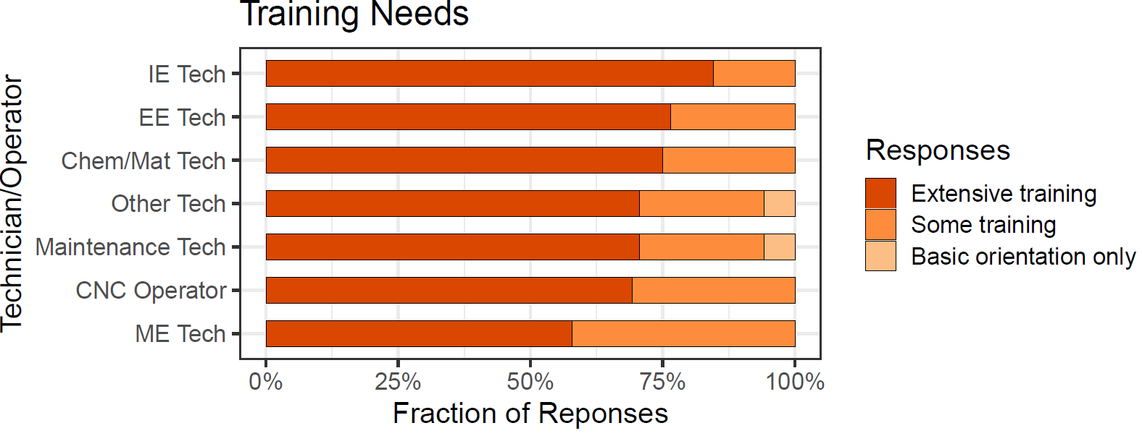
Figure 16 The training required for each position was assessed as extensive, some training, or basic orientation only (n=21). All positions require extensive training (>50% of the responses).
In comparing the training effort results to the hiring challenge results, we observe that all of the middle-skilled positions are difficult to hire and also require additional specialized training for new hires.

Skills required for in-demand positions

Mechanical Engineering Technician
Survey responses for mechanical engineering technicians are shown in Figure 7. Recommendations for training of mechanical engineering technicians based on these results are summarized in Table 5.
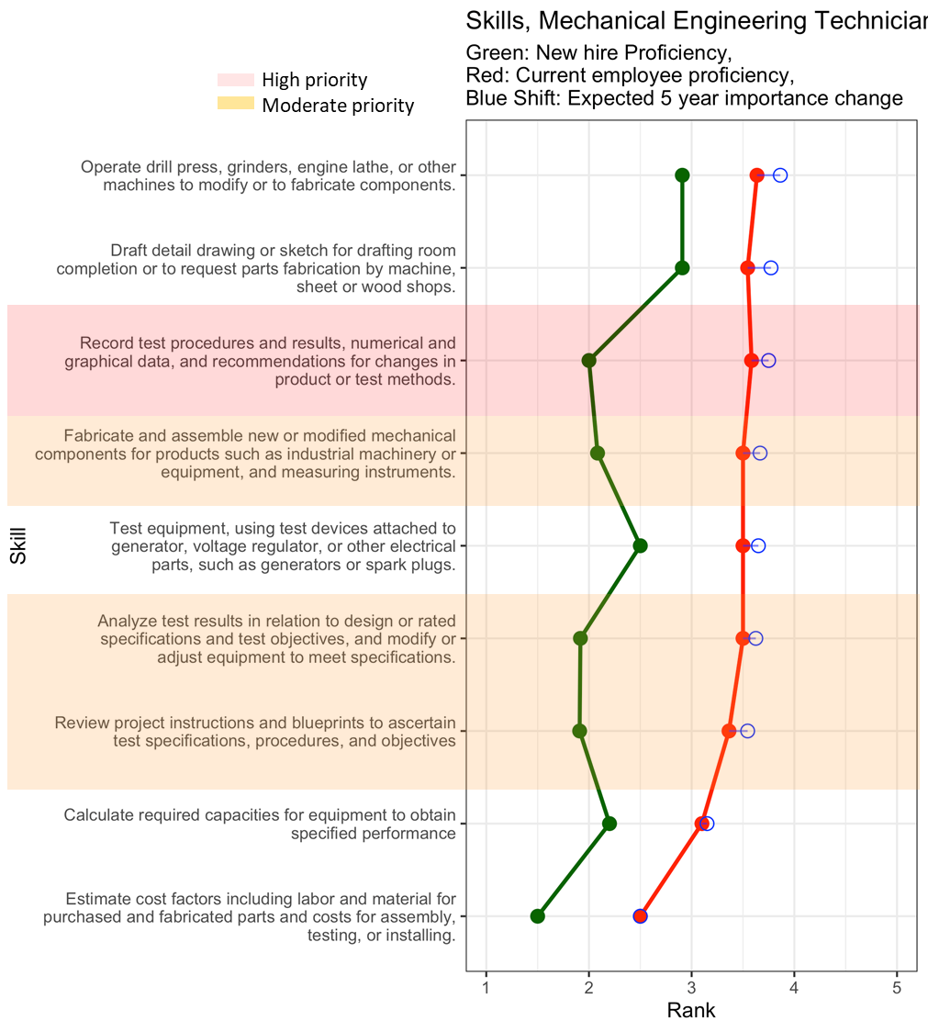
Figure 17. The gaps and expected future importance of skills for mechanical engineering technicians are shown with high priority skills highlighted in red and moderate priority skills highlighted in orange.
Table 11. Recommended changes in the training of mechanical engineering technicians in the FHE industry. The red skills are those that are high priority and the orange skills are those that are ranked as moderate priority and therefore have a skill gap and are also important in the future.
Recommendation | Skill | Full Skill Description
Emphasize training on… | Recommend changes in product or process design | Record test procedures and results, numerical and graphical data, and recommendations for changes in product or test methods.
Improve training on… | Fabrication methods | Fabricate and assemble new or modified mechanical components for products such as industrial machinery or equipment, and measuring instruments.
Improve training on… | Understand, evaluate, and maintain quality | Analyze test results in relation to design or rated specifications and test objectives, and modify or adjust equipment to meet specifications.
Improve training on… | Understand, evaluate, and maintain quality | Review project instructions and blueprints to ascertain test specifications, procedures, and objectives
Maintain training/evaluate training on… | Operate specific equipment | Operate drill press, grinders, engine lathe, or other machines to modify parts tested or to fabricate experimental parts for testing.
Maintain training/evaluate training on… | Drafting for fabrication | Draft detail drawing or sketch for drafting room completion or to request parts fabrication by machine, sheet or wood shops.
Maintain training/evaluate training on… | Understand, evaluate, and maintain quality | Test equipment, using test devices attached to generator, voltage regulator, or other electrical parts, such as generators or spark plugs.
Maintain training/evaluate training on… | Estimate system capabilities and costs | Calculate required capacities for equipment to obtain specified performance
Maintain training/evaluate training on… | Estimate system capabilities and costs | Estimate cost factors including labor and material for purchased and fabricated parts and costs for assembly, testing, or installing.

Electrical Engineering Technician
Survey responses for electrical engineering technicians are shown in Figure 8. Recommendations for training of electrical engineering technicians based on these results are summarized in Table 6.
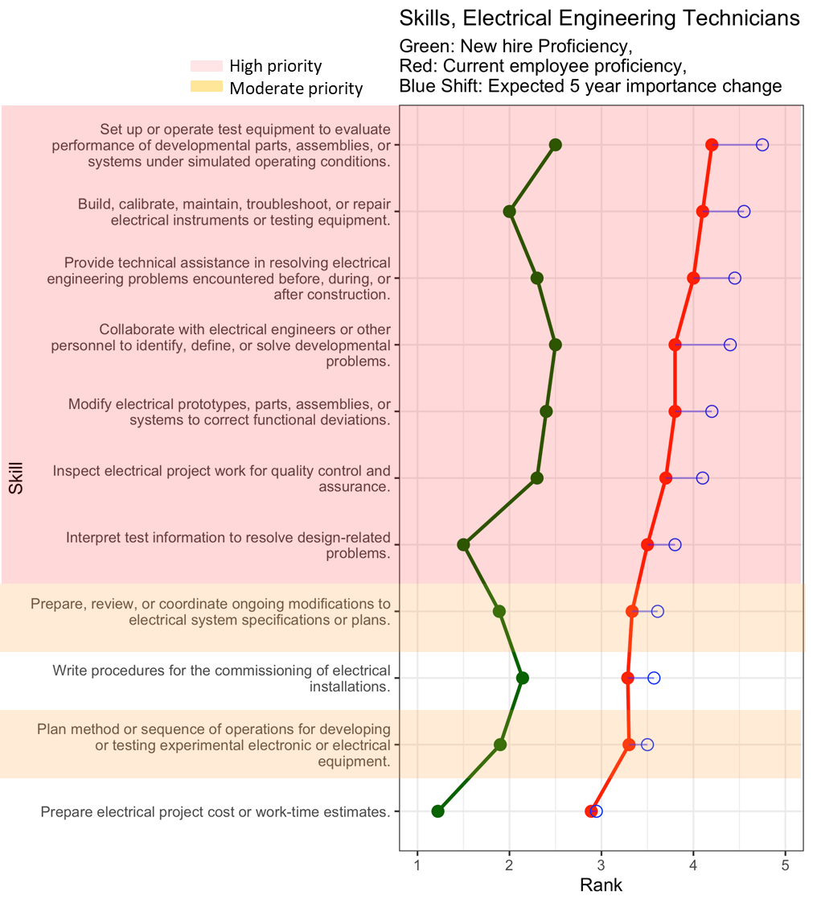
Figure 18. The gaps and expected future importance of skills for electrical engineering technicians are shown with high priority skills highlighted in red and moderate priority skills highlighted in orange.
Table 12. Recommended changes in the training of electrical engineering technicians in the FHE The orange skills are those that are ranked as moderate priority and therefore have a skill gap and are also important in the future.
Recommendation | Skill | Full Skill Description
Emphasize training on… | Diagnose and resolve process or product problems | Set up or operate test equipment to evaluate performance of developmental parts, assemblies, or systems under simulated operating conditions.
Emphasize training on… | Build and maintain electrical instruments or testing equipment | Build, calibrate, maintain, troubleshoot, or repair electrical instruments or testing equipment.
Emphasize training on… | Collaborate to improve design or troubleshoot problems | Provide technical assistance in resolving electrical engineering problems encountered before, during, or after construction.
Emphasize training on… | Collaborate to improve design or troubleshoot problems | Collaborate with electrical engineers or other personnel to identify, define, or solve developmental problems.
Emphasize training on… | Diagnose and resolve process or product problems | Modify electrical prototypes, parts, assemblies, or systems to correct functional deviations.
Emphasize training on… | Diagnose and resolve process or product problems | Inspect electrical project work for quality control and assurance.
Emphasize training on… | Develop and execute standard testing procedures  Develop and execute standard testing procedures | Interpret test information to resolve design-related problems.
Improve training on… |  | Prepare, review, or coordinate ongoing modifications to contract specifications or plans.
Improve training on… |  | Plan method or sequence of operations for developing or testing experimental electronic or electrical equipment.
Maintain training/evaluate training on… | Manage electrical system specifications | Write procedures for the commissioning of electrical installations.
 | Estimate project or process cost | Prepare electrical project cost or work-time estimates.

Industrial Engineering Technician
Survey responses for industrial engineering technicians are shown in Figure 9. Recommendations for training of industrial engineering technicians based on these results are summarized in Table 7.
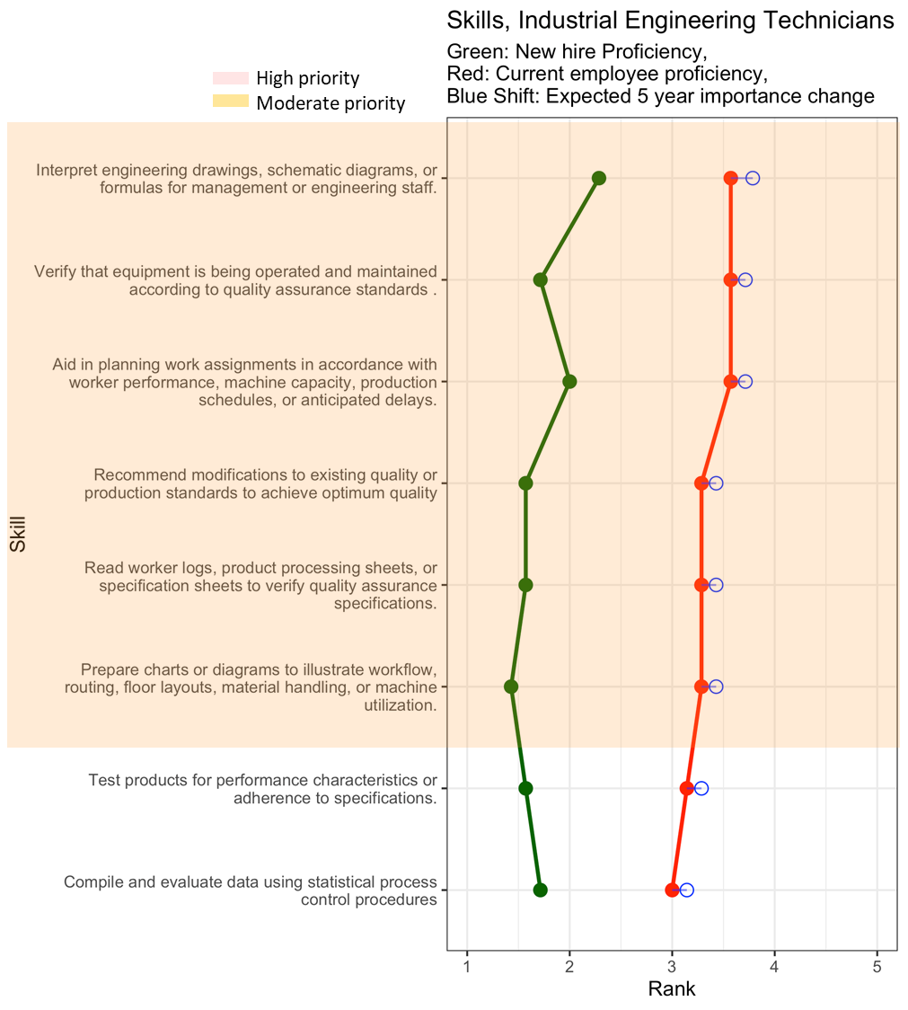
Figure 19. The gaps and expected future importance of skills for industrial engineering technicians are shown with high priority skills highlighted in red and moderate priority skills highlighted in orange.
Table 13. Recommended changes in the training of industrial engineering technicians in the FHE industry. The red skills are those that are high priority with a large gap and high importance in the future. The orange skills are those that are ranked as moderate priority and therefore have a skill gap and are also important in the future.
Recommendation | Skill | Full Skill Description
Improve training on… | Communication with engineering and management | Interpret engineering drawings, schematic diagrams, or formulas for management or engineering staff.
Improve training on… | Maintain product and process quality assurance standards | Verify that equipment is being operated and maintained according to quality assurance standards.
Improve training on… | Recommend operational & procedural changes | Aid in planning work assignments in accordance with worker performance, machine capacity, production schedules, or anticipated delays.
Improve training on… | Recommend operational & procedural changes | Recommend modifications to existing quality or production standards to achieve optimum quality
Improve training on… | Maintain product and process quality assurance standards | Read worker logs, product processing sheets, or specification sheets to verify quality assurance specifications.
Improve training on… | Communication with engineering and management | Prepare charts or diagrams to illustrate workflow, routing, floor layouts, material handling, or machine utilization.
Maintain training/evaluate training on… | Test, analyze and respond to process data | Test products for performance characteristics or adherence to specifications.
Maintain training/evaluate training on… | Test, analyze and respond to process data | Compile and evaluate statistical data to determine and maintain quality and reliability of products.

Chemical/Materials Technician
Survey responses for chemical/materials technicians shown in Figure 20. Recommendations for training of chemical/materials technicians based on these results are summarized in Table 14.
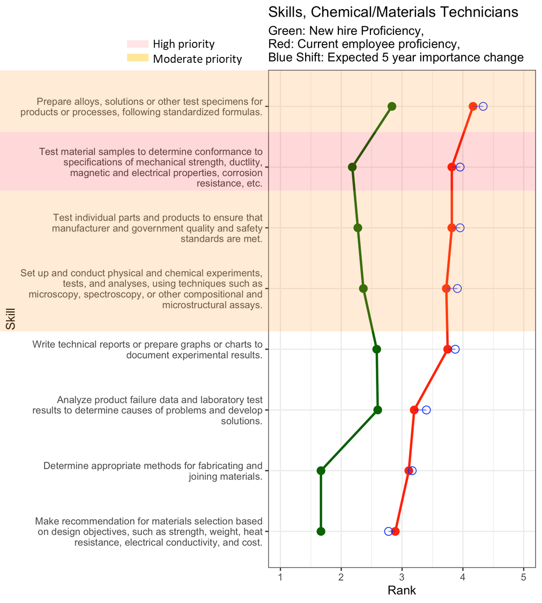
Figure 20. The gaps and expected future importance of skills for chemical/materials technicians are shown with high priority skills highlighted in red and moderate priority skills highlighted in orange.
Table 14. Recommended changes in the training of chemical/materials technicians in the FHE industry. The red skills are those that are high priority with a large gap and high importance in the future. The orange skills are those that are ranked as moderate priority and therefore have a skill gap and are also important in the future.
Recommendation | Skill | Full Skill Description
Emphasize training on… | Material testing | Test material samples to determine conformance to specifications of mechanical strength, ductlity, magnetic and electrical properties, corrosion resistance, etc.
Improve training on… | Set up and conduct experiments following quality and safety standards | Prepare chemical solutions for products or processes, following standardized formulas, or create experimental formulas.
Improve training on… |  | Test individual parts and products to ensure that manufacturer and government quality and safety standards are met.
Improve training on… |  | Set up and conduct physical and chemical experiments, tests, and analyses, using techniques such as microscopy, spectroscopy, or other compositional and microstructural assays.
Maintain training/evaluate training on… | Assess test results and identify root cause | Write technical reports or prepare graphs or charts to document experimental results.
Maintain training/evaluate training on… | Assess test results and identify root cause | Analyze product failure data and laboratory test results to determine causes of problems and develop solutions
Maintain training/evaluate training on… | Lab maintenance | Maintain, clean, or sterilize laboratory instruments or equipment.
Maintain training/evaluate training on… | Chemical or physical lab tests and result assessment | Conduct chemical or physical laboratory tests to assist scientists in making qualitative or quantitative analyses of solids, liquids, or gaseous materials.
Maintain training/evaluate training on… | Assess test results and identify root cause | Write technical reports or prepare graphs or charts to document experimental results.
Maintain training/evaluate training on… | Assess test results and identify root cause | Analyze product failure data and laboratory test results to determine causes of problems and develop solutions
Maintain training/evaluate training on… | Identify methods for fabricating and joining | Determine appropriate methods for fabricating and joining materials.
Maintain training/evaluate training on… | Materials selection | Make recommendation for materials selection based on design objectives, such as strength, weight, heat resistance, electrical conductivity, and cost.

CNC Tool Operator
Survey responses for CNC tool operators are shown in Figure 10. Recommendations for training of CNC tool operators based on these results are summarized in Table 8.
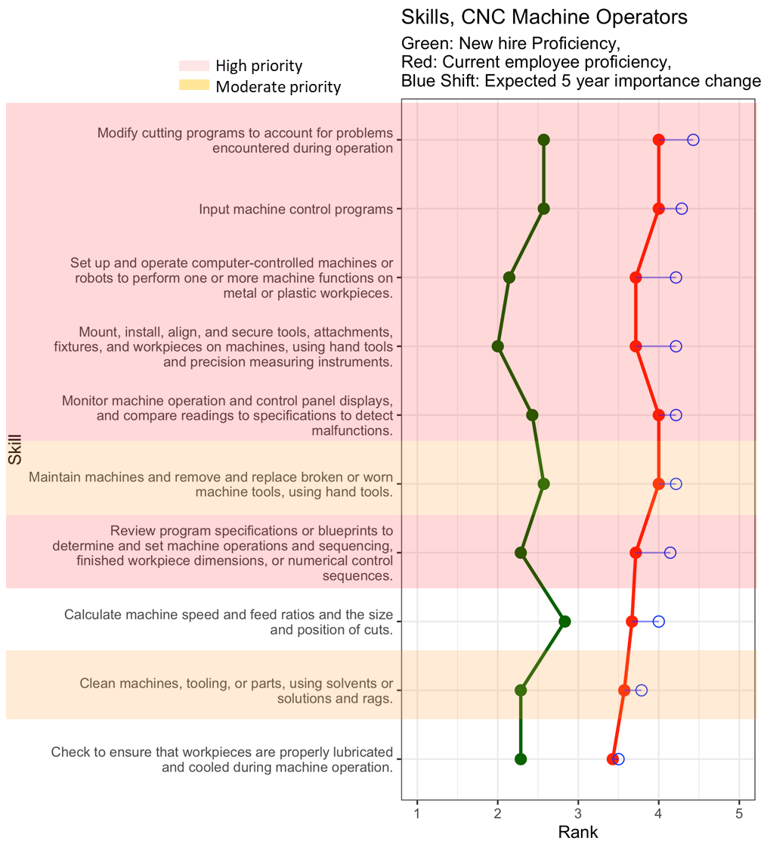
Figure 21. The gaps and expected future importance of skills for CNC tool operators are shown with high priority skills highlighted in red and moderate priority skills highlighted in orange.

Table 15 Recommended changes in the training of CNC tool operators in the FHE industry. The orange skills are those that are ranked as moderate priority and therefore have a skill gap and are also important in the future.
Recommendation | Skill | Full Skill Description
Emphasize training on… | Monitor and maintain machines | Modify cutting programs to account for problems encountered during operation
Emphasize training on… | Monitor and maintain machines | Input machine control programs
Emphasize training on… | Monitor and maintain machines | Set up and operate computer-controlled machines or robots to perform one or more machine functions on metal or plastic workpieces.
Emphasize training on… | Monitor and maintain machines | Mount, install, align, and secure tools, attachments, fixtures, and workpieces on machines, using hand tools and precision measuring instruments.
Emphasize training on… | Monitor and maintain machines | Monitor machine operation and control panel displays, and compare readings to specifications to detect malfunctions.
Emphasize training on… | Assess specifications or blueprints | Review program specifications or blueprints to determine and set machine operations and sequencing, finished workpiece dimensions, or numerical control sequences.
Improve training on… | Machine operation and maintenance | Maintain machines and remove and replace broken or worn machine tools, using hand tools.
Improve training on… | Machine operation and maintenance | Clean machines, tooling, or parts, using solvents or solutions and rags.
Maintain training/evaluate training on… | Calculate machine speeds and feed ratios | Calculate machine speed and feed ratios and the size and position of cuts.
Maintain training/evaluate training on… | Machine operation and maintenance | Check to ensure that workpieces are properly lubricated and cooled during machine operation.

Critical thinking skills
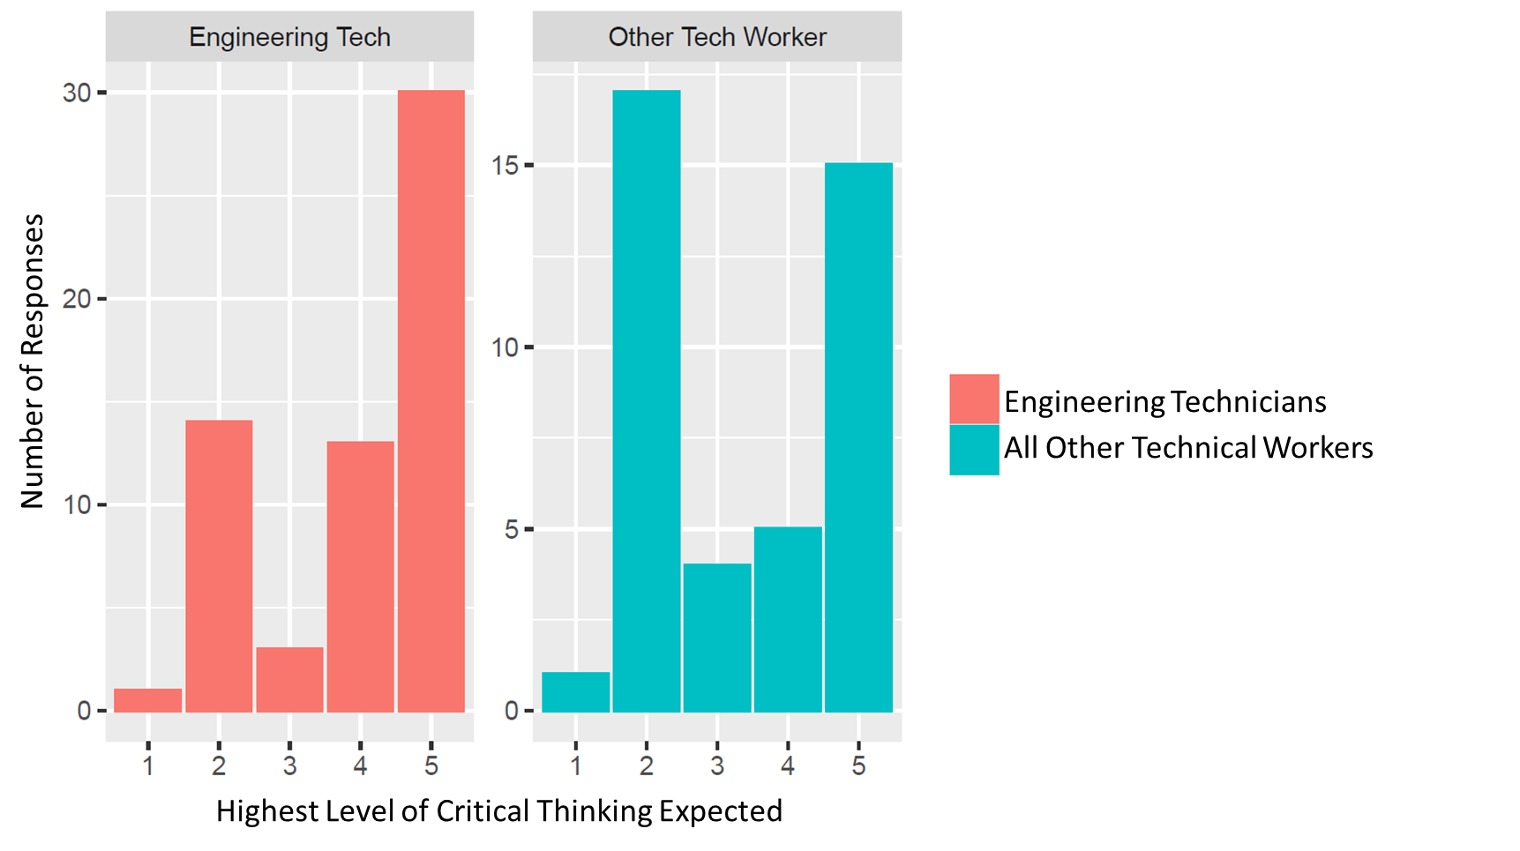
Figure 22. Respondents valued critical thinking skills for all occupations studied. However, most respondents expect a higher level of critical thinking for engineering technicians. While there are respondents that expect the highest level for other technical workers as well, a majority of respondents expect other technical workers to cause hypothesize
FHE firms shared that technicians are critical to solving problems since they are on the manufacturing front line and therefore become very sensitive to problems and develop an intuition on the causes of problems over time. While some firms don’t expect technicians to be able to have critical thinking skills at first, they do expect them to be able to develop these skills with time. At a minimum, FHE firms expect all technicians to be able to cause hypothesize. However, there are firms that expect technicians of all types, especially engineering technicians, to be able to determine a problem, communicate that problem with the engineering team, and suggest solutions to the problem. Respondents emphasized that this process is collaborative and therefore it is vital that technicians are able to work with their colleagues to identify a problem and make decisions.
Results indicate that the majority of engineering technicians (71%) are expected to have competency in nearly all aspects of critical thinking (perceiving, hypothesizing, testing, and interpreting testing). Of the total number of responses, 49% of respondents expect engineering technicians to also be able to communicate the outcome of the process. Most other technical production workers are expected to only perceive the issue and hypothesize a cause (47%) while a third of the respondents expected these workers to be able to master all aspects of critical thinking.
A standard practice for technicians at FHE firms is using protocols to calibrate equipment and verify standards. As such, firms recommend that curriculum includes practice on operating machinery, looking at and interpreting data from the machine, detecting if a machine is calibrated to the acceptable level, and reporting the data to the team. The interpretation of data was emphasized across firms and it was recommended that technician training include basic statistics to enable better decision-making. Several firms suggested that virtual reality (VR) or augmented reality (AR) technology could also be leveraged to practice critical thinking and data interpretation with manufacturing simulations.

Common Skills
To understand the skills needed broadly at the middle-skill occupation level, the research team has identified skills that are both shared (common) and important across multiple occupations to enable training programs to be relevant for companies across the FHE supply chain. Figure 23 shows the twelve highest weighted average importance scores for the general task/skill (GTS) level ranked from highest to lowest.
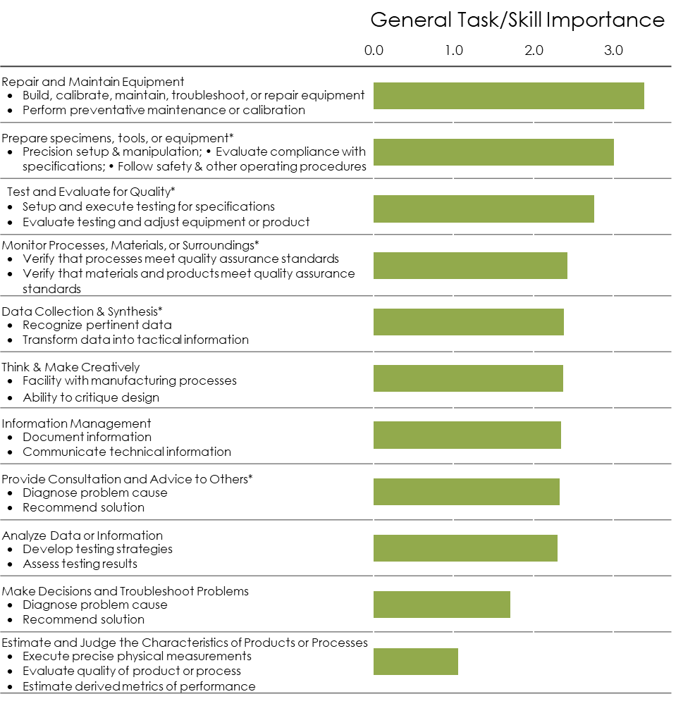
Figure 23 General Task or Skill ranked by weighted average importance of the skills within that class. Only GTS that are shared across at least two occupations are labeled as common and, therefore, included in this figure.
The top three ranked common skills include repair and maintain equipment, prepare specimens, tools or equipment, and test and evaluate for quality. These skills involve an understanding of the entire system from tools to each piece of equipment as well as knowledge of quality testing.

Advanced Fabrics and Fibers

Firm Classification

Table 16 Fabric and fiber industry classification archetype examples
Company | US Standard Industrial Classification –  DB Hoovers Expanded Version (SIC8) | North American Industrial Classification System (NAICS)
New Balance Athletics, Inc. | 23210200 Men’s and boys’ sports and polo shirts  23290205 Jackets (suede, leatherette, etc.), sport: men's and boys' | 315220 Men’s and Boys’ Cut and Sew Apparel Manufacturing
Haartz Corp | 22950201 Resin or plastic-coated fabrics | 313320 Fabric Coating Mills
99 Degrees Custom | 39990000 Manufacturing industries, nec | 339999 All other miscellaneous manufacturing
Warwick Mills | 22210400 Manmade and synthetic broadwoven fabrics | 313210 Broadwoven Fabric Mills
Gentex Corporation | 38120500 Defense systems and equipment | 334511 Search, Detection, Navigation, Guidance, Aeronautical, and Nautical System and Instrument Manufacturing
Auburn Manufacturing | 22620203 Fire resistance finishing: manmade and silk broadwoven  22210000 | 313310 Textile and Fabric Finishing Mills
Otex | 22410000 Narrow fabric milks | 313220 Narrow Fabric Mills and Schiffli Machine Embroidery
Fabreeka | 30691006 Molded rubber products | 423840 Industrial Supplies Merchant Wholesalers
Teufelberger Fiber Rope Corp | 22980000 Cordage and twine | 314994 Rope, Cordage, Twine, Tire Cord, and Tire Fabric Mills
Fall River Apparel, Inc. | 23920000 Household furnishings | 314120 Curtain and Linen Mills
Unwrapped, Inc. | 23930000 Textile bags | 314910 Textile bag and canvas mills
Table 17. Most common NAICS codes for firms identified as in the optical fiber cabling industry. These codes capture 90% of firms identified.
NAICS Code | NAICS Description | BLS Equivalent Code
313210 | Broadwoven Fabric Mills | 313000
313220 | Narrow Fabric Mills and Schiffli Machine Embroidery | ”
313310 | Textile and Fabric Finishing Mills | ”
313320 | Fabric Coating Mills | ”
314120 | Curtain and Linen Mills | ”
314910 | Textile bag and canvas mills | 314000
314994 | Rope, Cordage, Twine, Tire Cord, and Tire Fabric Mills | “
315220 | Men's and Boys' Cut and Sew Apparel Manufacturing | 315000
326299 | All Other Rubber Product Manufacturing | 326000
334511 | Search, Detection, Navigation, Guidance, Aeronautical, and Nautical System and Instrument Manufacturing | 334000
339999 | All Other Miscellaneous Manufacturing | 339000

Table 18. Focal occupations that were evaluated in this study. Bold titles represent representative occupations that were served as proxy for the subsequent specific occupations.
Occupation | Standard Occupation Classification Code
Middle-skilled
Electrical and electronics engineering technicians(representing)
Electrical and electronics engineering technicians |  | 17-3023
Electro-mechanical technicians |  | 17-3024
Electrical and electronics drafters |  | 17-3012
Industrial engineering technicians(representing)
Industrial engineering technicians |  | 17-3026
Aerospace engineering and operations technicians |  | 17-3021
Mechanical engineering technicians(representing)
Mechanical engineering technicians |  | 17-3027
Mechanical drafters |  | 17-3013
Chemical technicians |  | 19-4031
Maintenance and Support Technicians (representing)
Industrial machinery mechanics |  | 49-9041
Maintenance workers, machinery |  | 49-9043
Heating, air conditioning, and refrigeration mechanics and installers |  | 49-9021
Mobile heavy equipment mechanics, except engines |  | 49-3042
Electrical and electronics repairers, comm. and ind. equipment |  | 49-2094
Computer-controlled machine tool operators(representing)
Computer-controlled machine tool operators |  | 51-4011
Computer numerically controlled machine tool programmers |  | 51-4012
Other Technical Production Worker (representing)
Machinists |  | 51-4041
Tool and die makers |  | 51-4111
Fabrics Designers and Patternmakers |  | 51-6092
Lower-skilled
Sewing Machine Operators |  | 51-6031
Hand Sewers (representing)
Hand Sewers |  | 51-6051
Upholsterers |  | 51-6051
Fabric menders, except garment |  | 49-9093
Tailors, dressmakers, and custom sewers |  | 51-6052
Textile Cutting Machine Operators |  | 51-6062
Textile Knitting and Weaving Machine Operators |  | 51-6063

Respondent Demographics
Survey respondents came from a broad array of firms. As shown in Figure 2a, a majority of the respondents came from Massachusetts, with a few firms from other New England states. Firms ranged in size from as few as three employees to as many as 1,2000. The median firm size was 142 employees. Annual revenue ranged from $0.3M to $200M with a median of $7M per year (Figure 2b).
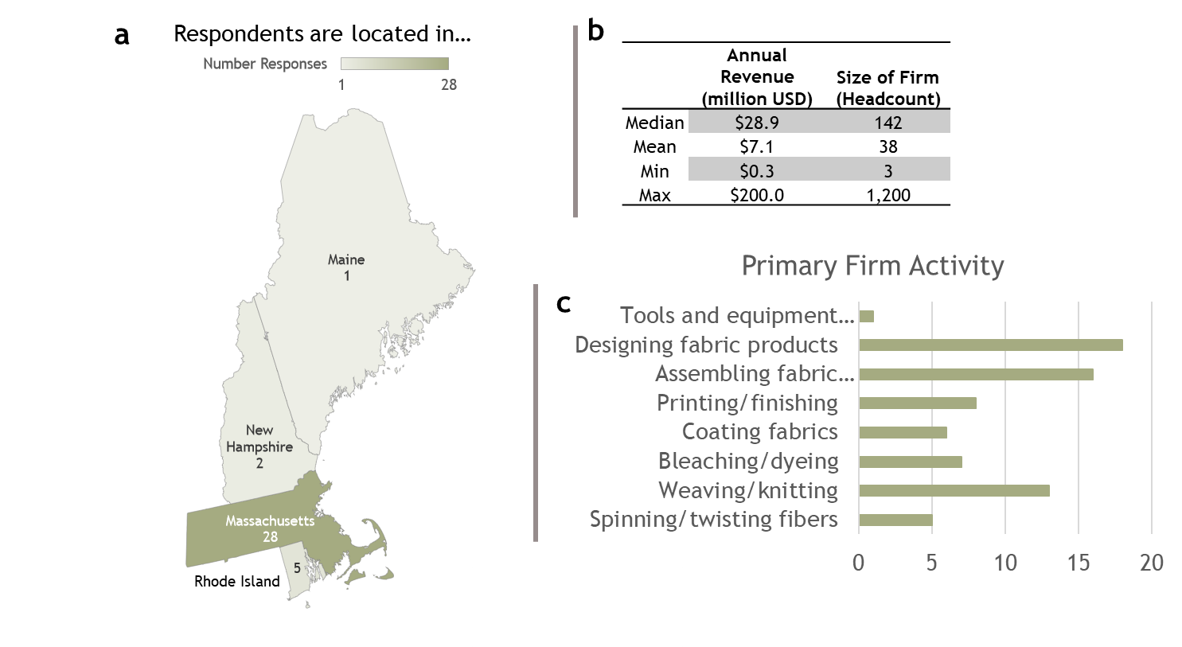
Figure 24. Distribution of respondent location, size, revenue, and primary supply chain activity.
Firms were asked to identify their role in the supply chain. There was a range of primary activities for each firm (see Figure 2c) with a majority focused on designing fabric products and assembling fabric products.
Finally, firms were asked about whether or not they currently, plan to, or do not use smart textiles. A majority of firms interviewed (62%) are either currently using or planning to use smart textiles. Thirty-eight percent (38%) of firms interviewed did not have any immediate plans to use smart textiles (Figure 25).
Figure 25. Distribution of responses of firm participation with smart textiles.

Demand for Occupations
The results of the interviews demonstrate that the overall demand for technical workers at the middle- and lower-skilled level is strong and many of the positions will grow over the next five years. It is important to note that there is not a single position where we expect strong growth (Figure 3). However, many of the positions are expected to have moderate growth. The positions with the greatest expected demand growth include technical maintenance and support workers or technical production workers (e.g. machinists), largely because these are ubiquitous positions that are relevant for most of the respondent companies (>75%). This suggests that a greater curriculum focus on more general technical training can help improve the workforce gaps at many of the companies in the advanced fabrics and fibers industry. Of the positions common to the companies interviewed (>50%), the lowered skill position, Sewing Machine Operator and the middle-skilled position, Electrical/Electronic Engineering Technician demonstrated the strongest growth. Finally, for the specialty positions (<50%), the Hand Sewer occupation is expected to have moderate growth with the Chemical Technician’s demand remaining constant over time.
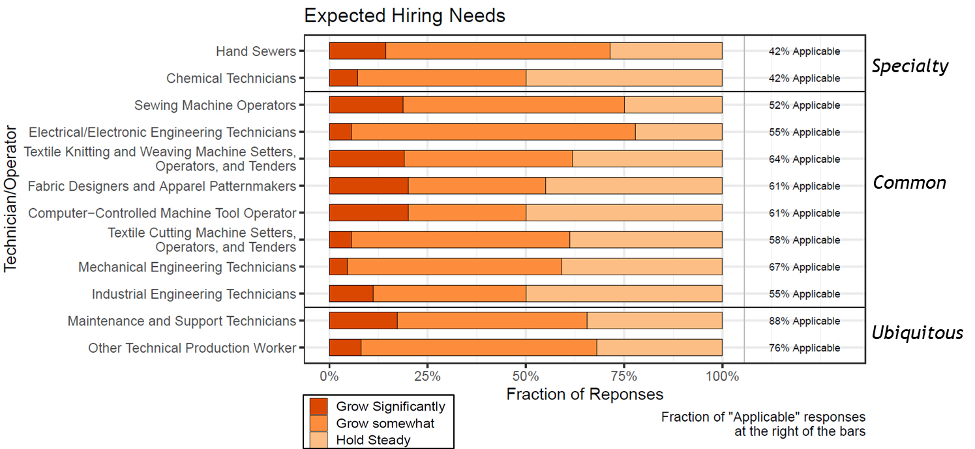
Figure 26. The technical worker occupations studied were classified according to future demand growth in the advanced fabrics and fibers industry. Occupations were also segmented into three categories of prevalence: ubiquitous (present in > 75% of firms), common (>50%), and specialty (<50%). Number of respondents, n =34.
The demand for each position can be summarized as follows:
Strong Growth | Moderate Growth | Hold
 | - Hand Sewers  - Sewing Machine Operators  - Electrical/Electronic Engineering Technicians  - Textile Knitting and Weaving Machine Setters, Operators, Tenders  - Fabric Designers and Apparel Patternmakers  - Textile Cutting Machine Operators  - Mechanical Engineering Technician  - Maintenance and Support Technicians  - Other Technical Production Worker | - Chemical Technicians  - Computer-Controlled Machine Tool Operator  - Industrial Engineering Technician

Hiring Challenges
Figure 4 shows interview responses concern hiring challenges for each occupation. While demand for these positions is expected to grow moderately, hiring challenges are pervasive particularly for all engineering technicians and knitting and weaving machine operators. There was not a single position that could be classified as easy to hire. Respondents explained that the biggest challenge in the industry is: 1) finding workers to fill these positions and 2) retaining workers over time. Respondents were asked to classify the level of difficulty for hiring each of the positions as hard (>60 days to fill the position), average (30-60 days), or easy (<30 days). Few respondents indicated that it was easy to hire, particularly for many of the middle-skilled positions as shown in Figure 4.
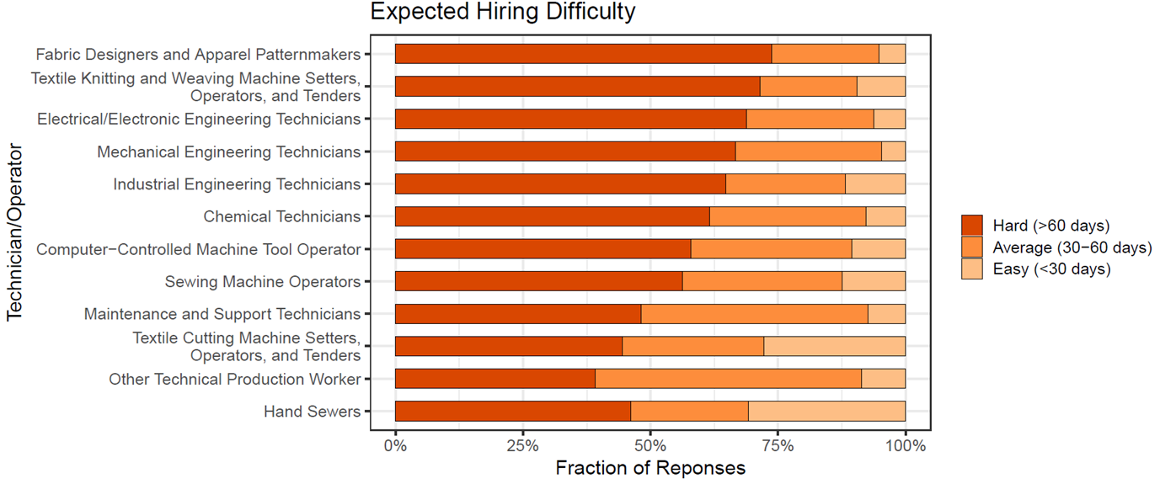
Figure 27 The difficulty of hiring the lower- and middle-skilled positions was assessed for the advanced fabrics and fibers industry (n=34). Many of the middle-skilled positions were found to be significantly difficult to hire, especially the Fabrics Designer and Patterns Maker position.
Respondents indicated that only two positions were somewhat easy to hire for (~25% of responses) including the Textile Cutting Machine Operator and the Hand Sewer position. For the Hand Sewer position, many of the respondents explained that there is a large population in the Massachusetts region with hand sewing experience and they typically try to recruit workers from other AFF companies. The remaining positions were all classified as difficult to fill, suggesting a low supply of technical workers as well as a challenge of attracting workers to this industry. Another challenge in hiring is attracting diverse candidates. Firms mentioned that finding female workers was particularly difficult.
Many respondents explained that training is only one side of the equation; enticement and retainment of workers are equally, if not more important in this industry. There was discussion of raising wages, creating opportunities for professional development and promotion, and creating opportunities for feedback from workers to improve retainment over time.
The hiring difficulty for each position can be summarized as follows:
Considerable hiring effort | Moderate | Nominal
- Fabric Designers and Apparel Patternmakers  - Textile Knitting & Weaving Machine Operators  - Electrical/Electronic Engineering Technician  - Mechanical Engineering Technician  - Industrial Engineering Technician  - Chemical Technician  - Computer-Controlled Machine Tool Operator  - Sewing Machine Operator | - Maintenance and Support Technicians  - Textile Cutting Machine Operator  - Other Technical Production Worker  - Hand Sewer

In comparing the demand and hiring results, maintenance and support technicians and other technical workers (e.g. machinists) are expected to have the largest growth, but are some of the easiest positions to fill in terms of hiring due to their non-specialized nature. Hand Sewers are the easiest to hire, yet are not in as high of demand. However, Mechanical Engineering and Electrical Engineering technicians are expected to have moderate demand growth, yet greater than 50% of respondents indicate they are difficult to hire.

Training Effort Required
Next, respondents were asked to assess the amount of on-the-job training required for new hires as extensive, some, or basic orientation only. Our findings indicate that more extensive training is required for middle-skilled technical workers than for lower-skilled operator workers (Figure 5). Many of the jobs in this industry are more specialized (e.g. Fabrics Designer and Apparel Patternmaker) and require on-the-job training because of the niche applications manufactured at each firm. A unique training challenge mentioned by a few respondents is addressing language barriers through the creation of non-English versions of training to eliminate more barriers to entry.
There are also position-specific training challenges. For instance, Fabric Designers and Apparel Patternmaker programs are largely centered around the fashion and apparel industry. However, respondents explained designers and patternmakers are in demand in other sectors of the industry and therefore more general training rather than apparel-specific training could increase the supply of qualified workers. For positions like Textile Knitting and Weaving Machine Operators, many firms currently send their workers to Europe or Asia because the training programs no longer exist in the U.S. To address these training challenges and help revive the workforce, several firms recommended a resurgence of apprenticeship programs between community colleges and AFF firms.
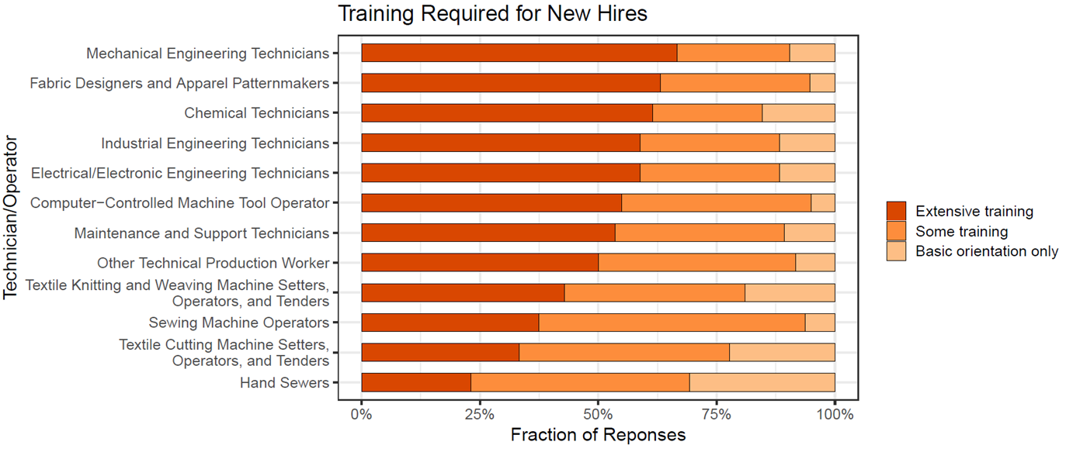
Figure 28 The training required for each position was assessed as extensive, some training, or basic orientation only (n=34). Most of the middle-skilled positions required extensive training (>50% of the responses) and the remaining positions required at least some training.
In comparing the training effort results to the hiring challenge results, we observe that many of the middle-skilled positions are difficult to hire and also require additional specialized training for new hires. Firms that were interviewed explained that it is often frustrating since it takes a long time to assess skillsets for hiring and they additionally need to invest time to train the worker. More often than not, after all of this effort to hire, the turnover rate for these positions is less than a year. Improved curricula to help reduce the training effort required would greatly benefit firms in the AFF industry.
The training challenges for each position can be summarized as follows:
Extensive training | Some training | Basic  orientation only
- Mechanical Engineering Technician  - Fabric Designers and Apparel Patternmakers  - Chemical Technician  - Industrial Engineering Technician  - Electrical/Electronic Engineering Technician  - Maintenance and Support Technicians  - Computer-Controlled Machine Tool Operator | - Other Technical Production Worker  - Textile Knitting & Weaving Machine Operators  - Sewing Machine Operators  - Textile Cutting Machine Operators  - Hand Sewer

Skills Required for In-Demand Positions

Mechanical Engineering Technician
Survey responses for mechanical engineering technicians are shown in Figure 29. Recommendations for training of mechanical engineering technicians based on these results are summarized in Table 19.
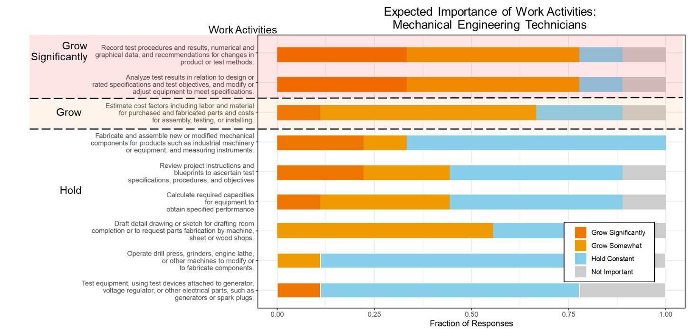
Figure 29. The expected importance of the work activities for mechanical engineering technicians are ranked from grow significantly to diminish and evaluate regionally.

Table 19. Recommended changes in the training of Mechanical Engineering Technicians in the advanced fabrics and fibers industry.
Recommendation | Skill | Full Skill Description
Increase emphasis on… | Recommend changes in product or process design*** | Record test procedures and results, numerical and graphical data, and recommendations for changes in product or test methods.
Increase emphasis on… | Analyze and respond to test data*** | Analyze test results in relation to design or rated specifications and test objectives, and modify or adjust equipment to meet specifications.
Increase emphasis on… | Estimate process cost | Estimate cost factors including labor and material for purchased and fabricated parts and costs for assembly, testing, or installing.
Maintain training on … | Fabrication methods | Fabricate and assemble new or modified mechanical components for products such as industrial machinery or equipment, and measuring instruments.
Maintain training on … | Interpret process or test requirements | Review project instructions and blueprints to ascertain test specifications, procedures, and objectives
Maintain training on … | Estimate equipment capabilities | Calculate required capacities for equipment to obtain specified performance
Maintain training on … | Drafting for fabrication | Draft detail drawing or sketch for drafting room completion or to request parts fabrication by machine, sheet or wood shops.
Maintain training on … | Electrical testing | Test equipment, using test devices attached to generator, voltage regulator, or other electrical parts, such as generators or spark plugs.
Maintain training on … | Operate specific equipment | Operate drill press, grinders, engine lathe, or other machines to modify parts tested or to fabricate experimental parts for testing.

Industrial Engineering Technician
Survey responses for industrial engineering technicians are shown in Figure 30. Recommendations for training of industrial engineering technicians based on these results are summarized in Table 20.

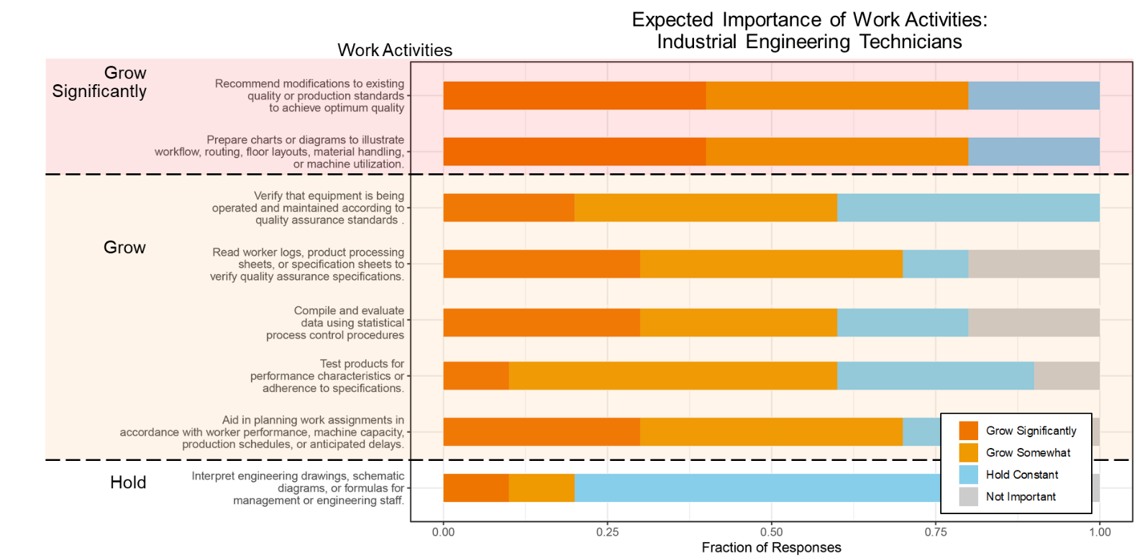
Figure 30 The expected importance of the work activities for industrial engineering technicians are ranked from grow significantly to diminish and evaluate regionally.

Table 20 Recommended changes in the training of Industrial Engineering Technicians in the advanced fabrics and fibers industry.
Recommendation | Skill | Full Skill Description
Increase emphasis on… | Recommend operational & procedural changes*** | Recommend modifications to existing quality or production standards to achieve optimum quality
Increase emphasis on… | Communication with engineering and management*** | Prepare charts or diagrams to illustrate workflow, routing, floor layouts, material handling, or machine utilization.
Increase emphasis on… | Maintain product and process quality assurance standards | Verify that equipment is being operated and maintained according to quality assurance standards.
Increase emphasis on… | Maintain product and process quality assurance standards | Read worker logs, product processing sheets, or specification sheets to verify quality assurance specifications.
Increase emphasis on… | Maintain product and process quality assurance standards | Test products for performance characteristics or adherence to specifications.
Increase emphasis on… | Analyze and respond to process data | Compile and evaluate statistical data to determine and maintain quality and reliability of products.
Increase emphasis on… | Recommend operational & procedural changes | Aid in planning work assignments in accordance with worker performance, machine capacity, production schedules, or anticipated delays.
Maintain training on… | Communication with engineering and management | Interpret engineering drawings, schematic diagrams, or formulas for management or engineering staff.

Fabric Designer and Patternmaker
Survey responses for fabric designer and patternmaker shown in Figure 31. Recommendations for training of fabric designers and patternmakers based on these results are summarized in Table 21.
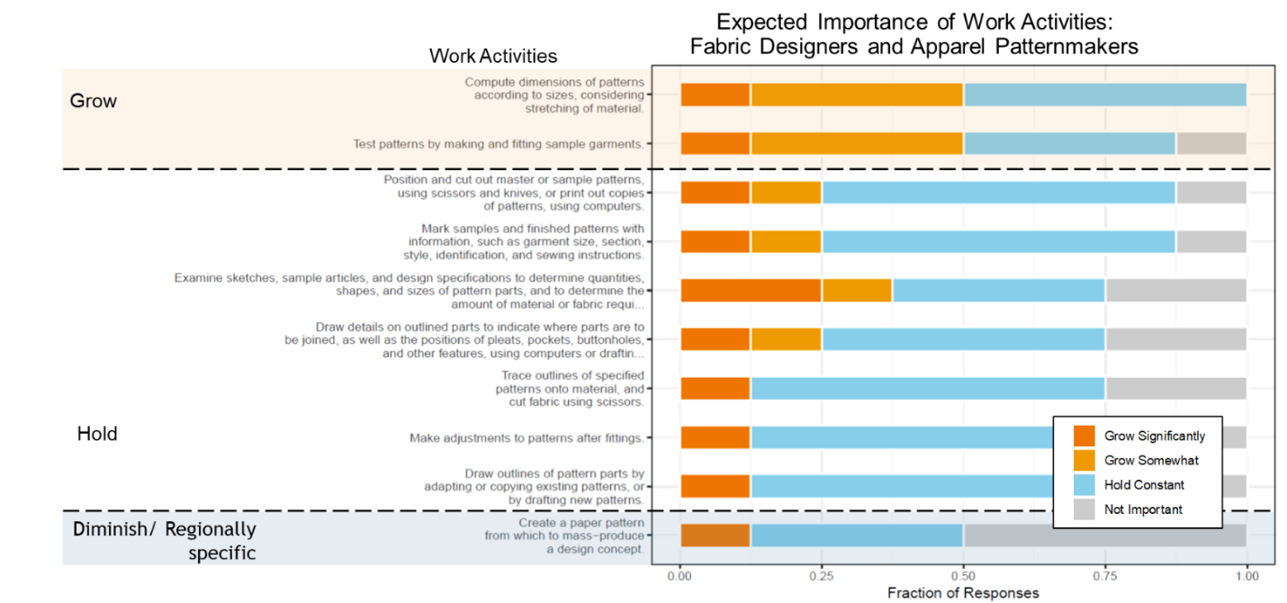
Figure 31 The expected importance of the work activities for fabric designers and patternmakers are ranked from grow significantly to diminish and evaluate regionally.

Table 21 Recommended changes in the training of fabric designers and patternmakers in the advanced fabrics and fibers industry.
Recommendation | Skill | Full Skill Description
Increase emphasis on… | Compute dimensions | Compute dimensions of patterns according to sizes, considering stretching of material.
Increase emphasis on… | Create samples | Test patterns by making and fitting sample garments.
Maintain training on… | Organize and make use of samples | Position and cut out master or sample patterns, using scissors and knives, or print out copies of patterns, using computers.
Maintain training on… | Organize and make use of samples | Mark samples and finished patterns with information, such as garment size, section, style, identification, and sewing instructions.
Maintain training on… | Estimate amount of material required | Examine sketches, sample articles, and design specifications to determine quantities, shapes, and sizes of pattern parts, and to determine the amount of material or fabric required to make a product.
Maintain training on… | Draw pattern and product details | Draw details on outlined parts to indicate where parts are to be joined, as well as the positions of pleats, pockets, buttonholes, and other features, using computers or drafting instruments.
Maintain training on… | Draw pattern and product details | Draw outlines of pattern parts by adapting or copying existing patterns, or by drafting new patterns.
Maintain training on… | Trace and cut patterns | Trace outlines of specified patterns onto material, and cut fabric using scissors.
Maintain training on… | Adjust patterns | Make adjustments to patterns after fittings.
Evaluate with their local industry the importance of… | Create paper patterns | Create a paper pattern from which to mass-produce a design concept.

CNC Tool Operator
Survey responses for textile knitting and machine operators shown in Figure 32. Recommendations for training of CNC tool operators based on these results are summarized in Table 22.

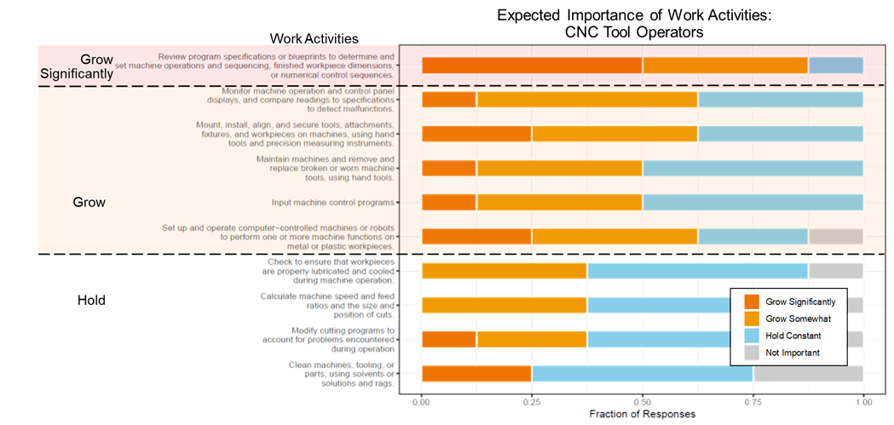
Figure 32 The expected importance of the work activities for CNC tool operators are ranked from grow significantly to diminish and evaluate regionally.

Table 22 Recommended changes in the training of CNC tool operators in the advanced fabrics and fibers industry.
Recommendation | Skill | Full Skill Description
Increase emphasis on… | Assess specifications or blueprints | Review program specifications or blueprints to determine and set machine operations and sequencing, finished workpiece dimensions, or numerical control sequences.
Increase emphasis on… | Apply precision measuring instruments | Mount, install, align, and secure tools, attachments, fixtures, and workpieces on machines, using hand tools and precision measuring instruments.
Increase emphasis on… | Monitor and maintain machines | Monitor machine operation and control panel displays, and compare readings to specifications to detect malfunctions.
Increase emphasis on… | Monitor and maintain machines | Maintain machines and remove and replace broken or worn machine tools, using hand tools.
Increase emphasis on… | Monitor and maintain machines | Input machine control programs
Increase emphasis on… | Monitor and maintain machines | Set up and operate computer-controlled machines or robots to perform one or more machine functions on metal or plastic workpieces.
Maintain training on… | Inspect machines | Check to ensure that workpieces are properly lubricated and cooled during machine operation.
Maintain training on… | Calculate machine speeds and feed ratios | Calculate machine speed and feed ratios and the size and position of cuts.
Maintain training on… | Alter machine settings | Modify cutting programs to account for problems encountered during operation
Maintain training on… | Clean | Clean machines, tooling, or parts, using solvents or solutions and rags.

Common Skills
In addition to understanding the detailed skills needs for each occupation, the research team has identified skills that are both important and shared (common) among multiple occupations. The purpose of this effort is to identify the skills needed broadly at the middle-skill occupation level to enable training programs to be relevant for companies across the advanced fabrics and fibers supply chain.
Figure 33 shows the ten highest weighted average importance scores for the general task/skill (GTS) level ranked from highest to lowest. The top three ranked common skills include documenting/recording data, getting information, and analyzing data or information, all which involve understanding and processing information and data. In addition, many of the remaining common skills (e.g. thinking creatively, making decisions and solving problems) involve critical thinking on the part of the worker.
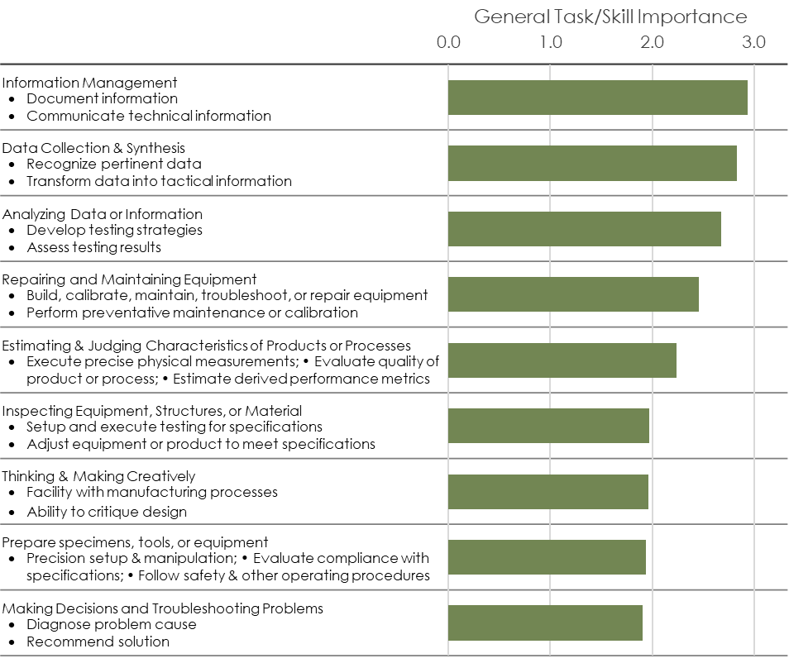
Figure 33 General Task or Skill ranked by weighted average importance of the skills within that class. Only GTS that are shared across at least three occupations are labeled as common and, therefore, included in this figure.

Integrated Photonics

Firm Classification
Table 23 Fiber cabling industry classification archetype examples
Company | US Standard Industrial Classification –  DB Hoovers Expanded Version (SIC8) | North American Industrial Classification System (NAICS)
AFL Telecommunications | 32290401 Fiber optics strands | 517911 Telecommunications Resellers
Corning Inc | 32290400 Glass fiber products (Primary)  33570102 Fiber optic cable (insulated) | 327212 Other pressed and blown glass and glassware manufacturing
OFS Fitel LLC | 33570102 Fiber optic cable (insulated) | 327212 Other pressed and blown glass and glassware manufacturing
Optical Cable Corporation | 33570102 Fiber optic cable (insulated) | 335921 Fiber optic cable manufacturing

Table 24. Most common NAICS codes for firms identified as in the optical fiber cabling industry. These codes capture 90% of firms identified.
NAICS Code | NAICS Description | BLS Equivalent Code
327212 | Other Pressed and Blown Glass and Glassware Manufacturing | 327000
327215 | Glass Product Manufacturing Made of Purchased Glass | ”
333314 | Optical Instrument and Lens Manufacturing | 333300
334210 | Telephone Apparatus Manufacturing | 334200
334220 | Radio and Television Broadcasting and Wireless Communications Equipment Manufacturing | ”
334417 | Electronic Connector Manufacturing | 334400
334419 | Other Electronic Component Manufacturing
335313 | Switchgear and Switchboard Apparatus Manufacturing | 335300
335921 | Fiber Optic Cable Manufacturing | 335900
335999 | All Other Miscellaneous Electrical Equipment and Component Manufacturing | ”

Table 25 US Standard Industrial Classification – DB Hoovers Expanded Version (SIC8) associated with archetype firms engaged in photonics component and system manufacturing and firms engaged in assembly and packaging of integrated photonic component assembly and packaging
US Standard Industrial Classification – DB Hoovers Expanded Version (SIC8)
Integrated Photonic Component Fabrication Firms
35599927 | Semiconductor manufacturing machinery
36619908 | Fiber optics communications equipment
36639901 | Antennas, transmitting and communications
36740000 | Semiconductors and related devices
36740103 | Light emitting diodes
36740200 | Integrated circuits, semiconductor networks, etc.
38250226 | Semiconductor test equipment
38269909 | Laser scientific and engineering instruments
38270100 | Optical instruments and apparatus
50650309 | Semiconductor devices
35599927 | Semiconductor manufacturing machinery
Integrated Photonic Packaging and Assembly Firms
35599927 | Semiconductor manufacturing machinery
36619908 | Fiber optics communications equipment
36740000 | Semiconductors and related devices
36740202 | Hybrid integrated circuits
36740206 | Microcircuits, integrated (semiconductor)
36749905 | Modules, solid state
38270000 | Optical instruments and lenses
38270100 | Optical instruments and apparatus

Table 26. Most common NAICS codes for firms identified as in the integrated photonic component fabrication, packaging, and assembly industries. These codes capture 85% of firms identified.
NAICS Code | NAICS Description | BLS Equivalent Code
334413 | Semiconductor and Related Device Manufacturing | 334400
334417 | Electronic Connector Manufacturing | “
334418 | Printed Circuit Assembly (Electronic Assembly) Manufacturing | “
334419 | Other Electronic Component Manufacturing | “
334515 | Instrument Manufacturing for Measuring and Testing Electricity and Electrical Signals | 334500
334516 | Analytical Laboratory Instrument Manufacturing | “
333314 | Optical Instrument and Lens Manufacturing | 333300
333242 | Semiconductor Machinery Manufacturing | 3330A1
334210 | Telephone Apparatus Manufacturing | 334200
334220 | Radio and Television Broadcasting and Wireless Communications Equipment Manufacturing | “

Table 27. Focal occupations that were evaluated in this study. Bold titles represent representative occupations that were served as proxy for the subsequent specific occupations.
Occupation | Standard Occupation Classification Code
Middle-skilled
Electrical and electronics engineering technicians(representing)
Electrical and electronics engineering technicians | 17-3023
Electro-mechanical technicians | 17-3024
Electrical and electronics drafters | 17-3012
Industrial engineering technicians(representing)
Industrial engineering technicians | 17-3026
Aerospace engineering and operations technicians | 17-3021
Mechanical engineering technicians(representing)
Mechanical engineering technicians | 17-3027
Mechanical drafters | 17-3013
Photonics Technician | 17-3029
Chemical technicians | 19-4031
Industrial machinery mechanics(representing)
Industrial machinery mechanics | 49-9041
Maintenance workers, machinery | 49-9043
Heating, air conditioning, and refrigeration mechanics and installers | 49-9021
Mobile heavy equipment mechanics, except engines | 49-3042
Electrical and electronics repairers, commercial and industrial equipment | 49-2094
Avionics technicians | 49-2091
Aircraft mechanics and service technicians | 49-3011
Camera and photographic equipment repairers | 49-9061
Computer-controlled machine tool operators(representing)
Computer-controlled machine tool operators | 51-4011
Computer numerically controlled machine tool programmers | 51-4012
Machinists(representing)
Machinists | 51-4041
Tool and die makers | 51-4111
Lower-skilled
Electrical and electronic assemblers (representing)
Electrical, electronic, and electromechanical assemblers | 51-2028
Coil winders, tapers, and finishers | 51-2021
Semiconductor processors | 51-9141
Optical equipment operators | 51-9083
Ceramics equipment operators | 51-9195

Respondent Demographics

Survey respondents came from a broad array of firms. As shown in Figure 2a, firms ranged in size from as few as four employees to as many as 10,000. The median firm size was 70 employees. Annual revenue ranged from $33M to nearly $32B with a median of $2B per year. Most respondents came from firms in California, Massachusetts, or New Jersey, but there were responses for all parts of the United States (See Figure 2b).
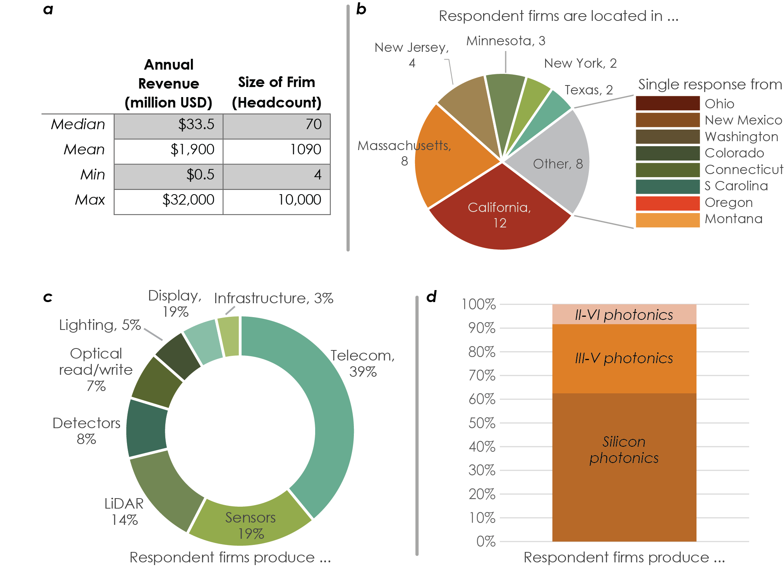
Figure 34. Distribution of respondent location for those that provided a location.
Respondent firms produced a range of products (see Figure 2c), but more than two-thirds were concentrated in the telecom/datacom, sensors, or LiDAR markets. The majority of respondent firms produce products from silicon (see Figure 2d) with about 1/3 producing III-V devices.
Finally, firms were asked to identify their role within the photonics supply chain. Responses about the firms primary activity in the supply chain are reported in Figure 25. Specifically, firms were asked if they primarily participated in the fiber cabling supply chain (blue bars) or the planar components supply chain (brown bars).
As Figure 25 makes clear, most respondents were primarily associated with the component supply chain and had a primary role in component fabrication or assembly, packaging, and test.
Figure 35. Distribution of responses of firm primary activity within the photonics supply chain. Firms could indicate more than one primary activity. Firms also indicated whether they were engaged primarily with the fiber cabling supply chain (blue) or the planar components supply chain (brown).

Demand for occupations
Our findings indicate a growing demand for technical workers, both middle- and lower-skilled, in the photonics industry. A breakdown of survey results is shown in and fiber firms (second row) and by general respondent trend of demand is expected to grow significantly (first column), grow (second column), hold (third), or be soft (fourth).
Considering the frequency of “grow significantly” and “grow” responses, these results indicate that demand growth for technical workers in the components sector is growing more rapidly than in the fiber sector. This result is not unexpected because the fiber industry is more mature, while the photonics component market continues to emerge. The positions with the greatest expected demand growth in both the component and fiber sectors are Photonics Technicians and Optical Equipment Operators. This suggests that curricula focused on the skills required for these two positions could greatly aid in addressing workforce gaps in the photonics industry.

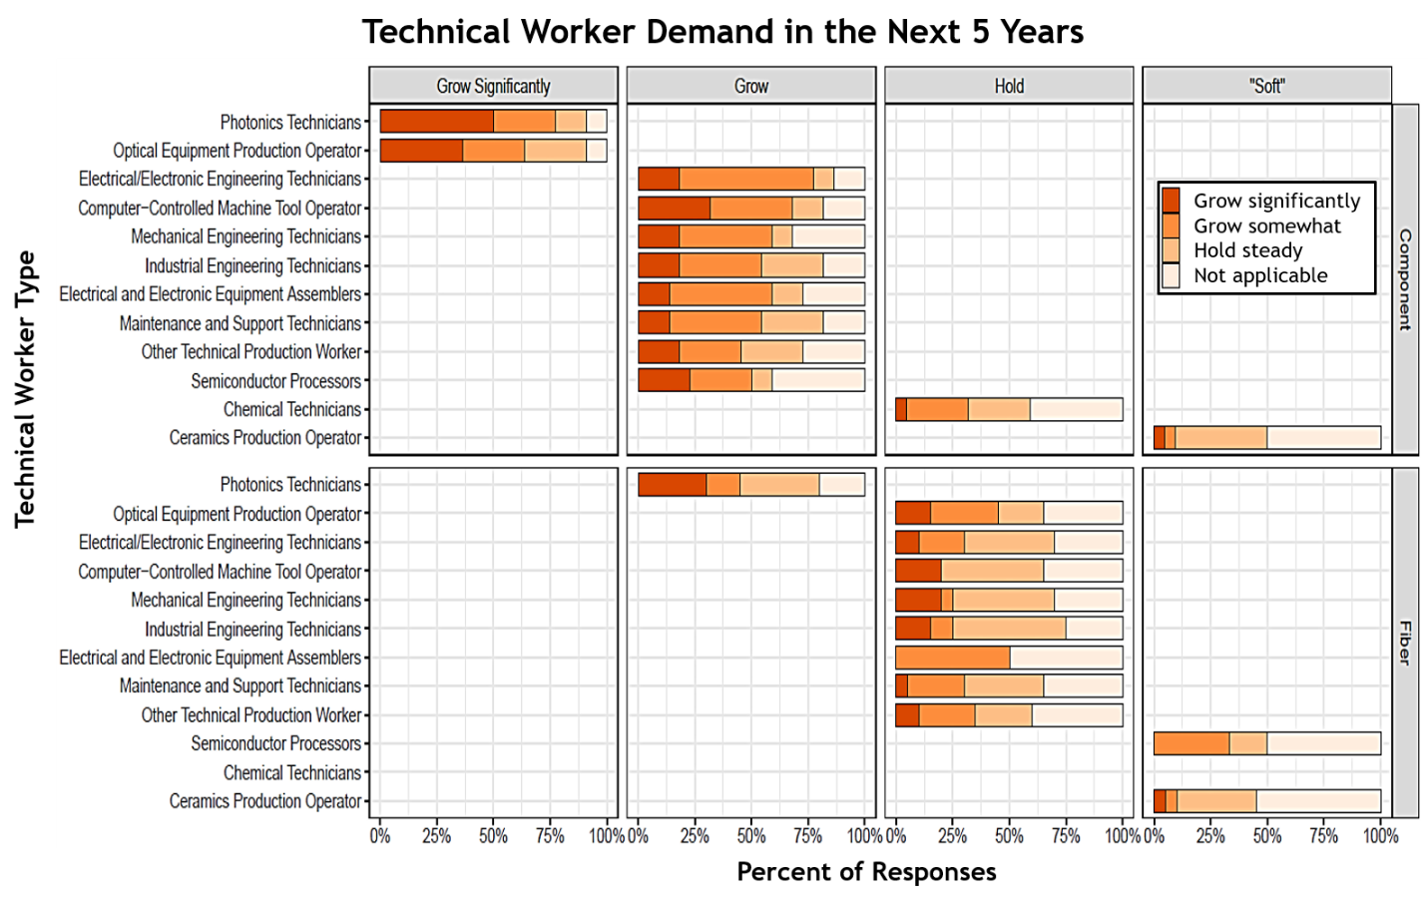
Figure 36. The technical worker occupations studied were classified according to future demand growth in the component and fiber sectors of the photonics industry. Number of respondents, n =47.
Because total demand for technical workers in this sector derives from both components and fiber firms, the researchers have attempted to identify an overall composite trend in demand. Considering responses from both types of firms the results indicate demand for the occupations can be categorized as follows:

Strong Growth | Moderate Growth | Hold | Soft
Photonics Technicians  Optical Equipment Operators | Computer-controlled (CNC) Machine Tools Operators  Electrical/Electronic Engineering Technicians  Industrial Engineering Technicians  Mechanical Engineering Technicians  Electrical and Electronic Equipment Assemblers  Maintenance and Support Technicians  Semiconductor Processors  Other Technical Production Worker | Chemical Technicians | Ceramics Production Operator

Hiring Challenges
In the survey, respondents were asked to identify the level of difficulty for hiring each of the studied middle- and lower-skilled positions. Hiring difficulty was classified as one of hard (>60 days to fill the position), average (30-60 days), or easy (<30 days). Results of survey responses are shown in Figure 37 segmented by sector (rows) and difficulty (columns). As with demand growth, the research team has grouped positions based on the overall set of responses into one of three levels of hiring difficulty labeled as considerable, moderate, or nominal.
In the component industry, Photonics Technicians and Semiconductor Processors were considered the most difficult to hire. Most positions presented some hiring difficulty with at least 25% of respondents indicating that a position was hard to fill. There was no position for which the majority of responses was easy to fill. These results show how there is a lower supply of more specialized technicians, especially for the component industry. It is likely that currently the more specialized roles (e.g. photonics technician) are filled by more common technician types with additional training upon hiring.
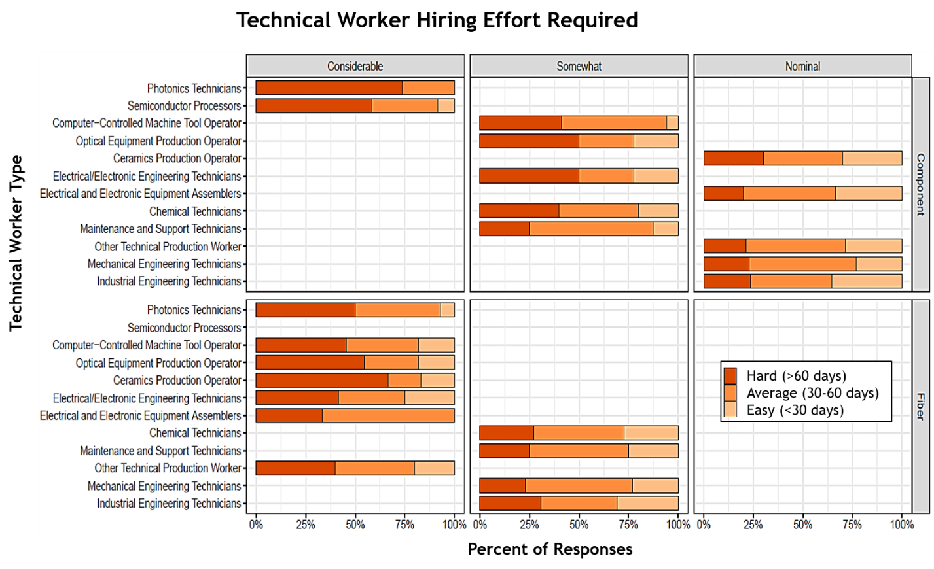
Figure 37. The difficulty of hiring various technician positions was assessed for the component and fiber industries (n=47). Photonics Technicians and Semiconductor Processers were found to be significantly difficult to hire for component companies. In the fiber industry, a majority of the positions are considerably or moderately difficult to hire.
In the fiber industry, however, a majority of occupations were classified as difficult to fill (see Figure 37), suggesting a more pervasive challenge of attracting technical workers.
Considering both sectors together the research team assembled the following composite trend for hiring effort.
- Considerable hiring effort
  - Photonics Technicians
  - Semiconductor Processors
  - CNC Machine Tool Operators
  - Ceramics Production Operators
  - Optical Equipment Production Operator
  - Electrical Engineering Technicians
- Moderate
  - Chemical Technicians
  - Maintenance and Support Technicians
  - Other Technical Production Workers
- Nominal
  - Mechanical Engineering Technicians
  - Industrial Engineering Technicians
  - Electrical and Electronic Equipment Assemblers

Training Effort Required
To understand the type of training involved for each of the occupations, survey respondents were asked to assess the amount of on-the-job training required for each position. The training required for new hires was categorized as extensive, some, or basic orientation only for new hires. Results of survey responses are shown in Figure 38 segmented by sector (rows) and extent of training required (columns).
In the components industry, many of the positions, including photonic technician, semiconductor processor, CNC tool operator, optical equipment operator, and electrical/electronic engineering technicians, require extensive on-the-job training. In the fiber industry, only photonic technicians were identified as requiring extensive training, the remaining positions are classified as only some training or basic training only. The results suggest that the more specialized roles require additional on-the-job training, which could be due to the low supply of specialized workers with adequate trainings. Curricula focused on these specialized positions could reduce the number of hiring days as well as the on-the-job training required.
Considering result from both the components and fiber sectors, these results suggest a composite trend in training challenges for the photonics industry as follows:
- Extensive training required
  - Photonics Technicians
  - Semiconductor Processors
  - CNC Machine Tool Operators
  - Electrical Engineering Technicians
  - Optical Equipment Production Operator
- Moderate training required
  - Mechanical Engineering Technicians
  - Maintenance and Support Technicians
  - Industrial Engineering Technicians
  - Electrical and Electronic Equipment Assemblers
- Nominal training required
  - Chemical Technicians
  - Ceramics Production Operators
  - Other Technical Production Workers
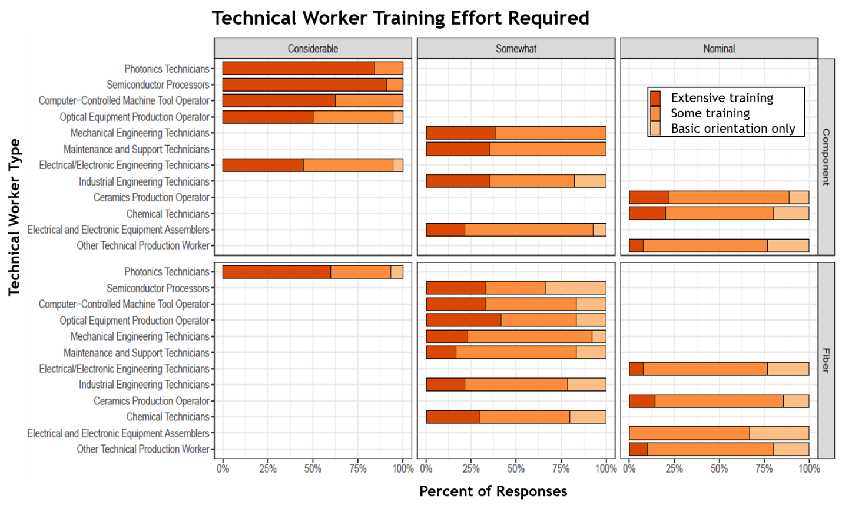
Figure 38. The training required for each position was assessed as extensive, some training, or basic orientation only (n=47). Several positions require extensive on-the-job training and most require at least some training.

Skills required for in-demand positions

Middle-Skilled Workers

Photonics Technician
Survey responses for photonic technicians are shown in Figure 29. Recommendations for training of Photonics Technicians based on these results are summarized in Table 19.
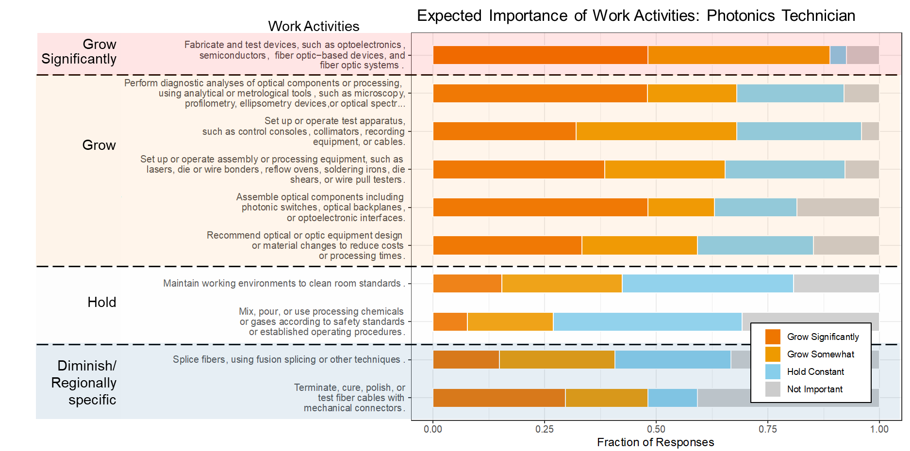
Figure 39. The expected importance of the work activities for photonics technicians are ranked from grow significantly to diminish and evaluate regionally.

Table 28. Recommended changes in the training of Photonics Technicians for the photonics industry.
Recommendation | Skill | Full Skill Description
Increase emphasis on… | Fabrication and assemble optical systems | Fabricate & test devices, such as optoelectronics, semiconductors, fiber optic-based devices, …
Increase emphasis on… |  | Set up or operate assembly or processing equipment, such as lasers, die or wire bonders, reflow ovens, soldering irons, die shears, or wire pull testers.
Increase emphasis on… |  | Assemble optical components including photonic switches, optical backplanes, ...
Increase emphasis on… | Diagnose and resolve process or product problems | Perform diagnostic analyses of optical components or processing, using analytical or metrological tools, …
Increase emphasis on… | Design and execute testing | Set up or operate test apparatus, such as control consoles, collimators, …
Increase emphasis on… |  | Fabricate & test devices, such as optoelectronics, semiconductors, fiber optic-based devices, …
Increase emphasis on… | Recommend design changes | Recommend equipment design or material changes to reduce costs or processing times.
Maintain training on… | Clean room standards | Maintain working environments to clean room standards.
Maintain training on… | Safety | Mix, pour, or use processing chemicals or gases according to safety standards …
Evaluate with their local industry the importance of… | Fiber handling | Splice fibers, using fusion splicing or other techniques. Terminate, cure, polish, or test fiber cables with mechanical connectors.

Mechanical Engineering Technician
Survey responses for mechanical engineering technicians are shown in Figure 40. Recommendations for training of mechanical engineering technicians based on these results are summarized in Table 29.
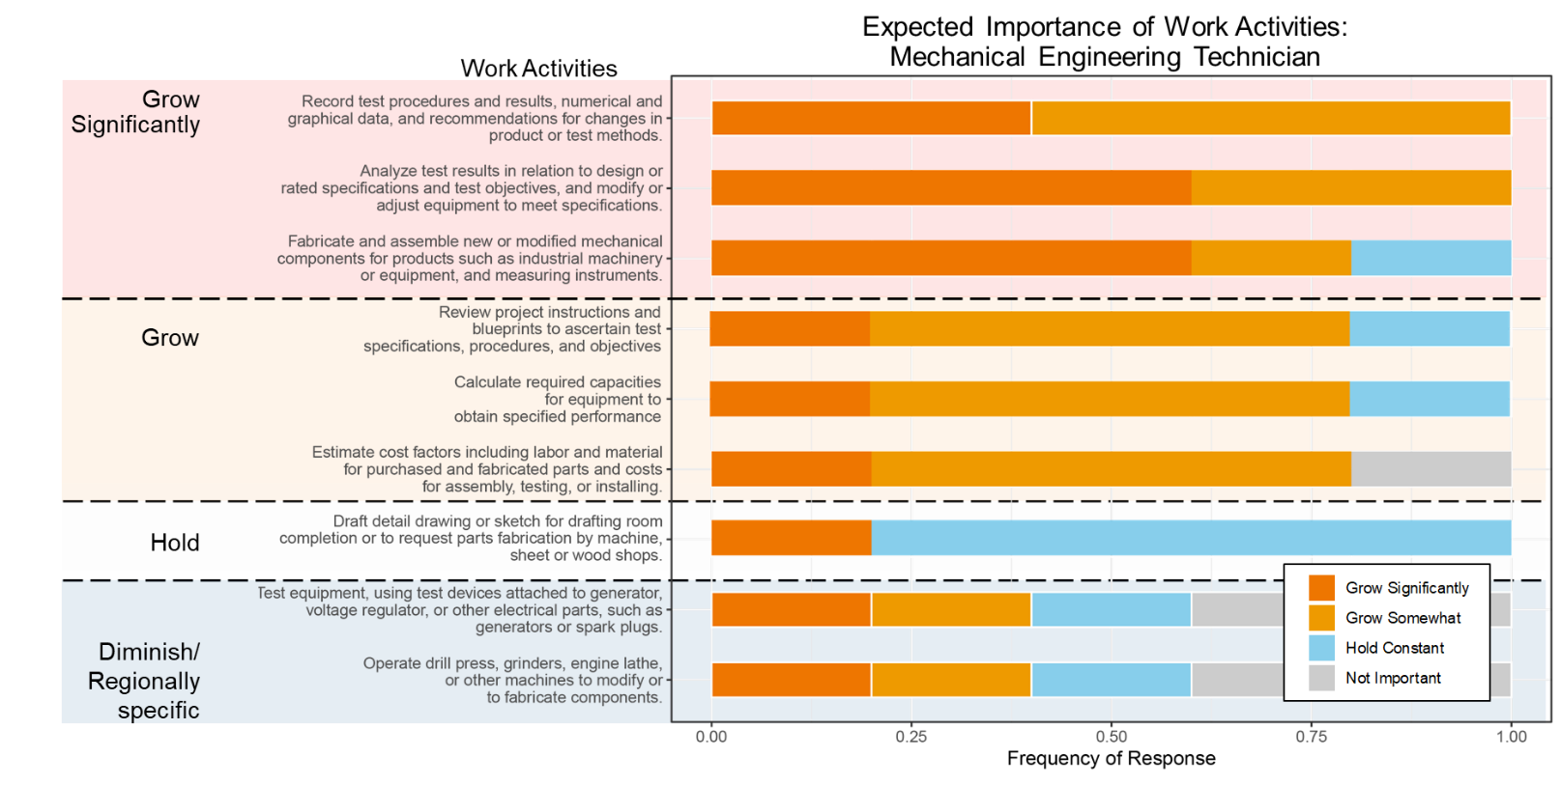
Figure 40. The expected importance of the work activities for mechanical engineering technicians are ranked from grow significantly to diminish or evaluate regionally.

Table 29. Recommended changes in the training of Mechanical Engineering Technicians for the photonics industry.
Recommendation | Skill | Full Skill Description
Increase emphasis on… | Analyze and respond to test data*** | Analyze test results in relation to design or rated specifications and test objectives, and modify or adjust equipment to meet specifications.
Increase emphasis on… | Fabrication methods *** | Fabricate and assemble new or modified mechanical components for products such as industrial machinery or equipment, and measuring instruments.
Increase emphasis on… | Recommend changes in product or process design*** | Record test procedures and results, numerical and graphical data, and recommendations for changes in product or test methods.
Increase emphasis on… | Interpret process or test requirements | Review project instructions and blueprints to ascertain test specifications, procedures, and objectives
Increase emphasis on… | Estimate equipment capabilities | Calculate required capacities for equipment to obtain specified performance
Increase emphasis on… | Estimate process cost | Estimate cost factors including labor and material for purchased and fabricated parts and costs for assembly, testing, or installing.
Maintain training on … | Drafting for fabrication | Draft detail drawing or sketch for drafting room completion or to request parts fabrication by machine, sheet or wood shops.
Evaluate with their local industry the importance of… | Electrical testing | Test equipment, using test devices attached to generator, voltage regulator, or other electrical parts, such as generators or spark plugs.
Evaluate with their local industry the importance of… | Operate specific equipment | Operate drill press, grinders, engine lathe, or other machines to modify parts tested or to fabricate experimental parts for testing.

Electrical Engineering Technician
Survey responses for electrical engineering technicians are shown in Figure 41. Recommendations for training of electrical engineering technicians based on these results are summarized in Table 30.
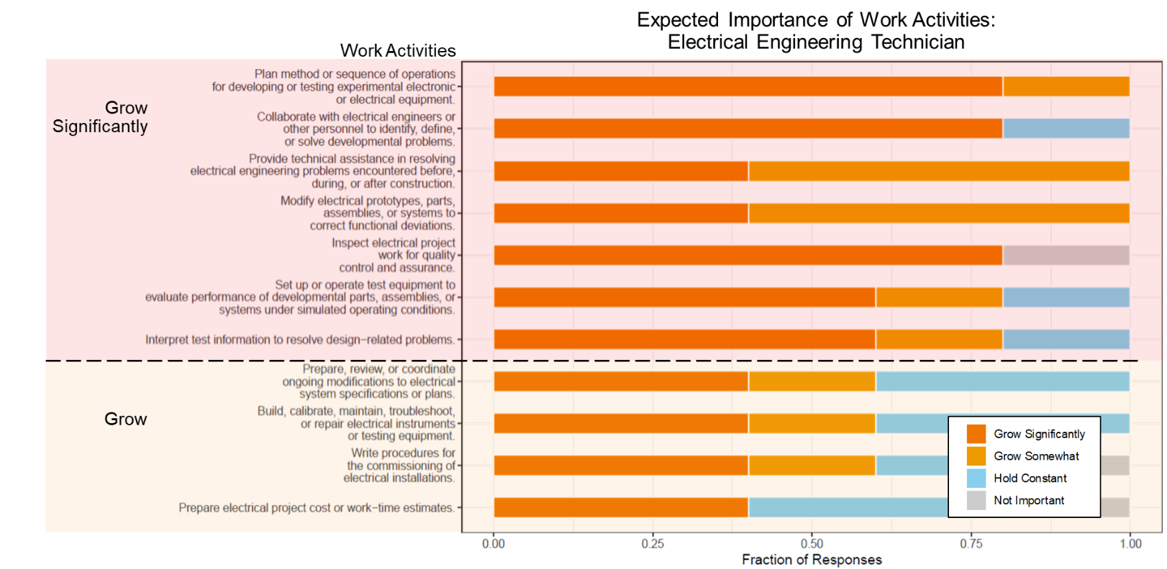
Figure 41. The expected importance of the work activities for electrical engineering technicians are ranked from grow significantly to grow.

Table 30. Recommended changes in the training of Electrical Engineering Technicians for the photonics industry.
Recommendation | Skill | Full Skill Description
Increase emphasis on… | Develop and execute standard testing procedures | Plan method or sequence of operations for developing or testing experimental electronic or electrical equipment.
Increase emphasis on… |  | Set up or operate test equipment to evaluate performance of developmental parts, assemblies, or systems under simulated operating conditions.
Increase emphasis on… | Collaborate to improve design or troubleshoot problems | Collaborate with electrical engineers or other personnel to identify, define, or solve developmental problems.
Increase emphasis on… |  | Provide technical assistance in resolving electrical engineering problems encountered before, during, or after construction.
Increase emphasis on… | Diagnose and resolve process or product problems | Inspect electrical project work for quality control and assurance.
Increase emphasis on… |  | Modify electrical prototypes, parts, assemblies, or systems to correct functional deviations.
Increase emphasis on… | Analyze and respond to test data | Interpret test information to resolve design-related problems.
Maintain training on … | Manage electrical system specifications | Prepare, review, or coordinate ongoing modifications to contract specifications or plans.
 | Build and maintain electrical instruments or testing equipment | Build, calibrate, maintain, troubleshoot, or repair electrical instruments or testing equipment.
 | Write installation procedures | Write procedures for the commissioning of electrical installations.
 | Estimate project or process cost | Prepare electrical project cost or work-time estimates.

Industrial Engineering Technician
Survey responses for industrial engineering technicians are shown in Figure 42Figure 29. Recommendations for training of industrial engineering technicians based on these results are summarized in Table 31.
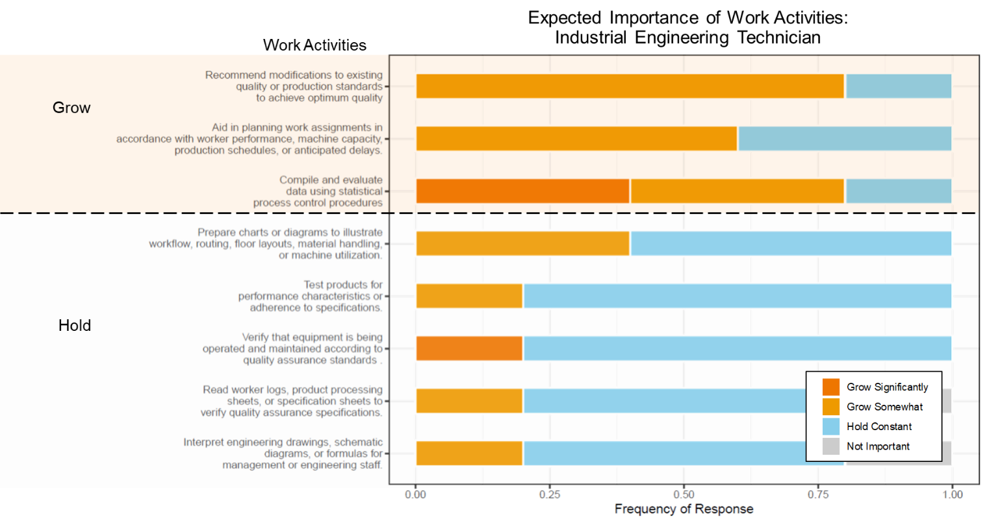
Figure 42. The expected importance of the work activities for industrial engineering technicians are ranked from grow to maintain.

Table 31. Recommended changes in the training of Industrial Engineering Technicians for the photonics industry
Recommendation | Skill | Full Skill Description
Increase emphasis on… | Recommend operational & procedural changes | Recommend modifications to existing quality or production standards to achieve optimum quality
Increase emphasis on… |  | Aid in planning work assignments in accordance with worker performance, machine capacity, production schedules, or anticipated delays.
Increase emphasis on… | Analyze and respond to process data | Compile and evaluate statistical data to determine and maintain quality and reliability of products.
Maintain training on… | Communication with engineering and management | Prepare charts or diagrams to illustrate workflow, routing, floor layouts, material handling, or machine utilization.
Maintain training on… |  | Interpret engineering drawings, schematic diagrams, or formulas for management or engineering staff.
Maintain training on… | Maintain product and process quality assurance standards | Test products for performance characteristics or adherence to specifications.
Maintain training on… |  | Verify that equipment is being operated and maintained according to quality assurance standards.
Maintain training on… |  | Read worker logs, product processing sheets, or specification sheets to verify quality assurance specifications.

Lower-Skilled Workers

Optical Equipment Operator
Survey responses for optical equipment operators are shown in Figure 43Figure 29. Recommendations for training of optical equipment operators based on these results are summarized in Table 32.
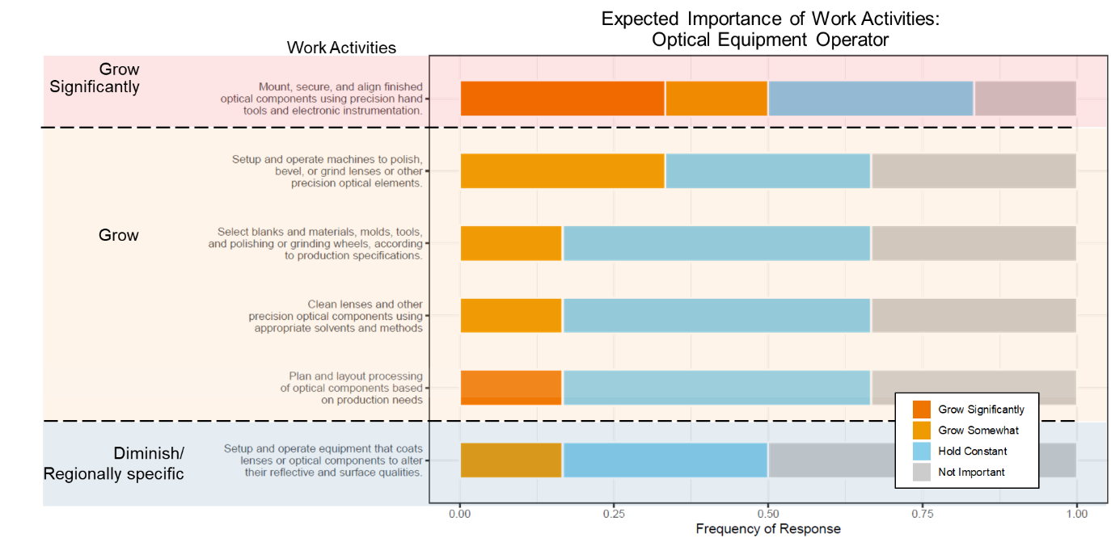
Figure 43. The expected importance of the work activities for optical equipment operators are ranked from grow significantly to diminish or evaluate regionally.

Table 32. Recommended changes in the training of Optical Equipment Operators for the photonics industry
Recommendation | Skill | Full Skill Description
Increase emphasis on… | Setup and operate precision optical machines | Mount, secure, and align finished optical components using precision hand tools and electronic instrumentation.
Increase emphasis on… |  | Setup and operate machines to polish, bevel, or grind lenses or other precision optical elements.
Increase emphasis on… | Select appropriate materials and processes | Select blanks and materials, molds, tools, and polishing or grinding wheels, according to production specifications.
Increase emphasis on… | Design processing plan | Plan and layout processing of optical components based on production needs
Increase emphasis on… | Optical component handling | Clean lenses and other precision optical components using appropriate solvents and methods
Evaluate with their local industry the importance of… | Setup and operate coating equipment | Setup and operate machines to polish, bevel, or grind lenses or other precision optical elements.

Ceramics Production Operator
Survey responses for ceramics production operators are shown in Figure 44. Recommendations for training of ceramics production operators based on these results are summarized in Table 33
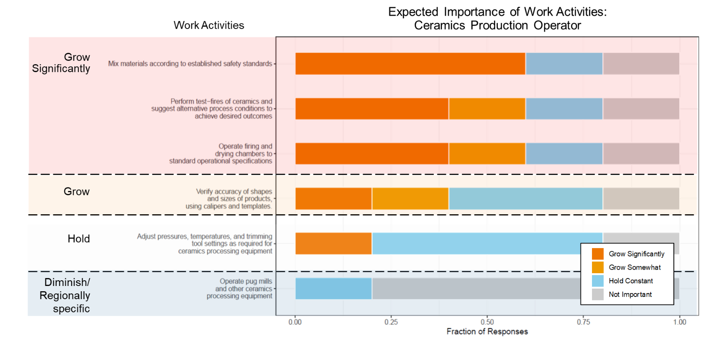

Figure 44. The expected importance of work activities for ceramics production operators are ranked from grow significantly to diminish or evaluate regionally.

Table 33 Recommended changes in the training of Ceramics Production Operators for the photonics industry
Recommendation | Skill | Full Skill Description
Increase emphasis on… | Recommend process design changes | Perform test-fires of ceramics and suggest alternative process conditions to achieve desired outcomes
Increase emphasis on… |  | Adjust pressures, temperatures, and trimming tool settings as required for ceramics processing equipment
Increase emphasis on… | Materials handling | Mix materials according to established safety standards
Increase emphasis on… | Operate firing and drying chambers | Operate firing and drying chambers to standard operational specifications
Increase emphasis on… | Testing and quality assurance methods | Verify accuracy of shapes and sizes of products using calipers and templates
Evaluate with their local industry the importance of… | Operate specific processing equipment | Operate pug mills and other ceramics processing equipment

Common Skills
While it is valuable to understand the skills trends within individual occupations, in many cases, training programs or courses will need to be more broadly applicable, serving the needs of multiple types of learners. To that end, the research team has attempted to identify those skills that are both important and shared (common) among multiple occupations.
Figure 45. General Task or Skill ranked by weighted average importance of the skills within that class. Only GTS that are shared across at least three occupations are labeled as common and, therefore, included in this figure.
Figure 45 shows the ten common GTS level skills associated with middle-skilled positions in photonics ranked from highest to lowest weighted average importance. Notably, the five highest ranked common skills – thinking & making creatively, analyzing data or information, making decisions & troubleshooting problems, estimating & judging characteristics of products or process, and providing consultation & advice to others – involve critical thinking skills.
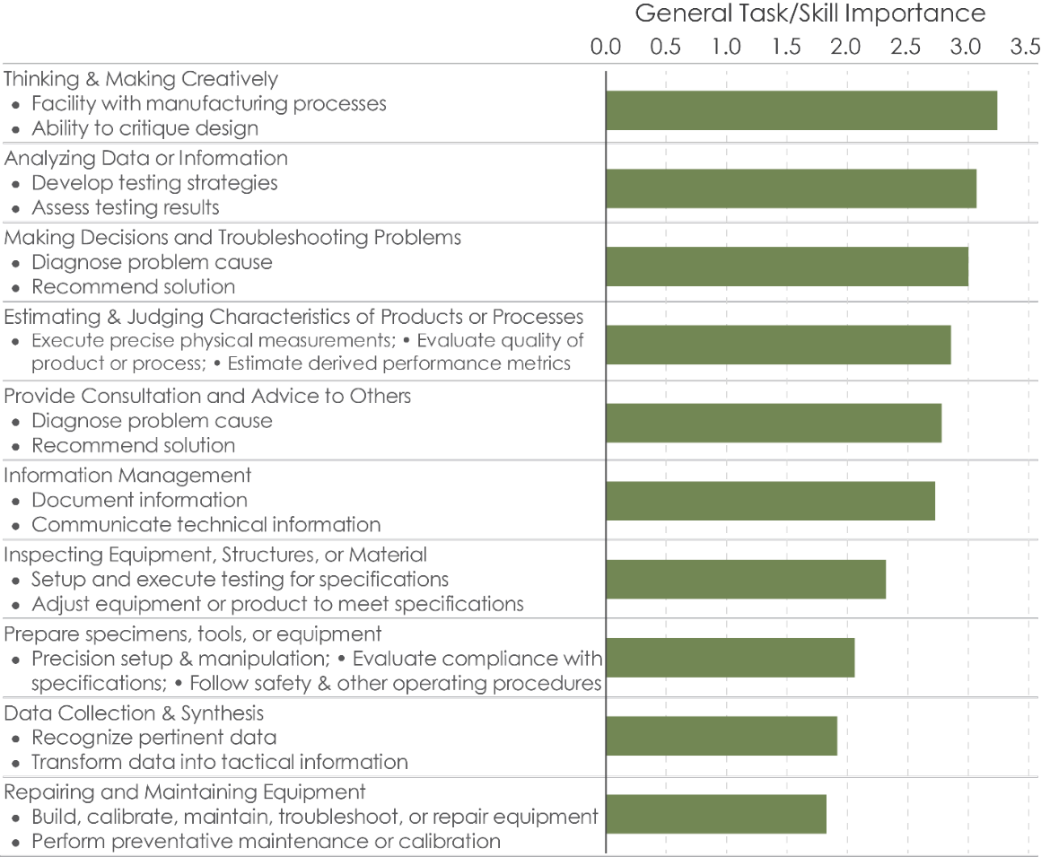

3D/Additive Manufacturing

Firm Classification

Table 34 3DP/AM industry classification archetype examples
Company | US Standard Industrial Classification –  DB Hoovers Expanded Version (SIC8) | North American Industrial Classification System (NAICS)
3Degrees, LLC | 73790203 – Online services technology consultants | 541512 – Computer Systems Design Services
Additive Technologies | 33130201 – Alloys, additive, except copper | 331110 – Iron and steel mills and ferroalloy manufacturing
3D Systems Corporation | 73720000 – Prepackaged software | 511210 – Software publishers
Stratasys | 5770000 – Computer peripheral equipment, nec | 334118 – Computer Terminal and other computer peripheral equipment manufacturing
FormLabs | 27590000 – Commercial printing, nec | 323111 – Commercial printing (except screen and books)
SLM Solutions | 36990202 -- Laser welding, drilling, and cutting equipment | 35590000 – Other industrial machinery manufacturing
AON3D | 35550000 – Printing trades machinery | 333244 – Printing machinery and equipment manufacturing
Additive Industries North America, Inc. | 39990000 – Manufacturing industries, nec | 39990000 – Manufacturing industries, nec

Table 35. Most common NAICS codes for firms identified as in the 3DP/AM industry. These codes capture 98% of firms identified.
NAICS Code | NAICS Description | BLS Equivalent Code
333999 | All Other Miscellaneous General-Purpose Machinery Manufacturing | 3330A1
323111 | Commercial printing (except screens and books) | 323100
333244 | Printing machinery and equipment manufacturing | 333200

Table 36. Focal occupations that were evaluated in this study. Bold titles represent representative occupations that were served as proxy for the subsequent specific occupations.
Occupation | Standard Occupation Classification Code
Middle-skilled
Additive technician*
Electrical and electronics engineering technicians(representing)
Electrical and electronics engineering technicians |  | 17-3023
Electrical and electronics drafters |  | 17-3012
Electro-mechanical technicians |  | 17-3024
Industrial engineering technicians(representing)
Industrial engineering technicians |  | 17-3026
Aerospace engineering and operations technicians |  | 17-3021
Mechanical engineering technicians |  | 17-3027
Mechanical drafters |  | 17-3013
Chemical/materials technicians (representing)
Chemical technician |  | 19-4031
Materials scientist |  | 19-2032
Maintenance and Support Technicians (representing)
Industrial machinery mechanics |  | 49-9041
Maintenance workers, machinery |  | 49-9043
HVAC mechanics and installers |  | 49-9021
Mobile heavy equipment mechanics, except engines |  | 49-3042
Electrical & electronics repairers, commercial & ind. equipment |  | 49-2094
Computer-controlled machine tool operators(representing)
Computer-controlled machine tool operators |  | 51-4011
Computer numerically controlled machine tool programmers |  | 51-4012
Other Technical Production Worker (representing)
Machinists |  | 51-4041
Tool and die makers |  | 51-4111
*The O*NET database does not currently include the additive technician position. Therefore, the position was modeled after the Urban Institute framework for an Additive Manufacturing Maintenance Technician(Urban Institute 2019)

Respondent Demographics
Survey respondents came from a broad array of firms. As shown in Figure 2a, a majority of the respondents came from Massachusetts, with a few firms from other states. Firms ranged in size from as few as 4 employees to as many as 205,000. The median firm size was 104 employees. Annual revenue ranged from $0.2M to $ 79,000M with a median of $18M per year (Figure 2b).
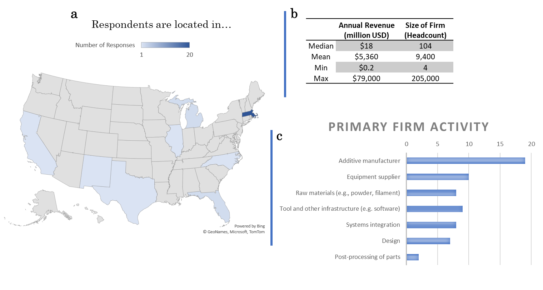
Figure 46. Distribution of respondent location, size, revenue, and primary supply chain activity.
Firms were asked to identify their role in the supply chain. There was a range of primary activities for each firm (see Figure 2c) with a majority focused on additive manufacturing and equipment suppliers.

Demand for occupations

3DP/AM firms indicated that the demand for the positions studied is expected to grow in the (Figure 3). The occupations expected to have the highest demand growth across the supply chain include additive technicians and CNC tool operators. Respondents indicated that CNC tool operators are particularly difficult to find and retain.
Among the occupations studied, nearly all positions are expected to experience moderate demand growth. The exception to this was the mechatronics technician and chemical/materials technician which were noted as “Not applicable” for more than 62% of respondents. This indicates that these types of workers are not common across 3DP/AM firms. However, for firms with these technicians, demand is expected to grow over time.
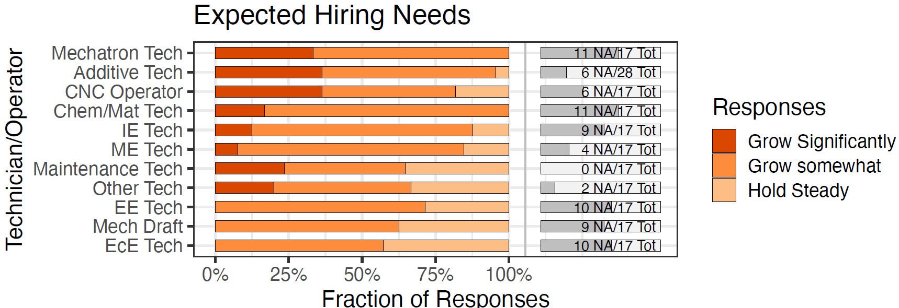
Figure 47. The technical worker occupations studied were classified according to future demand growth in the 3DP/AM industry. Fraction of ‘Not Applicable’ responses at the right of the bar. Firms indicated that other technical worker would likely be a quality or test technician.

The demand for each position can be summarized as follows:
Strong Growth | Moderate Growth | Hold
- Mechatronics Technician  - Additive Technician  - CNC Tool Operator | - Chemical/Materials Technician  - Industrial Engineering Technician  - Maintenance and Support Technician  - Other Technical Production Worker  - Mechanical Engineering Technician  - Electrical Engineering Technician  - Mechanical Drafter  - Electronics Engineering Technician

Hiring Challenges
Many firms expressed how hiring at the technician level is one of their biggest challenges (Figure 4) and many feel there is a worker shortage since positions are open for at least 3 to 4 months. For many, this has led to a backlog of work and firms have been turning to purchasing automated equipment to handle the workload. However, respondents also described that these machines still require a thinking human to be a part of the process. There is a significant need to build up talent within the 3DP/AM industry.
When asked about how long it typically takes to hire for these positions, most positions require at least 30-60 days to hire with 50% or more indicating more than 60 days for all positions except for industrial engineering technician, electrical engineering technician, and mechanical engineering technician. Respondents from smaller firms shared that they feel it can be a big risk to hire and train new employees at this time because many ultimately leave for a larger firm. These results suggest a low supply of technical middle-skilled workers as well as a challenge of attracting and retaining workers in this industry.
In comparing the demand and hiring results, most of the positions are difficult to hire for and are positions expected to have moderate to significant growth in the future. Both the additive technician and CNC tool operator position have significant growth expected and are difficult to hire compared to the other positions studied. These results suggest an emphasis on training and attracting additive technicians and CNC tool operators to meet the demands of the industry.
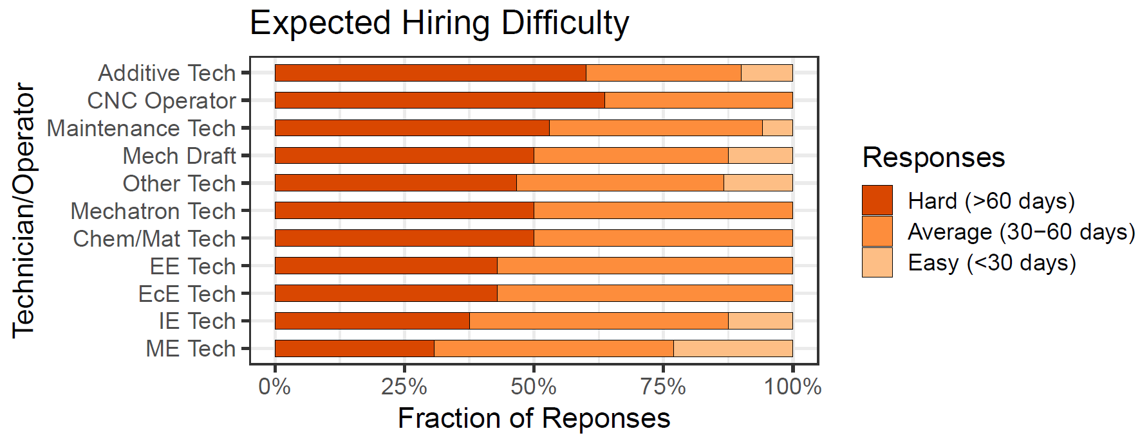
Figure 48 The difficulty of hiring middle-skilled positions was assessed for the 3DP/AM industry (n=30). Most positions were found to be difficult to fill.

The hiring difficulty for each position can be summarized as follows:
Considerable hiring effort | Moderate | Nominal
- Additive Technician  - CNC Tool Operator  - Mechanical Drafter  - Maintenance and Support Technician  - Other Technical Production Worker  - Mechatronics Technician  - Chemical/Materials Technician | - Electrical Engineering Technician  - Electronics Engineering Technician  - Industrial Engineering Technician  - Mechanical Engineering Technician

Training Effort Required

The amount of on-the-job training for each occupation was also evaluated by respondents as extensive, some, or basic orientation only. Many respondents shared that it is rare to find individuals with formal training in 3DP/additive and therefore most firms require at least some training (see Figure 5). For roles such as additive technician or maintenance and support, 3DP/AM firms look for individuals with a mechanical aptitude and interest in the area since most have not been exposed to additive or 3D printing in previous roles or training but are generally easier to train.
Smaller firms explained that while they want to give their technicians extensive on-the-job training, they don’t have the capacity or resources to do so. To help address this, firms suggested a rotational internship program where interns would be exposed to a number of different 3DP/AM practices and could receive cross-training. While some training is company specific, respondents suggested additional or improved training in the following areas:
- Safety
- Basic computer skills
- CAD software (e.g., Solid Works)
- 3DP software (e.g., Magics)
- Business knowledge (e.g., operating costs)
- Design for additive concepts/design rules
- Material properties
- Geometric dimensioning and tolerancing (GD&T)
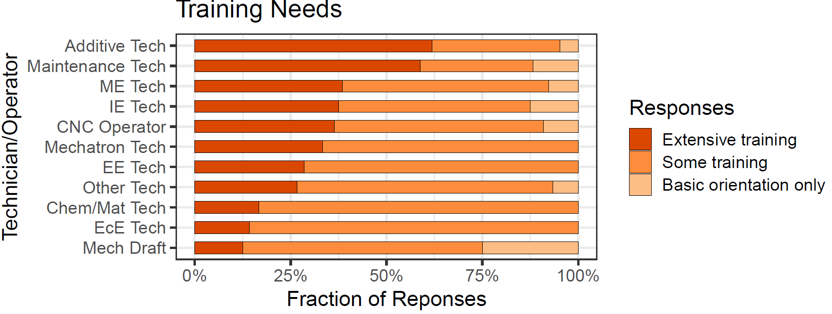
Figure 49 The training required for each position was assessed as extensive, some training, or basic orientation only (n=30). Most positions require at least some training with additive and maintenance and support technicians requiring significant on-the-job training.
In comparing the training effort results to the hiring challenge results, we observe that additive technicians, maintenance and support technicians, and CNC tool operators are all positions that require significant training and are difficult positions for firms to fill.

Skills required for in-demand positions

Additive Technician
Survey responses for additive technicians are shown in Figure 7. Recommendations for training of additive technicians based on these results are summarized in Table 5.
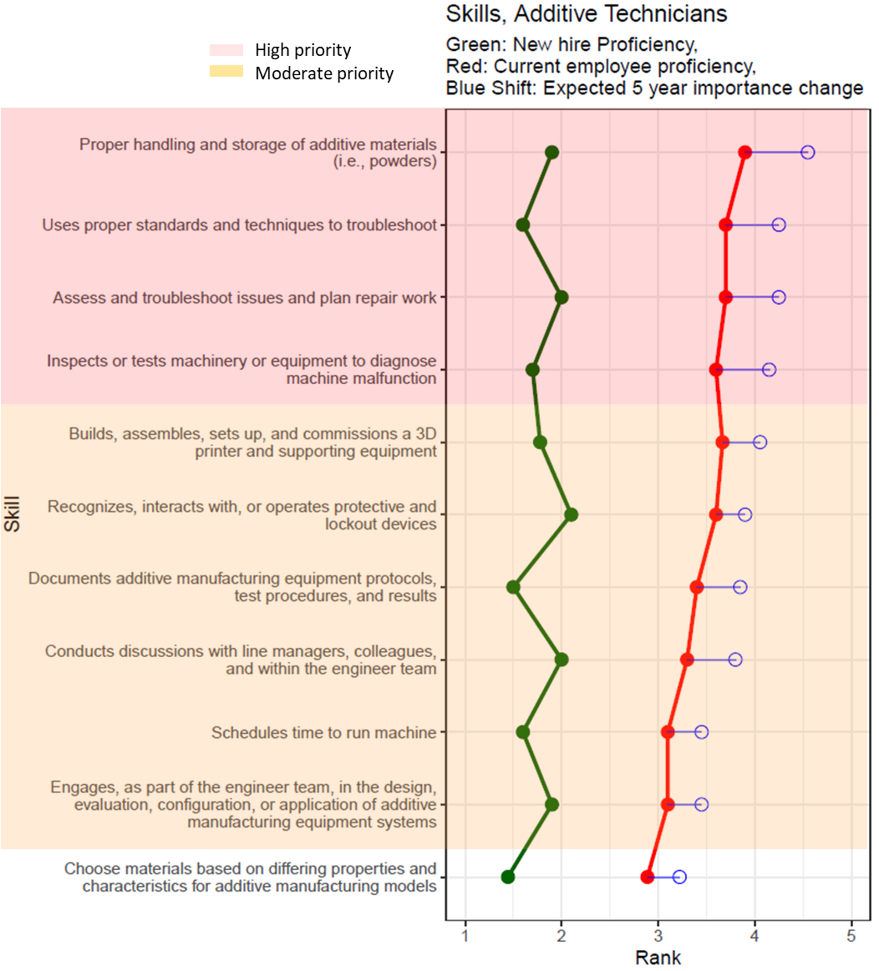
Figure 50. The gaps and expected future importance of skills for additive technicians are shown with high priority skills highlighted in red and moderate priority skills highlighted in orange.

Table 37. Recommended changes in the training of additive technicians in the 3DP/AM industry. The red skills are those that are high priority and the orange skills are those that are ranked as moderate priority and therefore have a skill gap and are also important in the future.
Recommendation | Skill | Full Skill Description
Emphasize training on… | Troubleshoot and follow standard protocols | Proper handling and storage of additive materials (i.e., powders)
Emphasize training on… | Troubleshoot and follow standard protocols | Uses proper standards and techniques to troubleshoot
Emphasize training on… | Troubleshoot and follow standard protocols | Assess and troubleshoot issues and plan repair work
Emphasize training on… | Inspect equipment | Inspects or tests machinery or equipment to diagnose machine malfunction
Improve training on… | Assemble and maintain 3D/additive machinery  Understand, evaluate, and maintain quality | Builds, assembles, sets up, and commissions a 3D printer and supporting equipment
Improve training on… |  | Recognizes, interacts with, or operates protective and lockout devices
Improve training on… |  | Documents additive manufacturing equipment protocols, test procedures, and results
Improve training on… | Collaborate and coordinate with team members | Conducts discussions with line managers, colleagues, and within the engineer team
Improve training on… | Collaborate and coordinate with team members | Schedules time to run machine
Improve training on… | Collaborate and coordinate with team members | Engages, as part of the engineer team, in design, evaluation, configuration, or application of additive manufacturing equipment systems
Maintain training/evaluate training on… | Choose proper materials | Choose materials based on differing properties and characteristics for additive manufacturing models

Mechanical Engineering Technician
Survey responses for mechanical engineering technicians are shown in Figure 51. Recommendations for training of mechanical engineering technicians based on these results are summarized in Table 38.
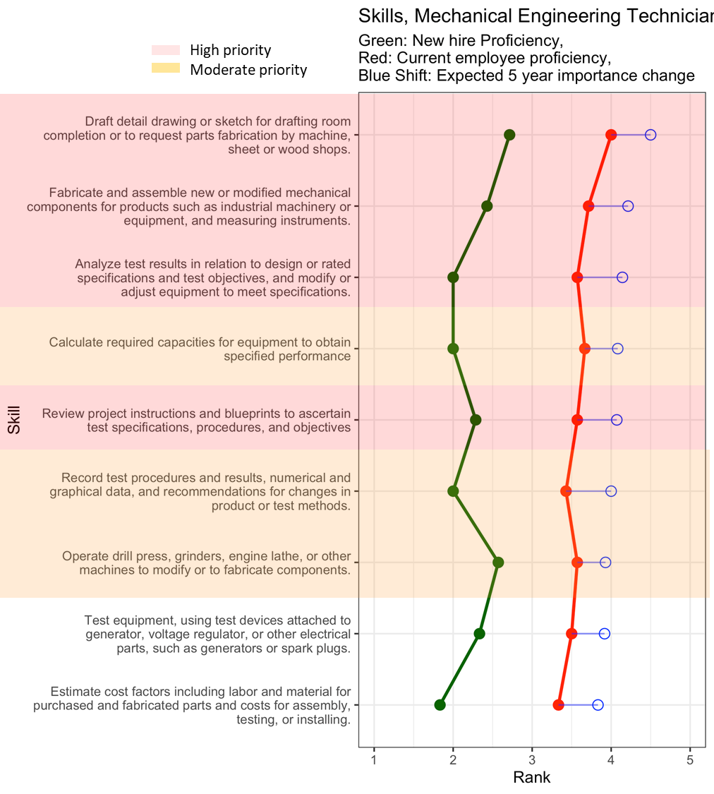
Figure 51. The gaps and expected future importance of skills for mechanical engineering technicians are shown with high priority skills highlighted in red and moderate priority skills highlighted in orange.

Table 38. Recommended changes in the training of mechanical engineering technicians in the 3DP/AM industry. The red skills are those that are high priority and the orange skills are those that are ranked as moderate priority and therefore have a skill gap and are also important in the future.
Recommendation | Skill | Full Skill Description
Emphasize training on… | Drafting for fabrication | Draft detail drawing or sketch for drafting room completion or to request parts fabrication by machine, sheet or wood shops.
Emphasize training on… | Fabrication methods | Fabricate and assemble new or modified mechanical components for products such as industrial machinery or equipment, and measuring instruments.
Emphasize training on… | Understand, evaluate, and maintain quality | Analyze test results in relation to design or rated specifications and test objectives, and modify or adjust equipment to meet specifications.
Emphasize training on… | Understand, evaluate, and maintain quality | Review project instructions and blueprints to ascertain test specifications, procedures, and objectives
Improve training on… | Recommend changes in product or process design | Record test procedures and results, numerical and graphical data, and recommendations for changes in product or test methods.
Improve training on… | Operate specific equipment | Operate drill press, grinders, engine lathe, or other machines to modify parts tested or to fabricate experimental parts for testing.
Improve training on… | Operate specific equipment | Calculate required capacities for equipment to obtain specified performance
Maintain training/evaluate training on… | Understand, test, and maintain quality | Test equipment, using test devices attached to generator, voltage regulator, or other electrical parts, such as generators or spark plugs.
Maintain training/evaluate training on… | Estimate operating costs | Estimate cost factors including labor and material for purchased and fabricated parts and costs for assembly, testing, or installing.

Industrial Engineering Technician
Survey responses for industrial engineering technicians are shown in Figure 8. Recommendations for training of industrial engineering technicians based on these results are summarized in Table 6.
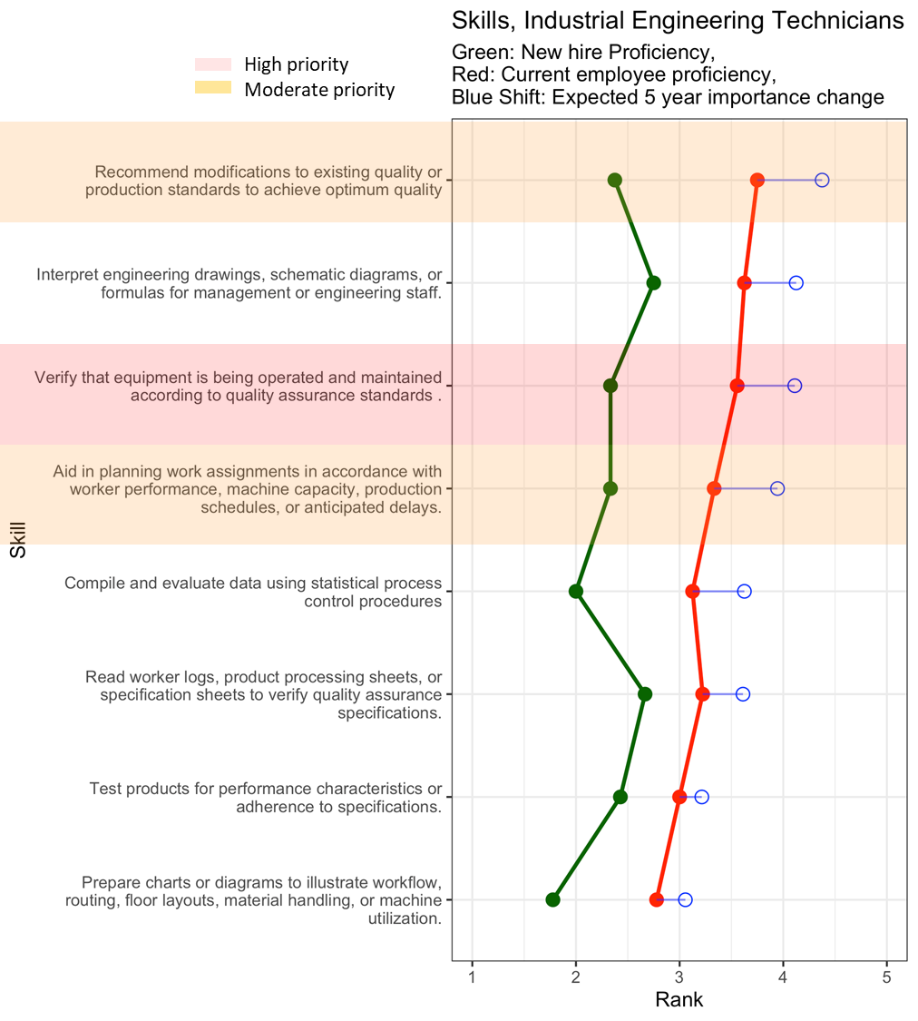
Figure 52. The gaps and expected future importance of skills for industrial engineering technicians are shown with high priority skills highlighted in red and moderate priority skills highlighted in orange.
Table 39. Recommended changes in the training of industrial engineering technicians in the 3DP/AM industry. The orange skills are those that are ranked as moderate priority and therefore have a skill gap and are also important in the future.
Recommendation | Skill | Full Skill Description
Emphasize training on… | Maintain product and process quality assurance standards | Verify that equipment is being operated and maintained according to quality assurance standards.
Improve training on… | Recommend operational & procedural changes | Aid in planning work assignments in accordance with worker performance, machine capacity, production schedules, or anticipated delays.
Improve training on… | Recommend operational & procedural changes | Recommend modifications to existing quality or production standards to achieve optimum quality
Maintain training/evaluate training on… | Communication with engineering and management | Interpret engineering drawings, schematic diagrams, or formulas for management or engineering staff.
Maintain training/evaluate training on… | Test, analyze and respond to process data | Compile and evaluate statistical data to determine and maintain quality and reliability of products.
Maintain training/evaluate training on… | Test, analyze and respond to process data | Test products for performance characteristics or adherence to specifications.
Maintain training/evaluate training on… | Maintain product and process quality assurance standards | Read worker logs, product processing sheets, or specification sheets to verify quality assurance specifications.
Maintain training/evaluate training on… | Communication with engineering and management | Prepare charts or diagrams to illustrate workflow, routing, floor layouts, material handling, or machine utilization.

Mechatronics Technician
Survey responses for mechatronics technicians are shown in Figure 53. Recommendations for training of mechatronics technicians based on these results are summarized in Table 40.
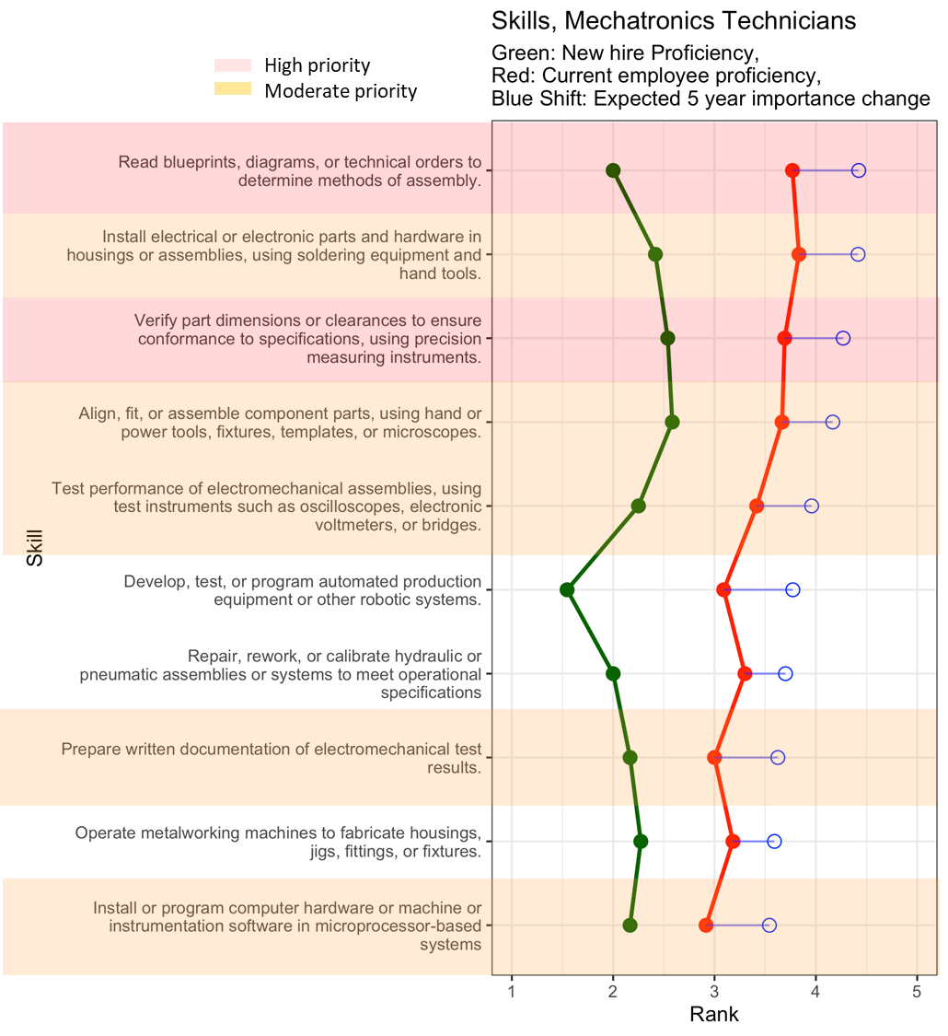
Figure 53 The gaps and expected future importance of skills for mechatronics technicians are shown with high priority skills highlighted in red and moderate priority skills highlighted in orange.

Table 40 Recommended changes in the training of mechatronics technicians in the 3DP/AM industry. The orange skills are those that are ranked as moderate priority and therefore have a skill gap and are also important in the future.
Recommendation | Skill | Full Skill Description
Emphasize training on… | Fabricate components and systems | Install electrical or electronic parts and hardware in housings or assemblies, using soldering equipment and hand tools.
Emphasize training on… | Fabricate components and systems | Align, fit, or assemble component parts, using hand or power tools, fixtures, templates, or microscopes.
Improve training on… | Understand, evaluate, and maintain quality | Read blueprints, diagrams, or technical orders to determine methods of assembly.
 | Understand, evaluate, and maintain quality | Verify part dimensions or clearances to ensure conformance to specifications, using precision measuring instruments.
 | Fabricate components and systems | Install electrical or electronic parts and hardware in housings or assemblies, using soldering equipment and hand tools.
 | Fabricate components and systems | Align, fit, or assemble component parts, using hand or power tools, fixtures, templates, or microscopes.
 | Use test instruments | Test performance of electromechanical assemblies, using test instruments such as oscilloscopes, electronic voltmeters, or bridges.
 | Prepare reports | Prepare written documentation of electromechanical test results.
 | Use test instruments | Test performance of electromechanical assemblies, using test instruments such as oscilloscopes, electronic voltmeters, or bridges.
Maintain training/evaluate training on… | Develop, test, and program hardware systems | Develop, test, or program automated production equipment or other robotic systems
Maintain training/evaluate training on… | Hydraulic or pneumatic assembly repair | Repair, rework, or calibrate hydraulic or pneumatic assemblies or systems to meet operational specifications
Maintain training/evaluate training on… | Operate metalworking machines | Operate metalworking machines to fabricate housings, jigs, fittings, or fixtures

CNC Tool Operator
Survey responses for CNC tool operators are shown in Figure 10. Recommendations for training of CNC tool operators based on these results are summarized in Table 8.
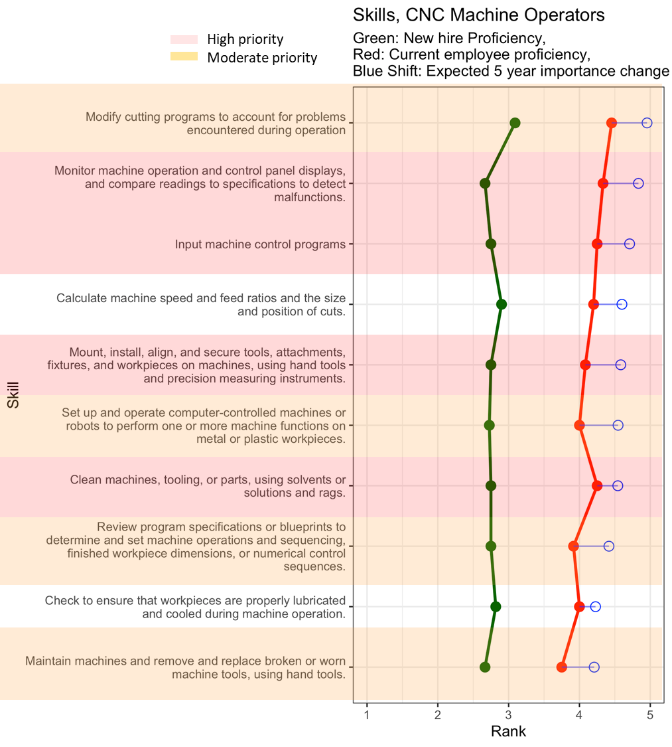
Figure 54. The gaps and expected future importance of skills for CNC tool operators are shown with high priority skills highlighted in red and moderate priority skills highlighted in orange.
Table 41 Recommended changes in the training of CNC tool operators in the 3DP/AM industry. The orange skills are those that are ranked as moderate priority and therefore have a skill gap and are also important in the future.
Recommendation | Skill | Full Skill Description
Emphasize training on… | Monitor and maintain machines | Monitor machine operation and control panel displays, and compare readings to specifications to detect malfunctions.
Emphasize training on… | Monitor and maintain machines | Input machine control programs
Emphasize training on… | Monitor and maintain machines | Mount, install, align, and secure tools, attachments, fixtures, and workpieces on machines, using hand tools and precision measuring instruments.
Emphasize training on… | Monitor and maintain machines | Clean machines, tooling, or parts, using solvents or solutions and rags.
Improve training on… | Troubleshoot and operate machines | Modify cutting programs to account for problems encountered during operation
Improve training on… | Troubleshoot and operate machines | Set up and operate computer-controlled machines or robots to perform one or more machine functions on metal or plastic workpieces.
Improve training on… | Assess specifications or blueprints | Review program specifications or blueprints to determine and set machine operations and sequencing, finished workpiece dimensions, or numerical control sequences.
Improve training on… | Machine operation and maintenance | Maintain machines and remove and replace broken or worn machine tools, using hand tools.
Improve training on… | Machine operation and maintenance | Clean machines, tooling, or parts, using solvents or solutions and rags.
Maintain training/evaluate training on… | Calculate machine speeds and feed ratios | Calculate machine speed and feed ratios and the size and position of cuts.
Maintain training/evaluate training on… | Machine operation and maintenance | Check to ensure that workpieces are properly lubricated and cooled during machine operation.

Mechanical Drafter
Survey responses for mechanical drafters are shown in Figure 55. Recommendations for training of mechanical drafters based on these results are summarized in Table 42.

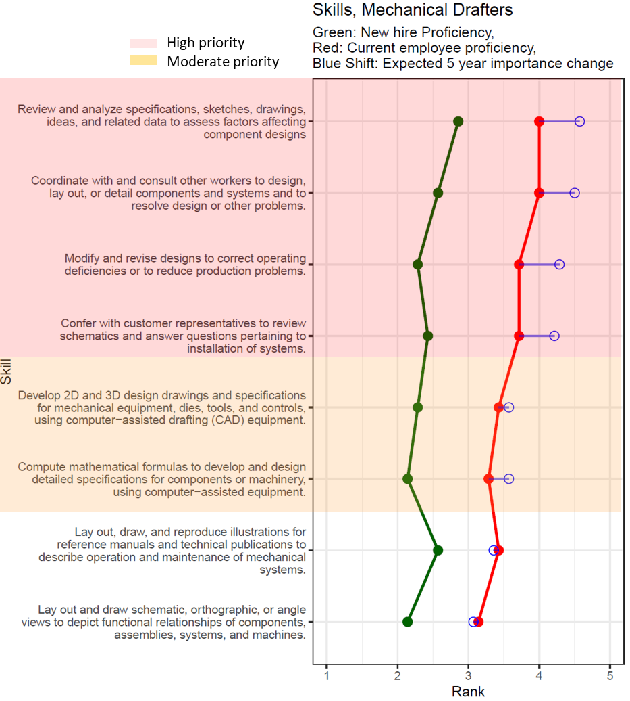
Figure 55 The gaps and expected future importance of skills for mechanical drafters are shown with high priority skills highlighted in red and moderate priority skills highlighted in orange.

Table 42 Recommended changes in the training of mechanical drafters in the 3DP/AM industry. The orange skills are those that are ranked as moderate priority and therefore have a skill gap and are also important in the future.
Recommendation | Skill | Full Skill Description
Emphasize training on… | Review designs and coordinate with other workers | Review and analyze specifications, sketches, drawings, ideas, and related data to assess factors affecting component designs
Emphasize training on… | Review designs and coordinate with other workers | Coordinate with and consult other workers to design, lay out, or detail components and systems and to resolve design or other problems
Emphasize training on… | Review designs and coordinate with other workers | Modify and revise designs to correct operating deficiencies or to reduce production problems
Emphasize training on… | Review designs and coordinate with other workers | Confer with customer representatives to review schematics and answer questions pertaining to installation of systems
Improve training on… | Use CAD equipment for design | Develop 2D and 3D design drawings and specifications for mechanical equipment, dies, tools, and controls, using CAD equipment.
Improve training on… | Use CAD equipment for design | Compute mathematical formulas to develop and design detailed specifications for components or machinery, using computer-assisted equipment.
Maintain training/evaluate training on… | Lay out and draw mechanical systems | Lay out, draw, and reproduce illustrations for reference manuals and technical publications to describe operation and maintenance of mechanical systems.
Maintain training/evaluate training on… | Lay out and draw mechanical systems | Lay out and draw schematic, orthographic, or angle views to depict functional relationships of components, assemblies, systems, and machines

Critical Thinking Skills
When trying to define what is meant by critical thinking, one definition is “the ability to analyze evidence and facts to form a judgment”(Gambrill 2005). More practically, we can classify these judgments with the following levels of critical thinking:
- Perceiving the issue – What should I measure or observe to know that a problem exists?
- Hypothesizing about problem cause – What might be causing the problem?
- Developing a framework for hypothesis testing – How can I confirm my hypothesis?
- Inferring whether tests confirm the hypothesis - Does the test suggest that my hypothesis was right?
- Communicating the outcome – How (and to whom) do I report on what has happened?
Respondents were asked to identify what level of critical thinking is expected of technicians. Responses were grouped by engineering technician positions and other technical workers shown in Figure 11.
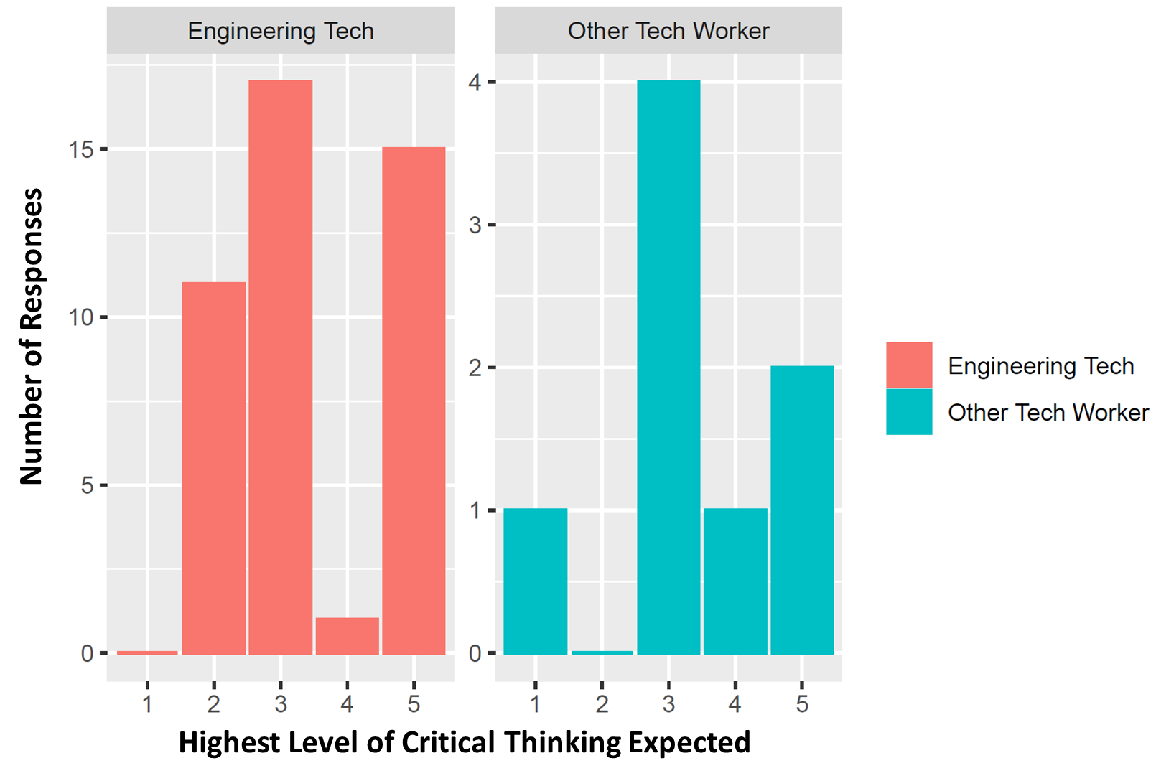
Figure 56. Respondents valued critical thinking skills for all occupations studied. However, most respondents expect a higher level of critical thinking for engineering technicians. While there are respondents that expect the highest level for other technical workers as well, a majority of respondents expect other technical workers to develop a framework for hypothesis testing.
Firms believe critical thinking is necessary for engineering technicians. They believe engineering technicians should be able to use a systems perspective to understand failures or challenges by using a triage process. Technicians that are able to contribute to detection of errors/failures and can communicate these issues are extremely valuable for firms. Technicians can be part of the solution and therefore firms suggest more practical and hands-on training exercises to prepare them for the manufacturing floor.
Results indicate that 40% of firms expect engineering technicians to have competency in nearly all aspects of critical thinking (perceiving, hypothesizing, testing, and interpreting testing). Most other technical production workers are expected to perform hypothesis testing (50%) while 25% of the respondents expected these workers to be able to master all aspects of critical thinking.

Common Skills
To understand the skills needed broadly at the middle-skill occupation level, the research team has identified skills that are both shared (common) and important across multiple occupations to enable training programs to be relevant for companies across the 3DP/AM supply chain. Figure 57 shows the eight highest weighted average importance scores for the general task/skill (GTS) level ranked from highest to lowest.
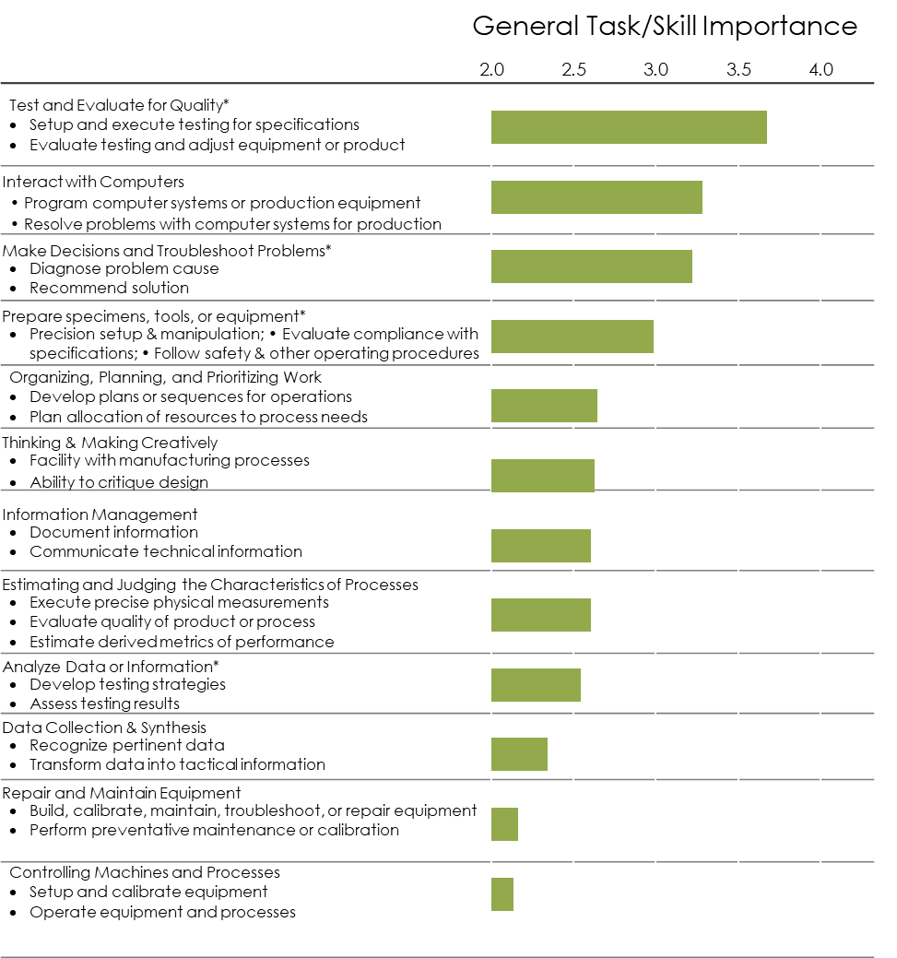
Figure 57 General Task or Skill ranked by weighted average importance of the skills within that class. Only GTS that are shared across at least two occupations are labeled as common and, therefore, included in this figure.

Cluster analysis results

Figure 58 Generalized tasks/skills rankings by advanced manufacturing industry. The highest weighted average importance score for the GTS level are ranked from highest (orange) to lowest (purple). The weighting of these skills is not comparable across industries, yet similarities and differences in rankings can be compared between the lists.

Figure 59. The average Silhouette score by the number of clusters that demonstrates the quality of the clusters. The score monotonically improves until eight individual clusters are formed and then declines as clusters become smaller.

Figure 60 Average Silhouette values by cluster count (x-axis) and method, designated by the different colors. The optimal cluster for most of the methods is around 8.

Table 43. Average Silhouette Values By Method and K
n | ward.D | ward.D2 | single | complete | average | mcquitty | median | centroid | diana | k-medoid
2 | 0.306 | 0.307 | 0.280 | 0.280 | 0.319 | 0.280 | 0.279 | 0.309 | 0.319 | 0.329
3 | 0.413 | 0.408 | 0.340 | 0.401 | 0.408 | 0.401 | 0.328 | 0.351 | 0.408 | 0.435
4 | 0.499 | 0.503 | 0.503 | 0.503 | 0.503 | 0.503 | 0.371 | 0.467 | 0.402 | 0.494
5 | 0.588 | 0.587 | 0.552 | 0.587 | 0.596 | 0.587 | 0.525 | 0.536 | 0.443 | 0.596
6 | 0.684 | 0.680 | 0.613 | 0.680 | 0.680 | 0.680 | 0.658 | 0.684 | 0.549 | 0.708
7 | 0.766 | 0.759 | 0.721 | 0.759 | 0.754 | 0.754 | 0.754 | 0.754 | 0.659 | 0.775
8 | 0.837 | 0.837 | 0.837 | 0.837 | 0.837 | 0.837 | 0.837 | 0.837 | 0.837 | 0.841
9 | 0.809 | 0.809 | 0.780 | 0.793 | 0.780 | 0.780 | 0.780 | 0.780 | 0.793 | 0.786
10 | 0.819 | 0.819 | 0.819 | 0.819 | 0.819 | 0.819 | 0.819 | 0.819 | 0.819 | 0.736

Table 44 The ranked skills list for each of the four clusters.
Rank | #1: Additive and Mechanical Engineering Technicians | #2: Chemical and Photonics Technicians | #3: CNC Operators and Mechatronics Technicians | #4: Electrical and Industrial Engineering Technicians
1 | 4.A.1.b.2: Inspecting Equipment, Structures, or Material (3.001; n=441) | 4.A.3.a.1: Performing General Physical Activities (3.512; n=161) | 4.A.3.a.2: Handling and Moving Objects (3.273; n=360) | 4.A.3.a.3: Controlling Machines and Processes (2.783; n=340)
2 | 4.A.1.a.2: Monitor Processes, Materials, or Surroundings (2.974; n=135) | 4.A.3.a.2: Handling and Moving Objects (2.938; n=600) | 4.A.1.a.1: Getting Information (3.185; n=456) | 4.A.3.b.4: Repairing and Maintaining Mechanical Equipment (2.783; n=170)
3 | 4.A.3.b.6: Documenting/Recording Information (2.866; n=396) | 4.A.3.b.6: Documenting/Recording Information (2.717; n=125) | 4.A.3.b.1: Interacting With Computers (3.005; n=1284) | 4.A.4.a.2: Communicating with Supervisors, Peers, or Subordinates (2.718; n=170)
4 | 4.A.2.b.2: Thinking Creatively (2.736; n=612) | 4.A.3.a.3: Controlling Machines and Processes (2.632; n=595) | 4.A.2.b.2: Thinking Creatively (2.845; n=360) | 4.A.4.b.6: Provide Consultation and Advice to Others (2.689; n=422)
5 | 4.A.3.a.3: Controlling Machines and Processes (2.681; n=702) | 4.A.2.a.4: Analyzing Data or Information (2.562; n=500) | 4.A.1.b.2: Inspecting Equipment, Structures, or Material (2.809; n=540) | 4.A.1.b.2: Inspecting Equipment, Structures, or Material (2.434; n=592)
6 | 4.A.3.b.4: Repairing and Maintaining Mechanical Equipment (2.531; n=90) | 4.A.2.a.1: Judging the Qualities of Things, Services, or People (2.273; n=125) | 4.A.1.a.2: Monitor Processes, Materials, or Surroundings (2.695; n=552) | 4.A.2.a.4: Analyzing Data or Information (2.295; n=422)
7 | 4.A.2.b.1: Making Decisions and Solving Problems (2.503; n=531) | 4.A.1.b.2: Inspecting Equipment, Structures, or Material (2.183; n=160) | 4.A.3.a.1: Performing General Physical Activities (2.654; n=276) | 4.A.2.b.2: Thinking Creatively (2.149; n=592)
8 | 4.A.2.b.6: Organizing, Planning, and Prioritizing Work (2.402; n=90) | 4.A.2.b.1: Making Decisions and Solving Problems (1.663; n=95) | 4.A.3.b.4: Repairing and Maintaining Mechanical Equipment (2.494; n=732) | 4.A.1.a.2: Monitor Processes, Materials, or Surroundings (2.108; n=504)
9 | 4.A.2.a.4: Analyzing Data or Information (2.384; n=306) | 4.A.4.b.6: Provide Consultation and Advice to Others (1.375; n=255) | 4.A.2.b.1: Making Decisions and Solving Problems (2.436; n=276) | 4.A.4.a.1: Interpreting the Meaning of Information for Others (2.094; n=252)
10 | 4.A.4.a.2: Communicating with Supervisors, Peers, or Subordinates (2.231; n=135) | 4.A.2.a.3: Evaluating Information to Determine Compliance with Standards (0.829; n=95) | 4.A.3.a.3: Controlling Machines and Processes (2.398; n=1464) | 4.A.2.b.6: Organizing, Planning, and Prioritizing Work (1.938; n=252)
11 | 4.A.1.a.1: Getting Information (2.156; n=306) |  | 4.A.3.b.6: Documenting/Recording Information (2.267; n=180) | 4.A.3.b.6: Documenting/Recording Information (1.901; n=340)
12 | 4.A.2.b.5: Scheduling Work and Activities (2.014; n=45) |  |  | 4.A.2.b.1: Making Decisions and Solving Problems (1.852; n=340)
13 | 4.A.1.b.3: Estimating the Quantifiable Characteristics of Products, Events, or Information (1.658; n=306) |  |  | 4.A.1.b.3: Estimating the Quantifiable Characteristics of Products, Events, or Information (1.351; n=170)

Figure 61 Ten different clustering approaches for the eight occupations across the advanced manufacturing industries. At eight clusters, most positions remain in their own clusters. However, in electrical engineering technicians, there is a fragmentation of clustering within the position suggesting that electrical engineering technicians have specialty skills required in different domains.

